WRITTEN EXAMINATION
Fall 2011, 4 pages

ENG0111: English for international students
Duration 4 hours Date: December 1, 2011
====================================================================

English-English dictionaries are allowed. REMEMBER TO DOUBLE-SPACE.
Answer sections 1-3. A pass mark is required on each section.

Exercise 1: Visual Information (30% of mark)

Based on the information conveyed by the map, write a small accompanying text [approximately 75 words] about malnutrition among young children worldwide.

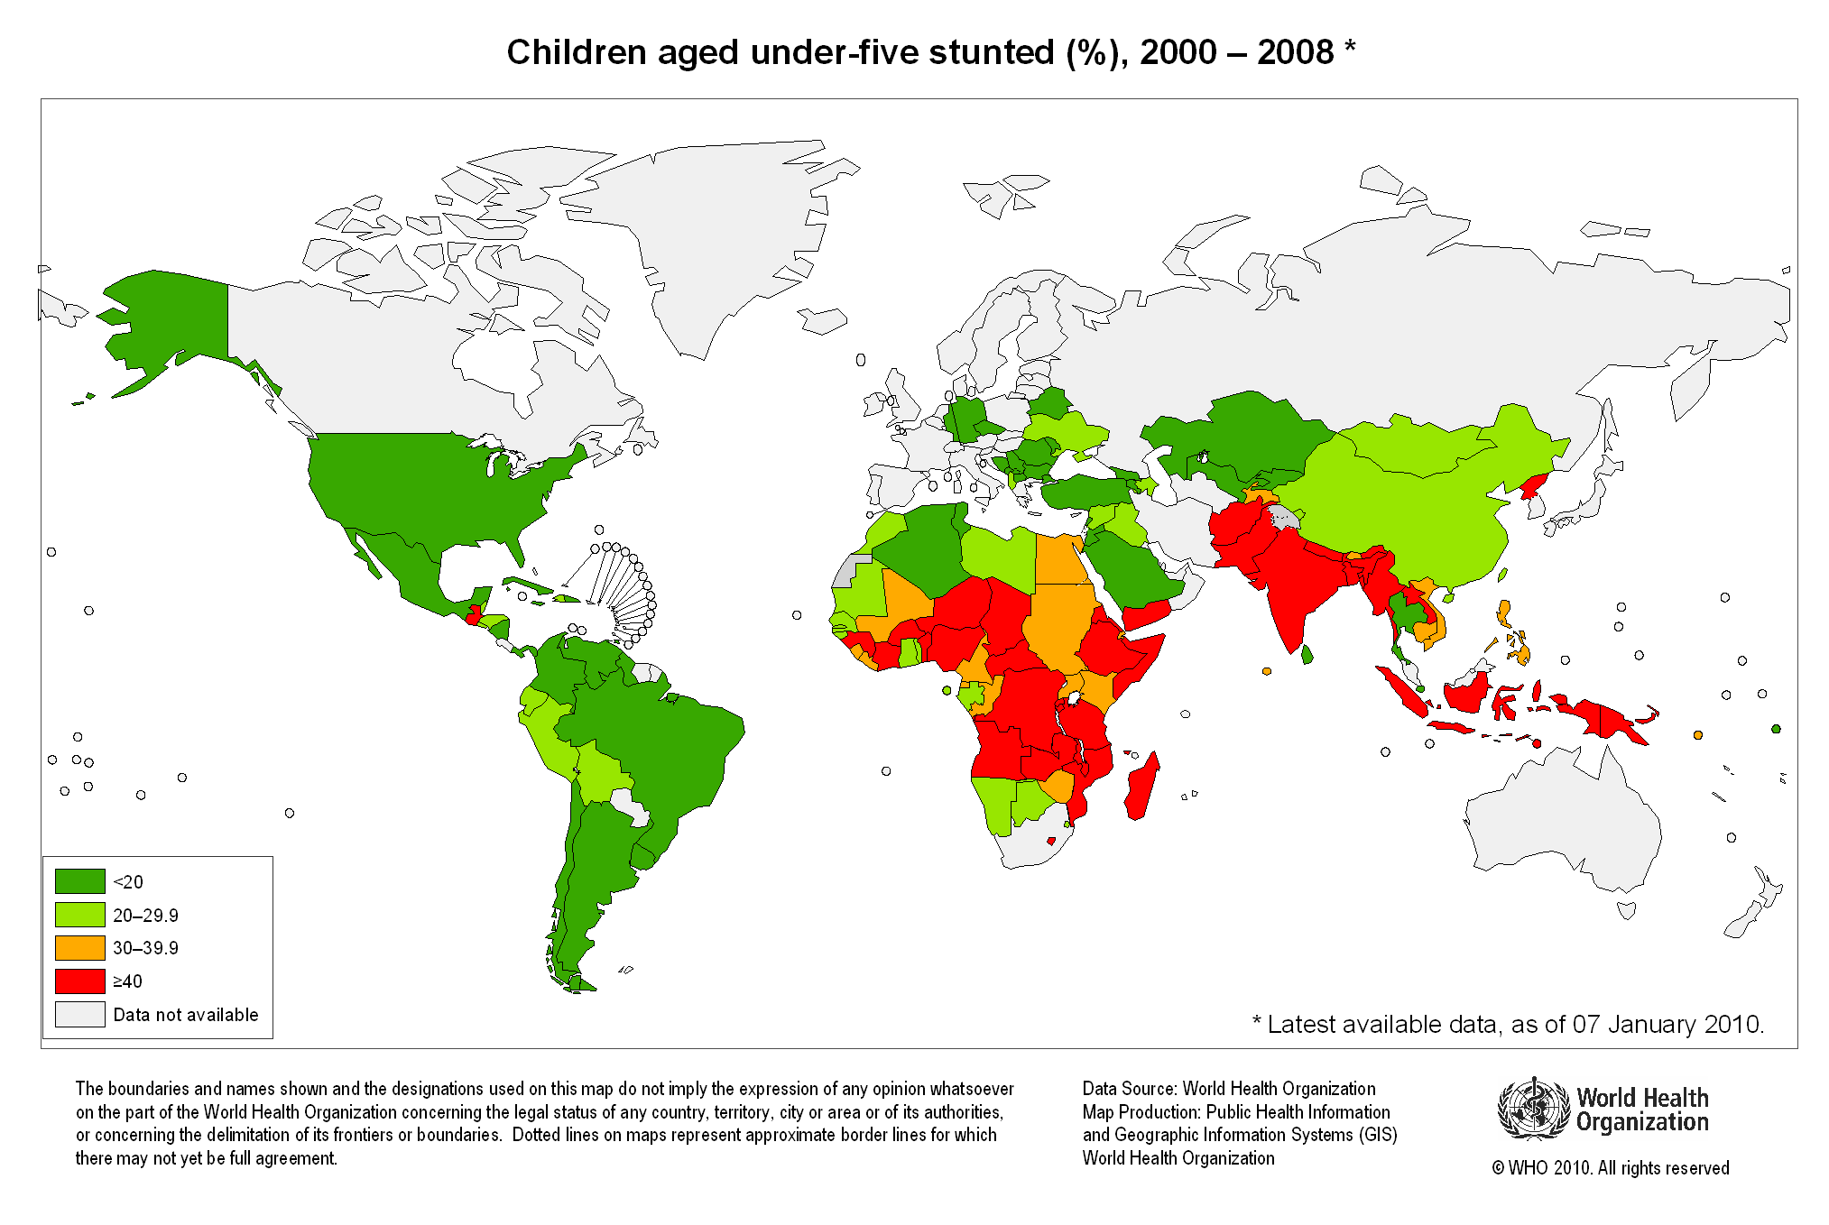

Exercise 2: Summary (40 %)

Read the text well. Look up the words that you do not understand. Write a summary of the text below, not exceeding 150 words. DOUBLE SPACE.

Public schools increasingly ban junk food in cafeterias
The commercial success of Morgan Spurlock's film Super Size Me placed a spotlight on the rising rate of obesity in the United States and the corresponding health problems caused by a prevalent high-fat, high-sugar diet without adequate physical exercise. The most recent data from the U.S. National Center for Health Statistics show that 30 percent of people 20 years of age and older are obese and 16 percent of children and teenagers between ages 6 and 19 are overweight - a rate that has more than tripled since 1980.
Studies show that obesity at a young age leads to a host of medical problems later in life, such as diabetes, heart disease, sleeping disorders and depression. A fat child's current health is also at risk, because he or she is often malnourished as well as overfed. Despite efforts by federal, state and local officials to educate younger people about making healthier food choices, many youngsters continue to satisfy their cravings for junk food at the expense of their own well-being.
Mark Zanger, a food reporter for the Boston Phoenix, writes in his article "What's For Lunch," that children usually prefer foods with simple sugars and starches, saturated fats and things they have eaten before to more healthy alternatives. "Almost every school cafeteria I visited reported that pizza is the most popular meal and that French fries are the most popular side dish," he said. As a result, officials are increasingly seeking to regulate the eating habits of children in the one area that is under their jurisdiction: public schools. Public school lunches already have nutritional guidelines and standards established by the federal government, which provides subsidies at the rate of $9.5 billion per year to help poor and lower-income students afford the meals served. However, vending machines that sell soft drinks and a la carte menu items like potato chips and candy have come under attack lately.
Bodybuilder, actor, and now California's governor, Arnold Schwarzenegger, announced in September that under newly enacted state laws, individual food items sold in California’s public schools, including those in vending machines and on the cafeteria menu, may not exceed 250 calories. Schools will be required to offer more fresh fruits and vegetables. Also, the new laws stipulate that the schools have until July 1, 2007, to replace half the sodas or soft drinks sold in their schools with more nutritious options, such as milk, juices, water and sports drinks. All juice drinks will have to contain at least 50 percent real juice and contain no added sweeteners. The legislation also requires that the remaining soda drinks be replaced by 2009.
In Arlington County, Virginia, students have been able to purchase items like candy, chips and soda from vending machines in their secondary school cafeterias, but the county school board voted in September to replace those items with healthier alternatives, as well as to post information about the fat and caloric content and nutrient levels of the items being offered. Mary H. Hynes, vice chair of the Arlington School Board told the Washington Post newspaper that the pressure to crack down on junk food is coming not only from health experts and government officials, but increasingly from parents themselves.
The Department of Agriculture (USDA) has placed new emphasis on encouraging children to eat healthier foods, unveiling a new "food pyramid" which illustrates daily nutritional guidelines in a format more easily accessible to children aged 6 to 11. The MyPyramid children's food nutrition guide depicts each of the five major food groups (grains, vegetables, fruits, milk and meat and beans) along with graphics of popular exercise activities. My Pyramid is an interactive educational, but entertaining, tool for children. The USDA also created an interactive computer spaceship game that helps to teach the balance between food and proper exercise. Agriculture Secretary Mike Johanns describes both the MyPyramid nutrition guide and the game as a “fun approach to addressing the very serious problem of childhood obesity,” adding that he hopes that as teachers use both in the classroom, the “message about the importance of healthy eating and physical activity will take hold.”
682 words [edited]
http://newsblaze.com/story/20051230055415nnnn.nb/topstory.html

Exercise 3: Text Comprehension (30%)
Read the previous text again and answer the questions or mark whether the statements are TRUE or FALSE. If FALSE, correct the statements.

- What is a vending machine?

- Because of considerable efforts by all levels of government, most young children today prefer healthful food if given the choice.

- What unhealthy combination has created the current obesity crisis?

- “Malnourished” means that someone is not getting enough food.

- How many adults are obese in the US?

- What are the main health problems associated with obesity?

- The health authorities are trying to regulate the eating habits of children in all schools, including private ones.

- The meals served in school cafeterias should not exceed 250 calories.

- Today, because of greater awareness, public school cafeterias serve only healthful food.

- What types of unhealthful items are sold by vending machines?

- MyPyramid is a computer game for young children.

- Which school cafeteria meal is the most popular with children across the nation?

- What is meant by the word “craving”?

- Which level of government subsidizes public school cafeterias?

- Why are subsidies needed?

