WRITTEN EXAMINATION
Spring 2011-Ia

ENG0111: English for international students
Duration 4 hours Date: June 3, 2011
====================================================================

English-English dictionaries are allowed. REMEMBER TO DOUBLE-SPACE.
Answer sections 1-3. A pass mark is required on each section.

Exercise 1: Short Essay (40% of mark)

Based on the information conveyed by the map, write a small essay (5-6 paragraphs) about maternal mortality in the world. Discuss what you believe are the main causes behind maternal mortality. Try to formulate good topic sentences. Reference the main information. The text should not exceed 250 words. Give your text a title.

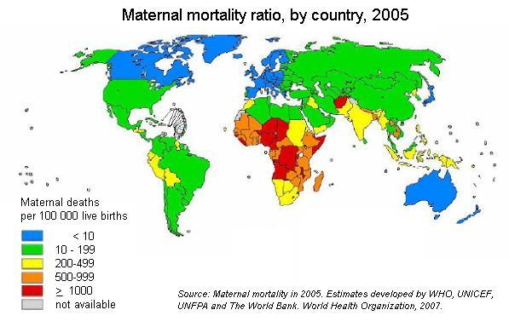

Exercise 2: Text Comprehension and Summary (60 %)

Read the text below carefully and answer the questions or mark whether statements are TRUE or FALSE. If FALSE, correct the statement. Then write a summary of the text, not exceeding 150 words.

Work resumes at stricken Japanese nuclear plant
Engineers have resumed work to restore the cooling system of reactor 3 at Japan’s stricken Fukushima Daiichi nuclear power plant, official sources say. Work had been suspended after a plume of black smoke was seen coming from the overheating reactor on Wednesday. Later on Thursday, two workers at reactor 3 were taken to hospital after being exposed to radiation.
The plant was badly damaged by the 9.0-magnitude earthquake and tsunami which struck north-eastern Japan on 11 March. Large communities have been completely obliterated, and the authorities believe the final death toll from the earthquake and tsunami may be more than 18,000. Exhausted and traumatized rescuers continue to sift through the mud and wreckage of towns devastated by the earthquake and tsunami.
Radiation from leaks in the Fukushima power plant has contaminated the local water supply and food produced nearby. Even the drinking water in Tokyo and the surrounding areas shows increased levels of radioactive iodine. Industry minister Banri Kaieda has ordered the monitoring of levels of radioactive iodine and cesium in soil, water and air around the plant to determine the extent of the contamination and how it will affect the farming and fishing industries. There were reports that shops in the capital had run out of bottled water, after Tokyo Governor Shintaro Ishihara said that levels of radioactive iodine in tap water were more than twice what is considered safe for babies.
Radiation readings on Thursday showed that levels in the Tokyo drinking water had now fallen back below the danger level. However, concern is growing among Japan’s neighboring countries. The Australian Quarantine and Inspection Service has implemented a holding order on all food products from the Fukushima, Gunma, Ibaraki and Tochigi prefectures. Singapore, Hong Kong, the Philippines and Canada have also placed firm restrictions on the imports of Japanese food products after the United States imposed an import ban on dairy products and vegetables produced on farms contaminated by Japan’s crippled nuclear power complex.
Dark smoke has been seeping from one of the reactors. Tepco, the operator of the severely damaged power plant, said the company had allowed work to resume on reactor 3 on Thursday morning, because it was safe for workers to return, Kyodo news agency reported. While the cause of the dark smoke remained unknown, there was no fire and radiation levels in the vicinity had not risen, the company added. The Japanese nuclear safety agency confirmed that the smoke had stopped early on Thursday, although steam continues to rise from reactors 1 to 4, according to Japanese television. AFP news agency reported that fire crews were again using high-pressure water jets to spray water into the storage pond on top of reactor 3 to stop the spent nuclear fuel rods inside from being exposed the air.
Later on Thursday, Japan’s nuclear safety agency said three workers stationed at reactor 3 had been exposed to high levels of radiation as they were laying power cables. Two of the workers have been taken to hospital. Spokesman for the company, Hideyuki Nishiyama, said the workers had been “exposed to radiation ranging from 170 to 180 mSv,” AFP reports. An exposure of 100 mSv per year is considered the lowest level at which an increase in cancer risk is evident.
All six reactors had their external power supplies restored on Tuesday night, but each piece of equipment has to be tested before it can be turned back on. Once the cooling systems have been restated, the reactors can be stabilized. However, the process could take weeks or even months.
The plant is 250 km north-east of Tokyo. The government has declared a 20-km exclusion zone and evacuated tens of thousands of people. Those living up to 30 km away have been told to stay indoors and close windows and ventilation systems to minimize exposure.
People in Fukushima prefecture have been told not to eat 11 types of green leafy vegetables grown locally because of contamination worries. Local producers have been ordered not to send the goods to market. Residents of Tokyo were warned on Wednesday not to give tap water to babies less than a year old, because the levels of radioactive iodine – which can cause thyroid cancer – in some areas are twice the recommended safe level. Officials have stressed that children would have to drink a lot of it before it harmed them. For the time being, there is no immediate health risk to others.
735 words. [BBC News, 24 March 2011 Adapted]

Questions:
- Where is the Fukushima Daiichi nuclear power plant located?
- Engineers have restored the cooling system of reactor 3 at Japan’s stricken Fukushima Daiichi nuclear power plant.
- How long will it take before the plant’s reactors have been stabilized?
- How many workers were taken to hospital by the time this article was written?
- How wide is the evacuation zone?
- In what ways are local farmers affected by the catastrophe?
- It is now safe to resume work at the Fukushima plant.
- What caused the destruction of the Fukushima Daiichi nuclear plan on March 11?
- What do you think is meant by the term “holding order?”
- What is the main goal of the power company in terms of securing the plant?
- What is the main hazard if you drink water containing high levels of radioactive iodine?
- What is the official estimated death toll in the wake of the tsunami by the time of this article?
- What is the threshold level of radiation; i.e. the level at which exposure to radiation becomes dangerous for humans?
- Which company operates the Fukushima Daiichi plant?
- Which countries have issued holding orders?
- Why is there concern about the drinking water around the destroyed power plant?

Précis [Summary]

Write a summary of the text in Exercise 2. Go paragraph by paragraph; identify the main ideas. Use your dictionary to understand difficult terms and to find synonyms. Paraphrase each paragraph to the best of your ability on a draft paper [not to be handed in]; then write a précis of not more than 150 words. Remember to double-space.

Sv = an international standardized unit [SI unit] indicating the level of ionizing radiation (equal to 100 rems) – abbreviation Sv. [mSv = millisievert]

