WRITTEN EXAMINATION
AUTUMN 2014
4 pages

ENG0111 – English for International Students
4 hours Monday, 1 December 2014

You are allowed to use an English–English dictionary. DOUBLE-SPACE (skip one line when you move down the page).
All questions must be answered in English. All answers must be written on copy-sheets.
Answer sections 1–3. A pass mark is required on each section.

Exercise 1: Visual information (30 percent of mark)
Based on the information conveyed by the graph, write a small accompanying text (not exceeding 60 words) about immigration into the U.S. Remember to DOUBLE SPACE.
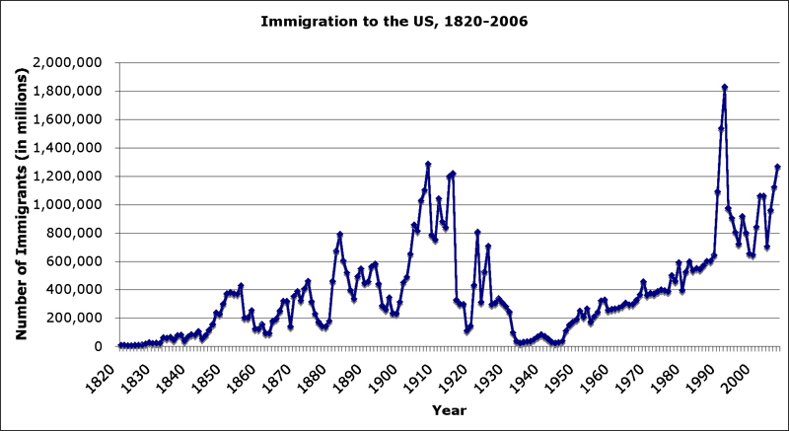

Exercise 2: Summary (40 percent of mark)
Read the text well. Look up the words that you do not understand. Write a summary of the text below, of approximately 150 words. Remember to DOUBLE SPACE.

Obama Moves Ahead to Reshape Immigration System
New York Times, 20 November 2014 | WASHINGTON
President Obama chose confrontation over conciliation on Thursday as he asserted the powers of the Oval Office to reshape the nation’s immigration system and all but dared members of next year’s Republican-controlled Congress to reverse his actions on behalf of millions of immigrants.
In a 15-minute address from the East Room of the White House that sought to appeal to a nation’s compassion, Mr. Obama told Americans that deporting millions is “not who we are” and cited Scripture, saying, “We shall not oppress a stranger for we know the heart of a stranger – we were strangers once, too.”
The prime-time speech reflected Mr. Obama’s years of frustration with congressional gridlock and his desire to frame the last years of his presidency with far-reaching executive actions. His directive will shield up to five million people from deportation and allow many to work legally, although it offers no path to citizenship.
“The actions I’m taking are not only lawful, they’re the kinds of actions taken by every single Republican president and every Democratic president for the past half-century,” Mr. Obama said. “To those members of Congress who question my authority to make our immigration system work better, or question the wisdom of me acting where Congress has failed, I have one answer: Pass a bill.”
Conservative lawmakers accused the president of abusing his office – Representative Kevin McCarthy of California, the House majority leader, called it a “brazen power grab” – and promised a fight when the Republicans take full control of Congress next year. But even before Mr. Obama’s speech, Republicans were divided about how to stop him and unsure how to express their anger without damaging their standing with Latinos.
Mr. Obama’s actions will sharpen the focus of government enforcement on criminals and foreigners who pose security threats. High-tech workers will have an easier time coming to the United States, and security on the border will be increased. The centerpiece of the president’s announcement is a new program for unauthorized immigrants who are the parents of United States citizens. About four million people will be eligible for a new legal status that would defer their deportations and allow them to work legally. They must pass background checks and pay taxes, but they will receive Social Security cards, officials said.
To those people, Mr. Obama said, “You can come out of the shadows.”
How Republicans choose to proceed in their opposition to the president’s directive will shape the final two years of Mr. Obama’s tenure and could help set the tone of the 2016 presidential campaign, but it remains unclear how they might undo them. The agency that will carry out most of the president’s executive actions, Citizenship and Immigration Services, is funded with application fees, and does not rely on a budget vote in Congress to keep operating.
But accusations of a presidential abuse of power appear to have gained traction in recent days, as a Wall Street Journal/NBC News poll found just 38 percent support for Mr. Obama’s executive actions even as there was broad support for a path to citizenship for unauthorized immigrants. In the poll, 48 percent said they opposed Mr. Obama’s actions. Even a few Democrats have expressed concern about the propriety of the president’s actions.
But immigration advocates and the president’s Democratic allies hailed the announcement even as they insisted that more should be done to provide legal protections for millions of unauthorized immigrants unaffected by Mr. Obama’s directives. Deepak Bhargava, the executive director of the Center for Community Change, called the changes “a massive breakthrough for the immigrant-rights movement.”
Fierce critics of the president’s actions described them in equally sweeping terms.
“This is a constitutional republic, not a banana republic,” said Jenny Beth Martin, the president of the Tea Party Patriots. “It’s time we all started acting like it.”
633 words (edited)
http://www.nytimes.com/2014/11/21/us/obama-immigration-speech.html

Exercise 3: Text comprehension (30 percent of mark)
Read the previous text again, and answer the questions or mark whether the statements are TRUE or FALSE. If FALSE, correct the statements. Write in full sentences, not in fragments. Remember to DOUBLE SPACE.

- What does Mr. Obama give as his reason for his proposal to reshape U.S. immigration policy?
- What is meant by confrontation over conciliation in line 1?
- What is meant by congressional gridlock in line 8?
- The American Congress will vote on the president’s new immigration reform.
- All illegal immigrants will soon become citizens of the U.S.
- What is meant by brazen power grab in line 18?
- The American public supports Mr. Obama’s plan for immigration reform.
- There is no precedent for an immigration reform such as the one Mr. Obama proposes now.
- Is it likely that Mr. Obama’s immigration reform will be reversed in the near future?
- In line 29, Mr. Obama says, “You can come out of the shadows.” What is meant by this?

The marks will be published in StudentWeb within 3 weeks. You will receive an e-mail when the result is ready.
For an explanation of the mark obtained, please contact the teacher responsible for the course within one week after the exam results have been published. Remember to include your name and candidate number. The examiner will decide whether to give a written or oral explanation.

