UNIVERSITETET
I OSLO
Institutt for litteratur, områdestudier og europeiske språk

WRITTEN EXAMINATION
2013/SPRING

4 pages

ENG 2152 Varieties of English Texts
4 hours Friday 31 May 2013
Candidates are allowed the use of one English–English dictionary.
The answers must be written in English.
All answers must be written on copy-sheets.

Answer Part I, ONE question from Part II and ONE question from Part III. Pass marks are required on all parts.

Part I
(30 %)
- Give brief accounts of any THREE of the following topics. Examples from English should be provided wherever relevant.
a. lexical density
b. register
c. the poetic macro-function of language
d. opposition connectives
e. knowledge schemata
f. felicity conditions

Part II
(35 %)
EITHER

- Give an account of the expression of values and attitudes in English. The attached excerpt of an article in The Economist (‘The Third Reich revisited: A new television drama about wartime Germany stirs up controversy’) should be used for exemplification. Add your own examples where relevant. (Text provided, no. 1)

OR
- Give an account of grammatical and lexical cohesion in English. The attached excerpt of an article in The Economist (‘The Third Reich revisited: A new television drama about wartime Germany stirs up controversy’) should be used for exemplification. Add your own examples where relevant. (Text provided, no. 1)

Part III
(35 %)
EITHER

- Give an account of the various ways in which speech and thought may be rendered in fiction. The attached excerpt from Graham Greene’s novel Monsignor Quixote should be used for exemplification. Add your own examples where appropriate. (Text provided, no. 2)

OR

- Discuss Fairclough’s account of ways in which language may be used to exercise power and to conceal unwelcome facts. The attached notice from the Lancaster Guardian, quoted from Fairclough, should be used for exemplification. Add you own examples where appropriate. (Text provided, no. 3)

Text provided, no. 1

The Third Reich revisited: A new television drama about wartime Germany stirs up controversy
GERMAN television viewers are used to frequent programmes exploring the Nazi era and the second world war. But rarely has such a programme triggered as much debate and interest as the screening in mid-March of a three-part drama, “Unsere Mütter, unsere Väter” (Our Mothers, Our Fathers), which tracks the lives of five young German friends from 1941 to 1945.
The fictional drama, based on scrupulous research, had on average 7.6m viewers per night. Suddenly the few survivors of Germany’s wartime generation are being sought out as never before by talk shows and newspapers. Grandfathers and grandmothers who for years kept silent, or were never asked, are facing questions about how it could happen, what it was like and whether they saw atrocities. Some more painful questions about who committed what atrocities are resurfacing, too.
Nearly 70 years after the end of the Third Reich, Germans feel compelled to keep their country’s Nazi history alive. “It’s not about guilt any more, but it is about collective responsibility,” says Arnd Bauerkämper, professor of history and cultural studies at the Free University in Berlin. The suspicion, however irrational, says Der Spiegel, a weekly, is that the German people are a special case, a historical outlier, who are unsure of themselves and must time and again seek reassurance. “It’s never over,” read a headline for an interview with Nico Hofmann, producer of the series.
All five characters in Mr Hofmann’s film reach that conclusion early on. They are swept along like corks in an ocean. The atrocities that two of them commit as soldiers—one executes a Soviet commissar, the other a Jewish girl—seem to come from their circumstances: obey or die. The real war criminals are the others who exult in killing or intellectualise it. That has prompted some critics to suggest that putting five sympathetic young protagonists into a harrowing story just offers the war generation a fresh bunch of excuses. It’s never over.

(Adapted from The Economist)
Text provided, no. 2
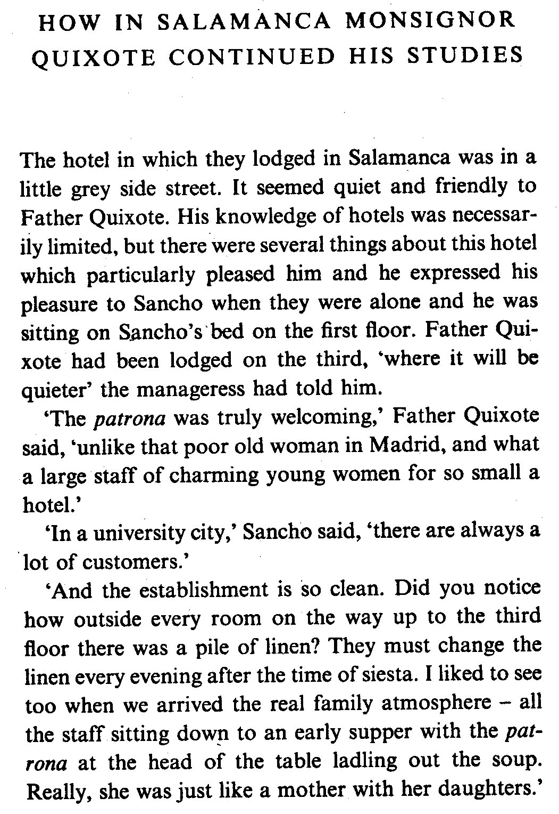

1

5

10

15

20

Text provided, no. 3

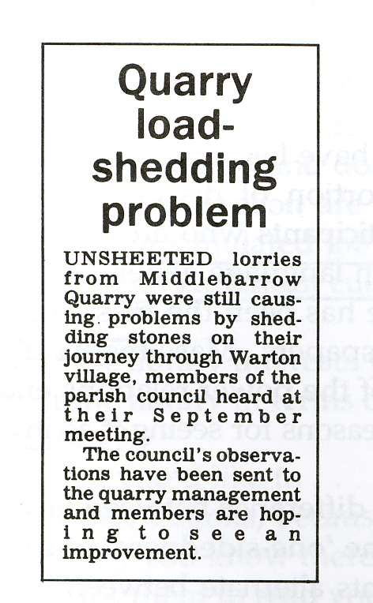
From the Lancaster Guardian 12 September 1986 (quoted from Fairclough)

The grades will be published within 3 weeks in StudentWeb.

For an explanation of the mark obtained, please contact the exam coordinator, Kristin Berstad (k.m.berstad@ilos.uio.no) within one week after the exam results have been published. Remember to include your candidate number. The examiner will decide whether to give a written or oral explanation.

