UNIVERSITETET
I OSLO
Institutt for litteratur, områdestudier og europeiske språk

SKOLEEKSAMEN/SKULEEKSAMEN
2010 HØST/HAUST
4 sider
Bokmål/Nynorsk

ENG2163 Global English
Eksamen varer i 4 timer/timar. Torsdag, 09.12.2010

Tillatt/Tillate hjelpemiddel: En/Ei engelsk-engelsk ordbok.
Oppgavene skal besvares på engelsk. / Svara skal skrivast på engelsk.

Answer ONE question from Part I and ONE question from Part II. Pass marks are required on both parts.

Part I
(60 %)
EITHER

- State briefly what an elicitation test is. Then explain the way results from Johansson’s elicitation test are presented in his article from 1979 (see excerpts below). You should further discuss what Johansson’s results on DARE and NEED (reproduced below) tell us about the use of those marginal auxiliaries in American and British English.
(Text provided, no. 1)
OR

- Explain what is meant by the term ‘marginal modals (marginal auxiliaries)’. Then give an outline of the use of DARE and NEED and the ways in which this use may vary syntactically, both across the national varieties of English and within each variety. You should also comment on the attached corpus material and discuss whether that can be used to shed any light on the variation in the use of DARE between the national varieties. You may further want to refer to other searches that could be made, and other corpora that could be used, to investigate this variation. The attached corpus material consists of all occurrences of modal dare in the following corpora: the Frown Corpus of American English from 1992, the FLOB Corpus of British English from 1991, the Australian Corpus of English (ACE) from 1986 (even that in its full version) and the Wellington Corpus of Written New Zealand English (WWC) from 1986-1990.
(Text provided, no. 2)

Part II
(40 %)
EITHER

- Give an account of the use of the two main verb forms referring to past time in English, the present perfect and the preterite. Then discuss how the distribution between the two verb forms seems to vary among the chief national varieties of English.

OR

- Outline the historical background of the English language in Australia. Then give an account of some of the grammatical characteristics of Australian English, focusing on AT LEAST TWO grammatical features which are taken up in texts on the reading list for this course dealing with Australian English.

Text provided, no. 1: Results presented in Stig Johansson (1979), ‘American and British English grammar: an elicitation experiment’
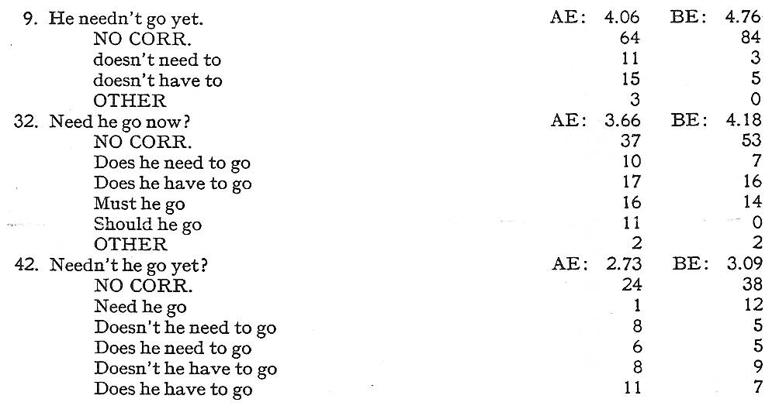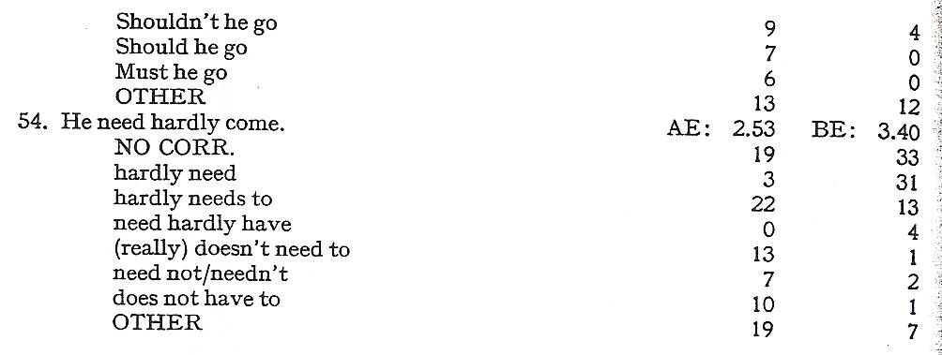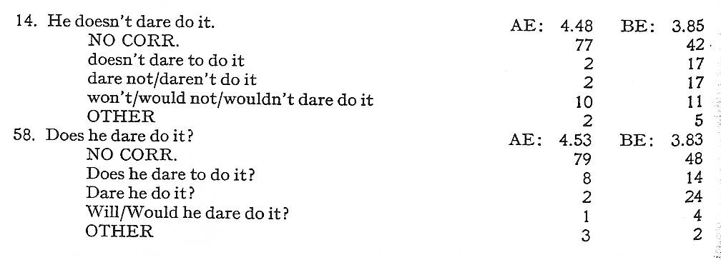

Text provided, no. 2: Occurrences of marginal modal auxiliary dare in Frown, FLOB, ACE and WWC

N | Concordance | File
1 | How dare you come to Chinatown and walk through … ? | frown_a
2 | Noone in possession of his faculties and desirous of retaining them would dare drive down the lane into territory … . | frown_a
3 | Few stage directors would dare mount such a scene. | frown_c
4 | Only one whose hope is not in this world would even dare to contravene the present sacred order. | frown_d
5 | … when, in the exercise of our passion, we dare to anticipate a decisive agent. | frown_d
6 | How, in all seriousness, would you dare do that? | frown_d
7 | She can do what I would never dare ... Her eye discerns … . | frown_e
8 | He did not think that even the Soviet rulers would dare to accept the consequences. | frown_f
9 | ... if I did not dare have sex with my own girl-friend, I could scarcely imagine it with anyone else | frown_g
10 | questions we didn’t dare ask because we knew no one had the answers. | frown_g
11 | How dare you refuse to acknowledge the divinity of the one Lord above? | frown_k
12 | “You want a drink?” ”I don’t dare.” I couldn’t stop. | frown_l
13 | ”How dare you,” she whispered. | frown_l
14 | ”You wouldn’t dare.” “Sure and why wouldn’t he?” | frown_n
15 | … a pleasure one should not dare prolong, no matter what happiness one felt. | frown_n
16 | Kord didn’t dare glance over his shoulder. | frown_n
17 | … just to get the hell out of the rehearsal hall and not dare to come back until Thursday | frown_p
18 | How dare he ask such personal questions? | frown_p
19 | He did not, however, dare to attack most of the graft and licences. | flob_b
20 | … a bold move, which Labour ignores but dare not repudiate. | flob_b
21 | One principle is paramount. We dare not allow any European border to be changed by military force. | flob_b
22 | ‘Eyes I dare not meet in dreams’. | flob_c
23 | I did not dare to breathe the words ‘Civil Aviation’. | flob_g
24 | Adams could not get through on the telephone. He would not dare approach the house. | flob_l
25 | ”So I dare say she’s told you a bit about the video we’ve been doing. | flob_l
26 | Actually we hardly dare look at her now, the tiny typist, such power does she wield. | flob_n
27 | ”This is insufferable! How dare they treat one of us .. in this way. Intolerable! | flob_n
28 | ”Don’t you dare bring your father into this!” | flob_n
29 | ”Gracious heaven, don’t dare say a word!” | flob_p
30 | ”You will find it out soon enough, I dare say.” | flob_p
31 | “It had not crossed my mind, but I dare say you are right.” | flob_p
32 | “How dare you?” She wrenched herself away from him. | flob_p
33 | ”I dare say she is teaching herself as well as you.” | flob_p
34 | He found himself saying, ”How dare you wear fur?” | flob_r
35 | Should he dress up, or down? He didn’t quite dare ring Venice to ask her. | flob_r
36 | But goals were not the only reason Docherty would not dare to drop Soper. | ace_a
37 | Because ritzy Australian restaurants are terribly precious about their exclusivity, few parents would dare to take their young in case of sneers from maitre. | ace_a
38 | We didn’t even dare talk about doubt, wounds, aches and feelings. | ace_a
39 | … we would have been foolhardy to dare to lie down to sunbake and let the children loose at the water’s edge. | ace_b
40 | How dare you insult animals in this way? | ace_b
41 | ‘How dare you’, he said, ‘invoke the divine name to justify what you want to do!’ | ace_d
42 | Why not dare to be different ? | ace_e
43 | If I had been at home I might have saved his life but it is of no use repining - I dare say Maher did his best … | ace_g
44 | After we have pierced the Pig’s body with ten thousand arrows will the monster again dare to grunt? | ace_p
45 | Perhaps I am in a way, because I dare not reveal my secret self. | ace_p
46 | ‘For you, Mrs Poultney, in those sparkling togs, it wouldn’t dare do otherwise.’ | ace_p
47 | … and he dare not purge its quicksilver harshly, for fear of converting it to copper. | ace_s
48 | “How dare they!” screamed Julie and gradually the word was passed down the line. | ace_w
49 | But Hifa-oro-roa was angry that a man of no standing should dare to usurp chiefly privilege in this way. | wwc_f
50 | ... and we children did not dare take liberties of any kind. | wwc_g
51 | Would they dare to come over? | wwc_g
52 | They were, dare I say it, a team of geriatrics | wwc_g
53 | I dare say nearly all of us have at some time or other ... | wwc_g
54 | ... dare she take off her cover and shakily stand and face him? | wwc_k
55 | ‘...why I... how dare you...’ | wwc_k
56 | ... though I dare not say this to her. | wwc_k
57 | She didn’t dare look at Ronnie and Beth. | wwc_k
58 | Tommy didn’t dare to step any closer. | wwc_l

