One-day course for Ph.D students, the Faculty of medicine, University of Oslo

Science writing & article publishing

Location: GA02 A1.1001 Auditorium Domus Odontologica, Rikshospitalet, Sognvannsveien 20

09.15-12.00

Karl Henrik Flyum, university lecturer:
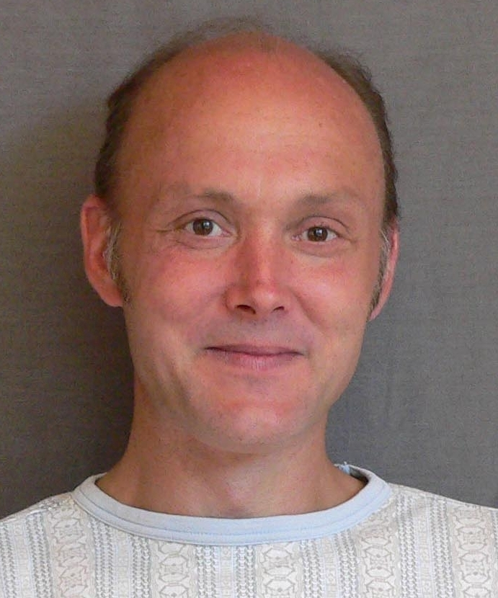
Writing with the Five Paragraph Method

This first part of the course is a writing workshop. No particular preparation is required to attend.
The Five Paragraph Method was developed for use in brief writing courses for master students in all disciplines at the University of Oslo. The method implies both an adaptation to the challenges of scholarly and scientific writing, and a methodical generalization and simplification.
The main aim of this workshop will be to offer the participants tools to exercise, to get started and to get on with their academic writing. It’s a kind of writer’s gym: to get fit for writing. With some exercise in this method you will always be able to write a couple of pages in half an hour.
The method will not only be useful for your own writing, but also for helping other writers, and for managing collaborative writing.

12.00-12.45 Lunch break

12.45- 15.30

Magne Nylenna, professor:
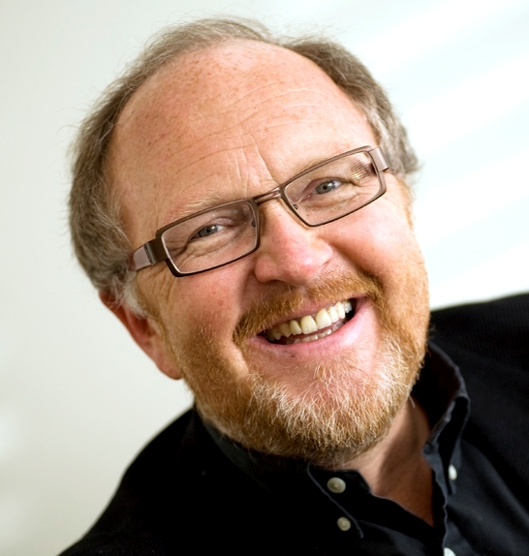
To publish & to present

Scientific articles in medicine and the health sciences constitute a particular academic genre. In this part of the course the principles of such publication will be presented and discussed. The main elements of an article will be presented in some detail, and the communication between the author and the editors and reviewers will be discussed.

Some main topics:
- Medical journals and publication
- Publication ethics
- IMRAD and the structure of medical papers
- From manuscript to published paper

15.30 End

In addition to the lunch break there will be a 10-15 minute break per hour. There will be registration of participants in both sessions. This course is offered in English at least once every year.

Oslo, September 14, 2011.
Faculty of medicine, University of Oslo

