# Heating and ventilation panel:

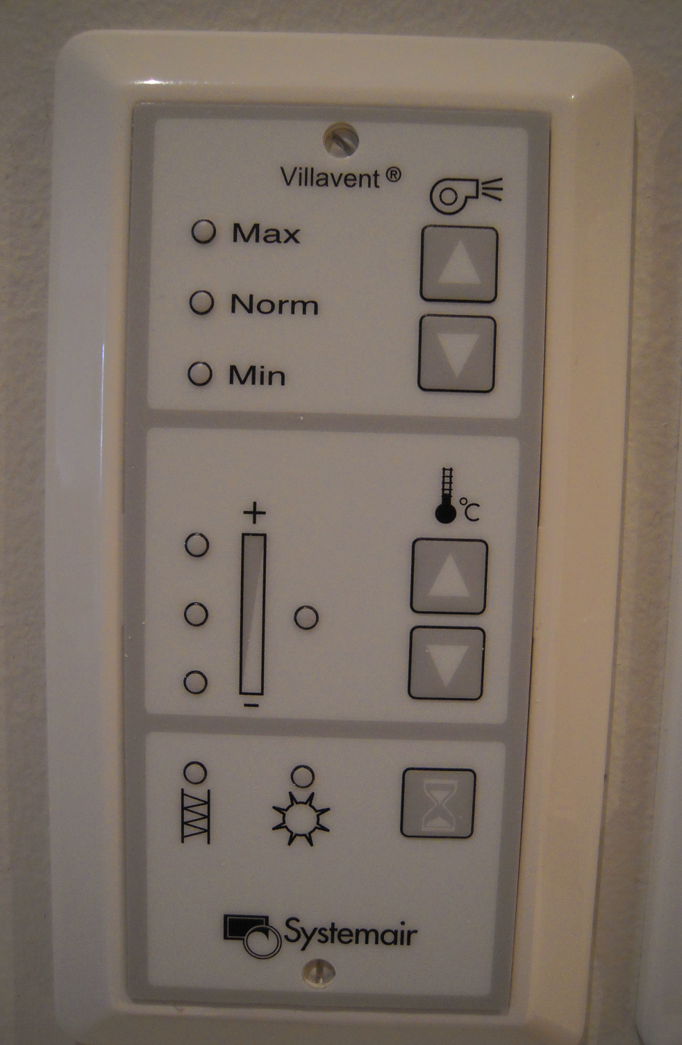

Automatic function. Nothing you need to think about.

It is just information whether or not the ventilationsystem is recovering heat or not.

If the light is on, the filter needs to be changed. Please contact the researcher housing office

Maintenance use only

Adjusting the airflow temperature (3 levels)

Adjusting power/speed on the ventilation system (3 levels)