UNIVERSITETET
I OSLO
Institutt for litteratur, områdestudier og europeiske språk

WRITTEN EXAMINATION
AUTUMN 2012
5 pages

ENG4163 – Global English
4 hours Friday 14 December 2012
You are allowed to use ONE English–English dictionary in this exam.
All questions must be answered in English.
Your answers must be written on copy-sheets.

Answer ONE question from Part I and ONE question from Part II. Pass marks are required on both parts.

Part I
(60 %)
EITHER

- Give an account of some of the claims which have been made about a difference in the distribution between the present perfect and preterite (past) verb forms among the four national varieties of English focused upon in this course. In your answer you should comment on the attached table and figure from Elsness (2009), ‘The perfect and the preterite in Australian and New Zealand English’. These show the results of a test of four constructions in the Feedback column of the publication Australian Style.
(Text provided, no. 1)
OR

- Give an account of the various mandative constructions which occur in English, taking care to mention how the distribution of these constructions seems to vary among the national varieties of English focused upon in this course. In your answer you should comment on the attached list of the 20 hits which result from a search on the string ‘recommend* that he’ in the British National Corpus. You should also suggest other corpus searches (search strings and corpora) which could be carried out to test this distribution. (Text provided, no. 2)

Part II
(40 %)
EITHER

- State what collective nouns are. Then discuss what light the attached results from Johansson (1979), ‘American and British English grammar: An elicitation experiment’, may shed on the use of collective nouns in American vs. British English. In your answer you should take care to explain the way in which the results from the elicitation test are presented in the article (see the attachment). You should also suggest corpus searches (search strings and corpora) which could be carried out to test the use of collective nouns further (even in other national varieties). (Text provided, no. 3)

OR

- Give an account of the use of English loan words in Norwegian on the basis of the article by Johansson and Graedler. In your answer you should mention some of the problems involved in the decision about what to recognise as English loan words. You should also explain the difference between the frequency of loan words in dictionaries and in running texts; consider the text genres where English loan words are particularly frequent and the time when the adoption of English loan words has been most common; and comment on Norwegian attitudes towards the use of English loan words.

Text provided, no. 1
Table 4 and Figure 6 from Johan Elsness (2009), ‘The perfect and the preterite in Australian and New Zealand English’

Table 4 Sentences tested in the Feedback column of Australian Style, with recorded
results: Raw figures and vertical percentages within each sentence pair.
Sentences |  | Results
Ia | That problem has been solved long ago. | 67 (12.1 %)
Ib | That problem was solved long ago. | 486 (87.9 %)
IIa | I know Joanna is around somewhere - Alex has just spoken to her. | 327 (56.1 %)
IIb | I know Joanna is around somewhere - Alex just spoke to her. | 256 (43.9 %)
IIIa | You speak remarkably good French. Have you ever lived in France? | 461 (81.3 %)
IIIb | You speak remarkably good French. Did you ever live in France? | 106 (18.7 %)
IVa | Have you told them the news yet? | 497 (89.1 %)
IVb | Did you tell them the news yet? | 61 (10.9 %)

Figure 6 Percentage of present perfect constructions in Feedback column according to age of respondent [constructions I – IV as set out in Table 4]

Text provided, no. 2
The 20 results from the British National Corpus of a search on the string ‘recommend* that he’

1 | A2M 81 | LOS ANGELES (UPI) — The jury which convicted a confessed devil-worshipper, Richard Ramirez, of 13 ‘Night Stalker’ murders has recommended that he be executed.
2 | AA4 144 | CZECHOSLOVAKIA's playwright-turned-politician, Mr Vaclav Havel, moved a step nearer to the presidency yesterday when the country's Communist Prime Minister, Mr Marian Calfa, recommended that he should be installed by the end of the year.
3 | BME 33 | In spite of his good work, the Wells Committee recommended that he should, along with housing and urban management, town and country planning and valuation — previously amalgamated by Council into a single General Practice Committee — follow an examination curriculum dedicated to General Practice with a ‘typical subject’ only at final level.
4 | CBF 7548 | The judge gave Vernage five life sentences and recommended that he serve at least 25 years.
5 | CEJ 2954 | He was guilty of blasphemy and could now be taken to the Roman Governor with the recommendation that he suffer the death penalty.
6 | CER 1116 | Paul Gross, a chemistry professor at Wake-Forest, recognised Pons' ability and recommended that he go to graduate school.
7 | CMG 763 | The medical officer of health of the county council was expected to exercise general supervision over the work of the public health and medical staff in the various services including the hospitals , but it was recommended that he should interfere as little as possible in the clinical work, i.e. between doctor and patient.
8 | CN2 58 | I telephoned him at home immediately and told him about the fatigue failure, adding my recommendation that he should order the examination of all UK registered Boeing 707/300 stabilisers for signs of similar failure at the earliest opportunity.
9 | FPN 262 | But my present belief is that if Profumo had come to me for advice (and my advice, of course, would only have made sense if one postulates that Profumo would have told me the truth), I would have recommended that he should throw in the towel; assert that he had no intention of allowing his private life to be discussed in public; apologise to the Prime Minister for the embarrassment he had caused both to him and to the party, and withdraw rapidly.
10 | FPN 270 | When George Wigg asked my view about this, I recommended that he should urge Harold Wilson to oppose any such investigation and I drafted a letter which Wigg suggested Wilson should write to the Prime Minister.
11 | FT5 968 | He had remained well until June 1992, when he developed generalised lymphadenopathy and his doctors recommended that he should start zidovudine.
12 | FYW 1028 | Psychiatric reports were eventually obtained and recommended that he should be detained in hospital for treatment, not in prison.
13 | G3D 1652 | This collective picture is then reflected back to the sufferer with the recommendation that he or she finds out whether his or her contemporaries in treatment observe the same picture.
14 | GUR 1049 | They went along with the feeling that Tony should have a non-residential supervision order but strongly recommended that he should change his school.
15 | GW9 1757 | On 12 June, this impression was reinforced by a call from the Special Agent in Charge of the DEA's Birmingham field office, who strongly recommended that he plead guilty to the passport violation charge and at all costs ‘don't get the DEA involved in your case’.
16 | H7S 337 | Hizir Bey was greatly impressed by him and sent him to Murad II, recommending that he be given a teaching post.
17 | HHV 22730 | I know that the hon. Gentleman is assiduous about detail, and I recommend that he reads article 2 of the directive.
18 | JXW 1269 | Recommend that he's taken ashore at the next port of call and arrange for him to be flown home to an orthopaedic unit.
19 | K5D 12025 | THE FORMER Western Isles depute finance director has started a court action to challenge a recommendation that he should personally pay over cash lost following the collapse of the Bank of Credit and Commerce International.
20 | K5D 12042 | Mr Lawrie said the recommendation that he should pay a sum to the council to be fixed by the Scottish Secretary is unreasonable.

Text provided, no. 3
From Stig Johansson (1979), ‘American and British English grammar: An elicitation experiment’

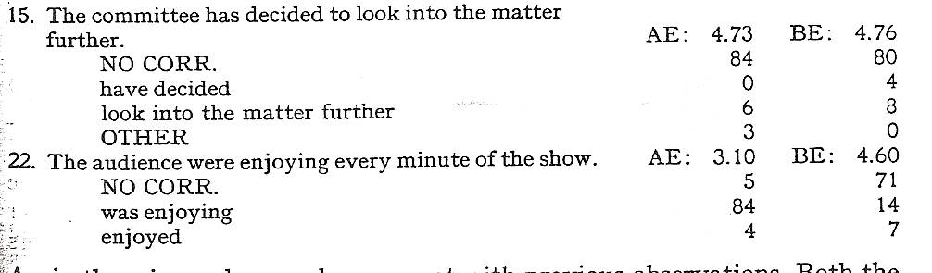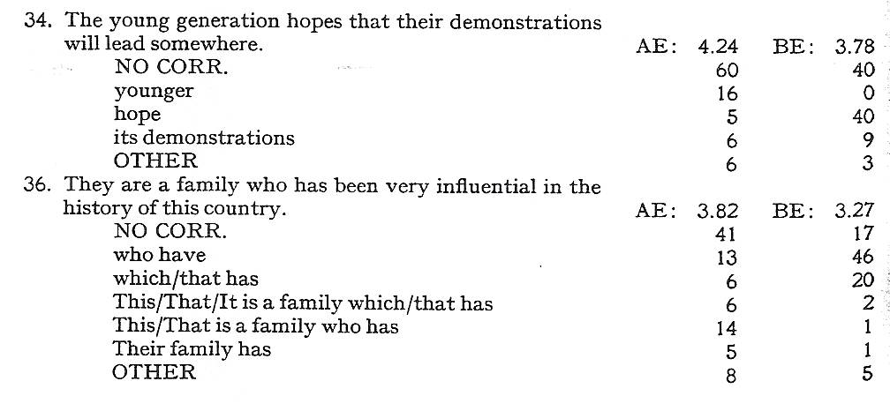

Explanation: For an explanation of the mark obtained, please contact the teacher responsible for the course within one week after the exam results have been published in StudentWeb. Remember to include your name and candidate number. The examiner will then decide whether to give a written or an oral explanation.

