**UNIVERSITY OF OSLO**

**Faculty of Mathematics and Natural Sciences**

**Exercise 1**

1. An action potential in the myocard (heart cell) is the beginning of a contraction of the heart muscle. What is an action potential, what triggers the action potential and what stops it?

Answer: The student should be able to describe an action potential of a cell, the trigger in a heart cell is an electrical pulse that is depolarizing the membrane, the end is the closure of first Na+ channels, and then K+ channels.

1. The electrical activity of the heart can be measured by means of electrodes and an ECG-monitor. Which electronic components would you use in the ECG-device, and why?

Answer: Operational amplifiers with the regular characteristics (high CMMRR, high input impedance, low noise, ++), resistors for setting up the op-amps, limit current, voltage division, and in combination with capacitors for making a bandwith filter for the wanted frequency. All of the components should be mentioned with a short explanation of the use of each of them.

*Figure 1. The Apple Watch with an ECG-function (source: https://www.iphonefirmware.com/wp-content/uploads/2018/12/watchOS-5.1.2-for-Apple-Watch-now-available-with-ECG-app-new-Infograph-complications-more-iphonefirmware-com.jpg)*

1. In figure 1, you can see an example of a smart watch that is equipped with

electrodes for ECG measurements. Is it possible to take a decent ECG-measurement with electrodes located on the watch only? If it is possible, explain how. Which lead will this represent in the standard Einthoven-triangle?

**Answer:** Yes, it is possible to take a decent ECG-measurement, but a prerequisition is that you have two electrodes, one on each hand. For all practical purposes, the arm without the clock needs to touch the electrode on the clock so that you can have a two-electrode measurement. This represents lead I in Einthovens triangle, that is not the best lead for monitoring ECG because the electrical activity moves from the right to the left AND downwards, and it is mainly the right-left activity that will be picked up by the electrodes in lead one.

The student should be able to understand that you´ll need one electrode on each side of the heart (= on each arm) for a proper ECG-measurement. They should also know that this represent lead I in the triangle. The suitability of lead one for ECG-monitoring is not expected as it is not a question, but could be a part of the discussion of the term “decent ECG”

1. If you would like to redesign the smart watch in order to make a so-called “unipolar” measurement, what would you need to do?

**Answer:** There is no real unipolar measurement because there is no reference electrode infinitely far away, but the best approach is to use a Wilson-terminal solution as the reference. In consequence, more electrodes are needed.

The student should know and be able to describe the difference between unipolar and bipolar measurement and what it means for the electrode setup.

**Exercise 2**

1. Choose a suitable method for measuring the minute-volume (= cardiac output) of the heart, and describe briefly the principles of the method

**Answer:** Any suitable method can be chosen, Ficks method, dye dilution, thermodilution, ultrasound.

The student should be able to make a short description of the basic principles for the chosen method.

1. Figure 2 shows a pulmonary artery catheter that can be used for indicator cardiac output measurements. Explain briefly:
   * 1. How we can make sure that the catheter is correctly positioned without image guiding?

**Answer:** There are two methods, image guiding (typically with X-ray), and with pressure measurements during insertion. The last one is preferred because of the simplicity

Any of the two methods are valid, full score is given for one of them

* + 1. How is it possible to measure the cardiac output (= the blood volume from the left ventricle) when the catheter is located in the pulmonary artery?

**Answer:** Typically, thermodilution is selected (could be dye dilution as well). Insert a bolus of cold saline, measure the change in concentration and integrate to find flow according to the equation.

A brief explanation is good enough answer

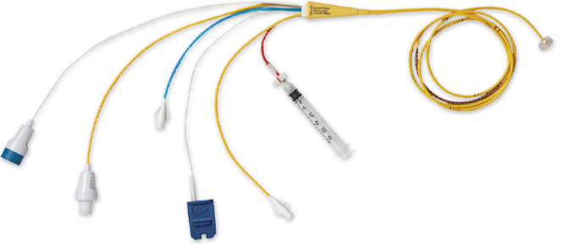

*Figure 2. A pulmonary artery catheter (Source: Edwards Lifesciences)*

1. There are two dominating methods for indicator measurements of cardiac output: Thermodilution and dye-dilution. Explain why you need to puncture the artery with the dye-dilution method, in opposition to the thermodilution method.

**Answer:** Thermodilution is simple to implement in a small catheter, all you need is a simple thermoresistor (wire). To measure dye concentration, you’ll need a spectrometer which is large equipment impossible to fit in a small catheter.

The student should be able to describe the constraints of a catheter and why the instrumentation is more voluminous for dye dilution

1. The catheter is equipped with a thermistor at the cathetertip. Explain why a thermistor in the bloodstream might be problematic, and how you can design a circuit that will provide constant current to the thermistor when measuring the output of the thermistor.

**Answer:** There is basically two different ways of using a thermistor in the bloodstream, choosing constant current or constant temperature. Two problems of constant current sensor circuit with a thermistor in the blood stream:

1. Time constant of the sensor embedded in the probe is a few tenths of a second, too long for the desired frequency response of 0 to 25 Hz
2. To achieve reasonable sensitivity at high velocities a high current is needed. A high current will lack sufficient cooling when the blood flow stops so that the temperature will rise, and fibrin will coat the sensor.

Constant temperature sensor overcomes problems:

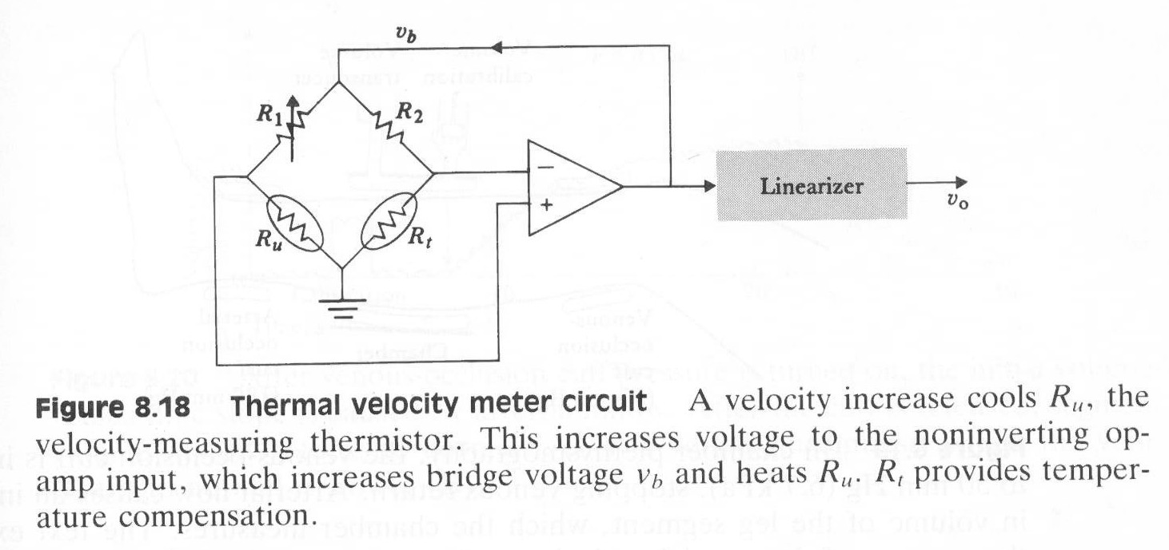

Ru is heated. Velocity increases -> Ru cools and resistance increases -> more positive voltage on the pos terminal -> increased vb -> increased bridge power -> increased Ru -> cooling is counteracted

High-gain negative feedback -> bridge is always in balance -> constant temp at Ru

High gain negative feedback divides sensor time constant by a factor equal to the loop gain = improved frequency response

Varying blood temperature -> Rt (temperature compensating thermistor)

The student should be able to describe the main problem of thermistor-heating and the solution with a balanced wheatstone-bridge with constant current

**Exercise 3**

1. Describe the most important differences between a regular X-ray tube and a CT-tube, and explain why these differences are important.

**Answer**: Two main differences:

1. Oil cooling – the CT-tube anode is constantly exposed for a long period of time, this will heat the anode. Rotating anode will not provide sufficient cooling
2. Flying focal spot – Normally you can choose between a small and a wide focal spot. A wide focal spot gives good coverage and fast image acquisition at the cost of poor resolution, a small focal spot gives higher resolution but poor coverage. The flying focal spot is an electromagnetically controlled electron beam that allows wobbling of the hitting point on the anode. As a result, good resolution is maintained but fast acquisition and less aliasing artifacts

The student should be able to both differenciate and briefly discuss the consequences

1. Explain briefly how a CT-image is created, the most relevant source of error and measures that can be taken to counteract this

**Answer**: An x-ray system with rotating tube and detector, then bakprojection or iterative methods needed for image construction. The most common error is blur due to back projection weaknesses that origin from the fact that you don’t know the exact position of the signals from each position. Filtered backprojection or iterative procedures are both simpler and better. There are other sources of error as well like beam hardening, streak artifacts, view aliasing, partial volume, and cone beam artifacts, but the student is not supposed to know much about them.

The student is supposed to know about the backprojection-problem and the use of filter

1. Name the two main image reconstruction methods, explain briefly the basic differences and main strengths and weaknesses of each

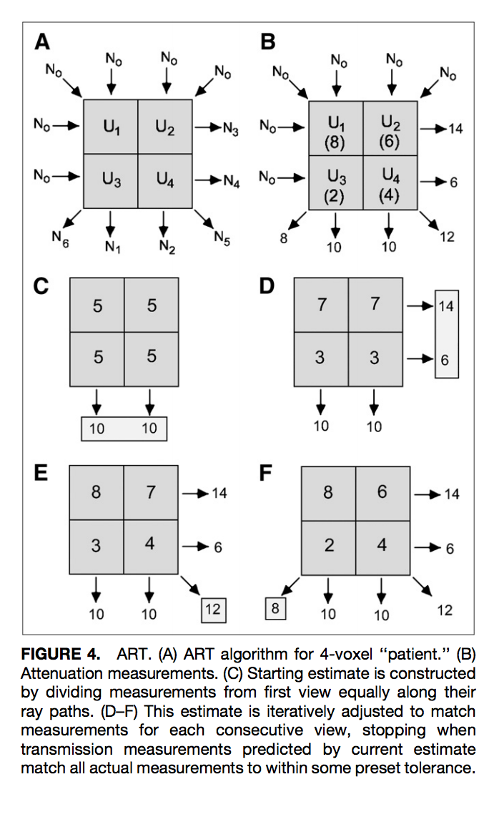

**Answer**: Filtered backprojection and iterative methods.

Strengths IM: Less dose, high quality, no streaking artefacts

Strengths FBP: Fast, computational inexpensive

Weakness IM: Random errors will make sure that no iteration will match perfectly, computational more expensive and time consuming

Weakness FBP: High dose

Filtered backprojection is well known, iterative methods

should be known and the student should be able to describe the differences and main strength and weaknesses of each method.

The student is supposed to know about the backprojection-problem and the use of filter and should be able to describe pros and cons.

**Exercise 4**

1. Give one examples of how we can use ultrasound for diagnostic procedures, and one example for therapeutic procedures.

**Answer:** Several alternatives, but for example ultrasonic flowmeter for diagnostic procedures and a harmonic scalpel for therapeutic procedures. Any alternatives that contain ultrasound for a therapeutic/diagnostic purpose is okay.

1. Describe briefly the difference between an ultrasound blood pressure monitor, and an oscillometric blood pressure monitor. Which of the two methods is most suitable for measuring pathological low blood pressures (= hypotensive blood pressure), and why?

**Answer:** This is the crux of the exercise, and the student should be able to discuss the topic based on the knowledge of the different methods. The hypotensive patient has decreased systolic and diastolic pressure, and the pathological hypotensive patient has severely decreased pressure. The origin of the oscillometric signal is the palpable pulsating arterial pulsewave, but when the pressure is lowered the flanks of the pulsewave will diminish. In some cases, the pulsation can be so weak that it is difficult to measure with the oscillometric method (which can also happen with muscle atrophy because the pulse wave will be damped in the soft tissue). In consequence, the ultrasonic method that measures the blood vessel wall movement is less susceptible to artefacts and is the method of choice for this group of patients.