**Crystallography revisited**

1. Are there grain boundaries in amorphous materials?
2. Can crystalline solids be isotropic?
3. Sketch the  direction and the  plane in an orthorhombic cell.
4. Sketch the  direction and the  plane in a monoclinic cell.
5. In tetragonal crystals which are
   1. the directions of the  form and
   2. planes of the  form
6. (a). Determine the relation between zone axis indices and Weber indices (expressly defined for hexagonal unit cells)
7. Convert the zone axis indices  and  into Weber indices. Convert the  and  Miller indices into Miller-Bravais indices.
8. What is the utility of the 4 indices?

**Diffraction Questions**

1. According to the structure factor expression what are the conditions for constructive interference for a body center cubic cell? And for a body center tetragonal cell?
2. Fully and consistently index the following diffraction pattern obtained by transmission electron microscopy. The structure is simple cubic with *a* = *b* = *c* = 0.2 nm.

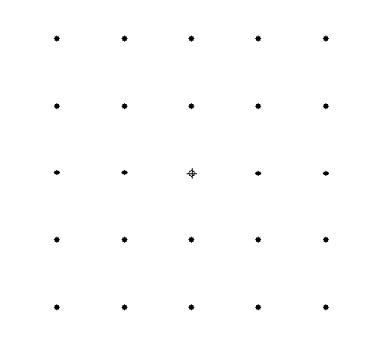

R1 = R2

R2

R1

1. Fully and consistently index the following diffraction pattern of Ni obtained by transmission electron microscopy with basis on the expected reflections for a fcc structure. The electron wavelength is 0.002507 nm and the camera constant (L) is 0.869 m.
   1. R1 = 1.24 cm, R2 = 1.07 cm
   2. R1 = R2 = 1.75 cm

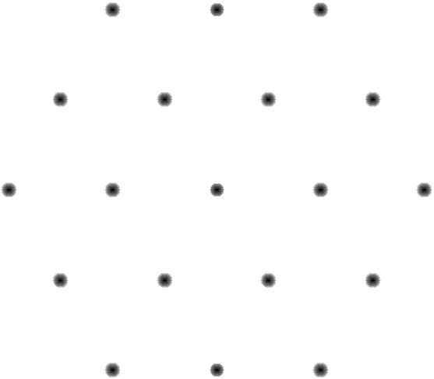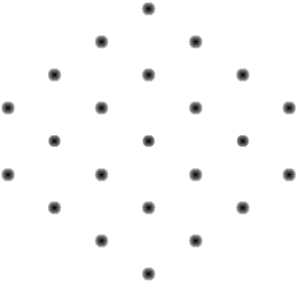

R2

R1

R2

R1

a. b.

a. b.

4. The following diffraction pattern has been obtained from nanostructured copper. Is the material oxidized?

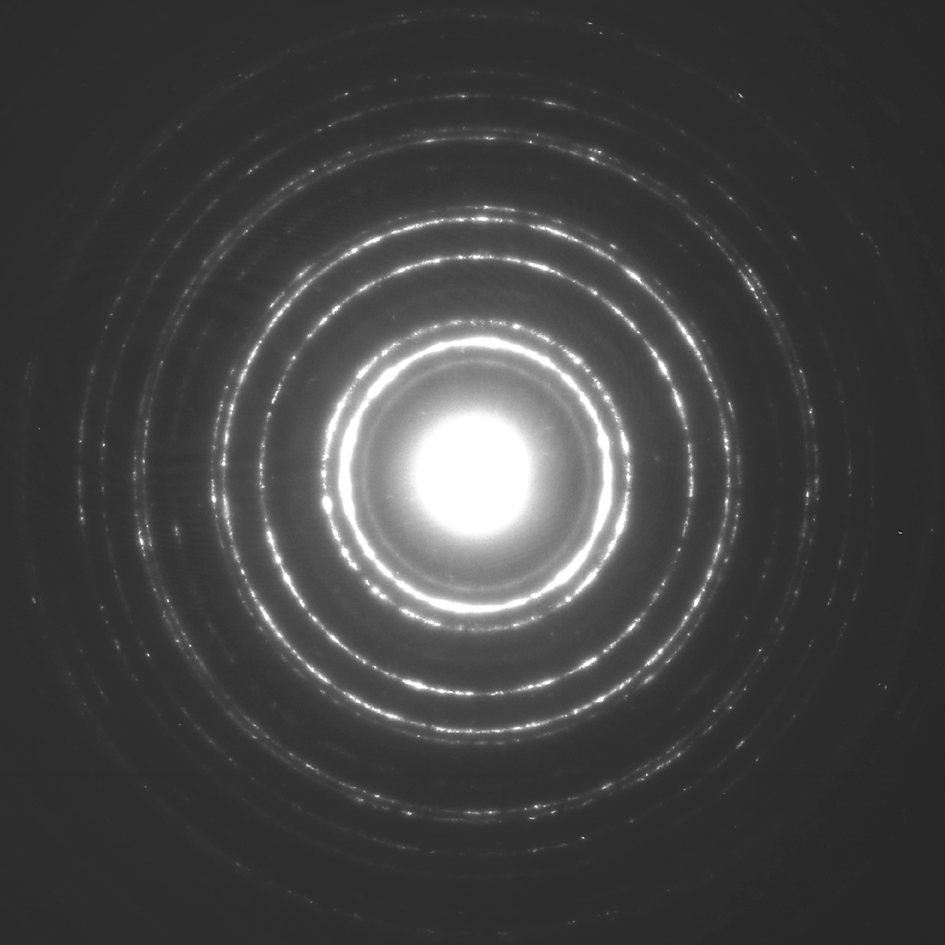

1. Simulate kinematical and dynamical diffractograms for the Co3W phase using a suitable software package.
   1. What is the structure type of this phase?
   2. Compare the simulated diffractograms of Co3W with Ni3Sn. What are the differences?
   3. What is the important difference between kinematical and dynamical diffractograms?

**Equations:**

Relation between R and L (camera length):

R=L*(1/d)

Angle between (h1k1l1) and (h2k2l2) in the cubic system:

Equation 1

Zone axis of plane of (h1k1l1) and (h2k2l2):



**Data:**

