Solution FYS3610 2015

PROBLEM 1 (10 points)
- Sketch the entire magnetosphere, both the dayside and the nightside. Label all regions and boundaries of interest! (6 points)
  - 1 pt for correct drawing, bow shock, magnetosheath, magnetopause, lobes, plasma sheet
- Describe the frozen-in concept! What is magnetic reconnection and why does the frozen-in concept break down during magnetic reconnection? (3 points)
  - 1 pt for plasma/magnetic field are tied together, opposite magnetic fields merge (current breakdown), magnetic field diffuses/anomalous resistivity/plasma changes field line
- Under what condition is magnetic reconnection most active on the dayside of the terrestrial magnetosphere? (1 point)
  - IMF Bz negative

PROBLEM 2 (10 points)
- Sketch the electron density profile in the ionosphere, both the dayside profile and the nightside profile! Label the different regions and give their altitude ranges! (4 points)
  - 1 pt for correct dayside profile, nightside profile, names, altitudes
- Describe the physical mechanism that is responsible for the formation of the ionosphere! What mechanism is responsible for the difference between the dayside and nightside profiles? (3 points)
  - 1 pt for ionization by solar EUV radiation, F region radiative recombination (slow), E region dissociative recombination (fast)
- At 500 km altitude, atomic oxygen (O) is the dominant neutral, and hence O⁺ is the dominant ion. The production rate of O⁺ is given by
$$q_{O^{+}}=J_{O}n_{O}\left(h\right)e^{-τ\left(h\right)}$$
where $J_{O}$ is the ionization frequency of O (about $2×{10}^{-7}$ s⁻¹), $n_{O}\left(h\right)$ is the density of the neutral O atom, and $τ\left(h\right)$ is the optical depth. For an oxygen density of ${10}^{14}$ m⁻³ and an optical depth of 0.06, what is the production rate of O⁺? (1 point)
1 pt for correct value
- Assuming the production rate from c), what is the typical time needed to build up an electron density of $n_{e}={10}^{11}$ m⁻³? (2 points)
  - 1 pt for writing down tau = ne/q and 1 pt for correct value

PROBLEM 3 (10 points)
- Write down the equation of motion for a charged particle in a static electric and magnetic field! Name all parameters! (2 points)
  - 1 pt equation, 1/5pt per parameter
- Assuming no electric field and a constant magnetic field in the z-direction, simplify the equation of motion and derive an expression for the gyrofrequency! (5 points)
  - 1 pt for correct formula, 1 pt for working out the cross product, 1 pt for derivative, 1pt for substitution, 1 pt for realizing simple harmonic oscillator
- In the figure below, the magnetic field is pointing out of the sheet of paper. In the bottom left area, the magnetic is twice as strong as in the top left region; it is 0 right of the dashed line. Complete the trajectory of a charged particle as indicated! (3 points)
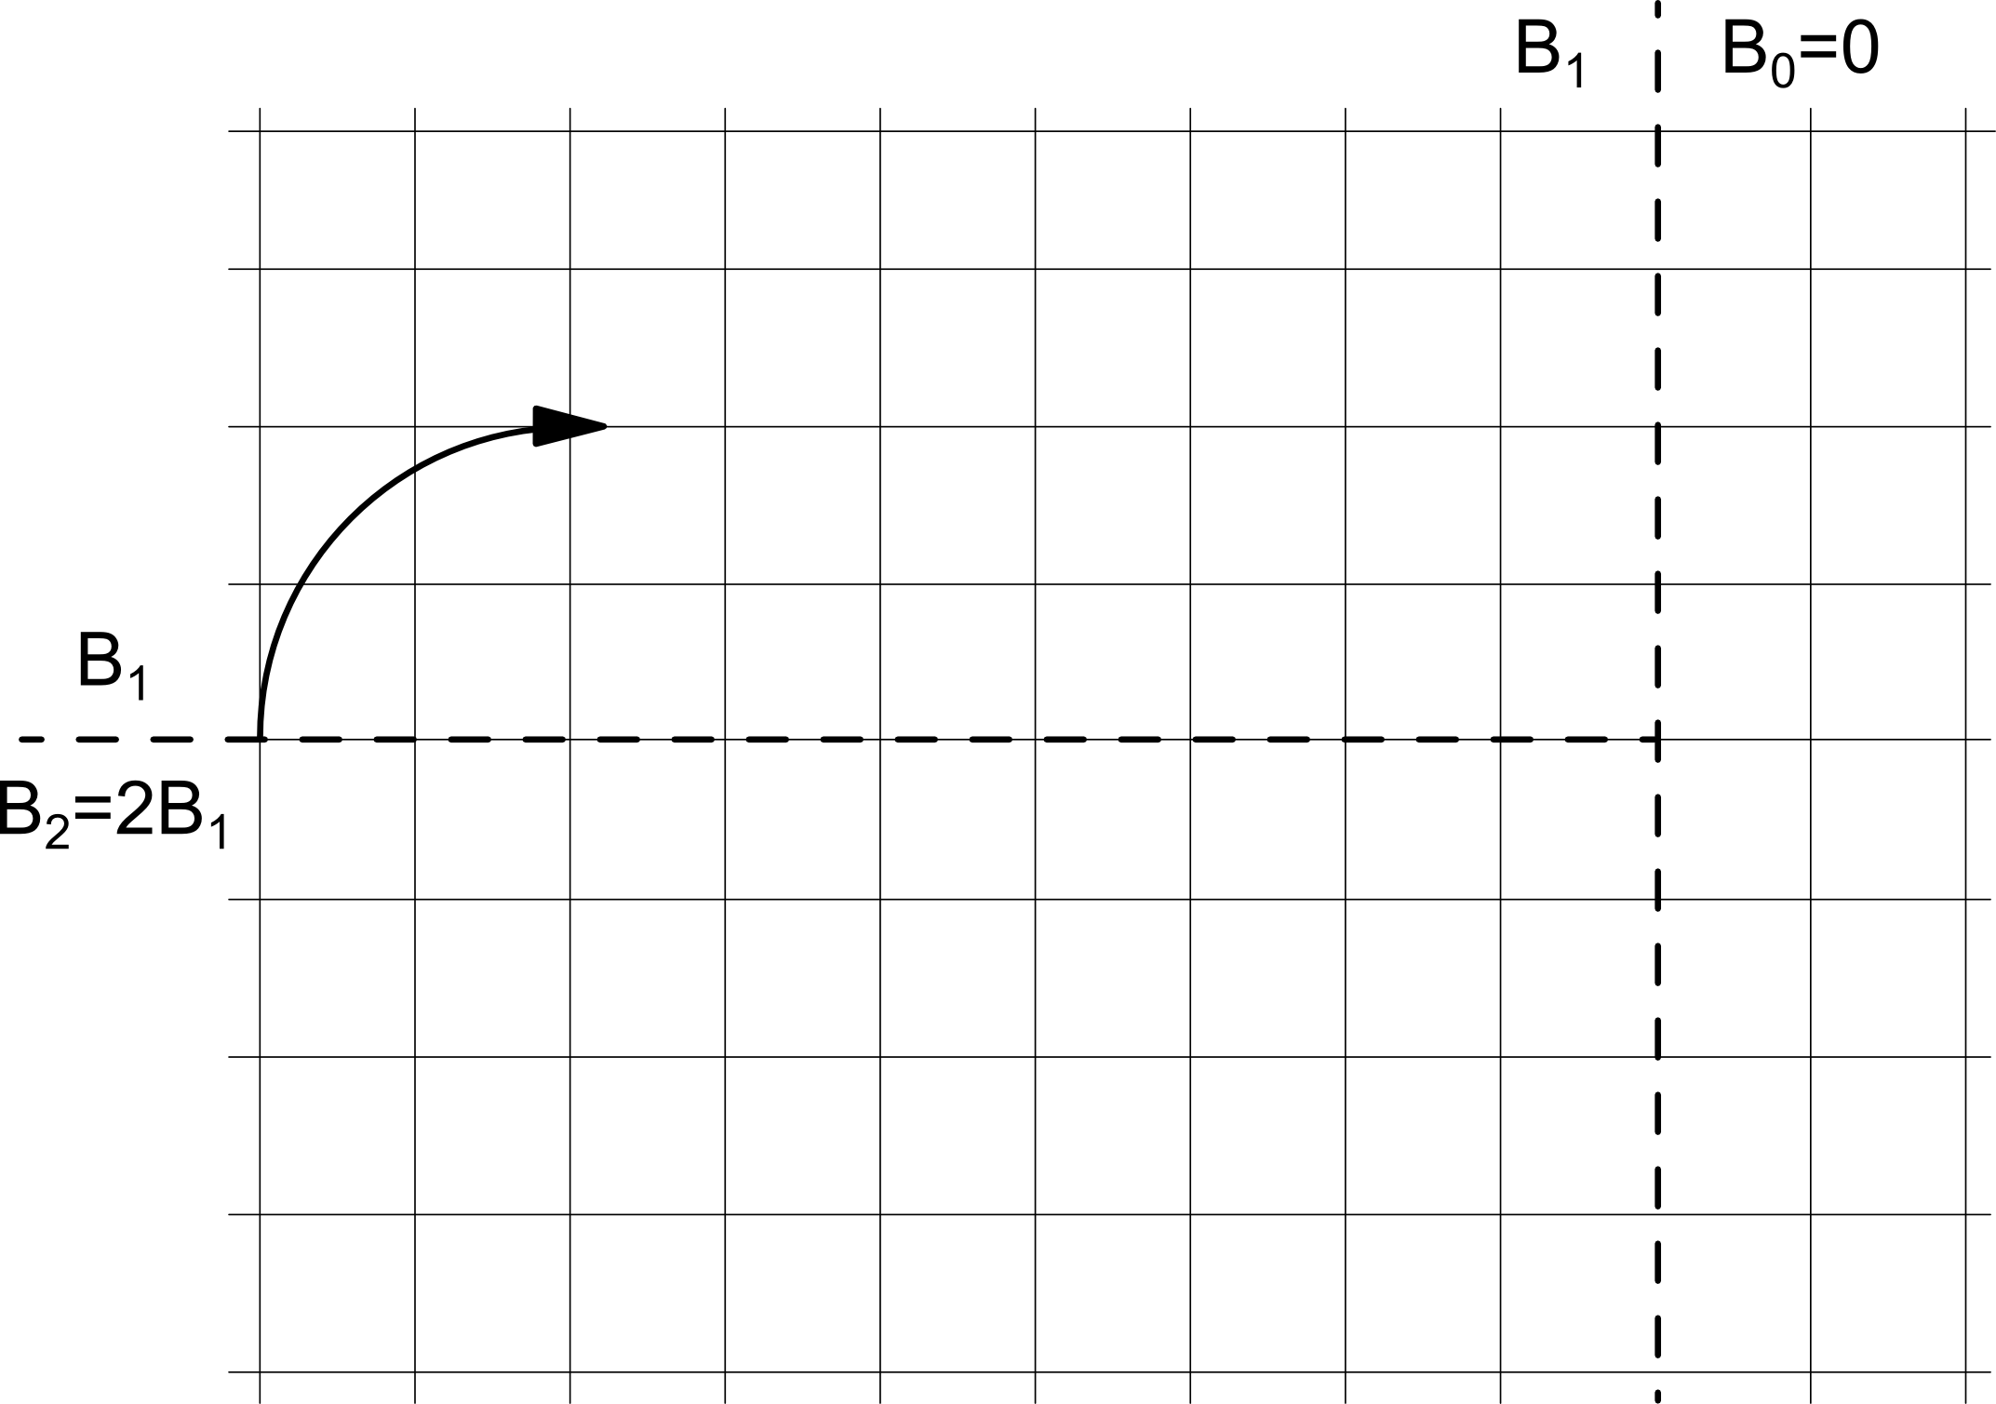

1 pt for correct gyroradius in top left, 1 pt for correct gyroradius in bottom left, 1 pt for straight line on right

PROBLEM 4 (10 points)
- In the ionosphere, electrons typically have temperatures of $T_{e}=1000$ K. What velocity does this temperature correspond to when assuming that the thermal energy $k_{B}T_{e}$ is equal to the electron’s kinetic energy? (2 point)
  - 1 pt for correct formula, 1 pt for correct value
- The magnetic moment $μ$ of a gyrating particle is given by
$$μ=\frac{mv_{⊥}^{2}}{2B}$$
where $m$, $v_{⊥},$and $B$ are the particle mass, the particle velocity perpendicular to the magnetic field and the magnetic field strength, respectively. What is the magnetic moment of an electron gyrating at the velocity calculated under a) at an altitude of 500 km exactly above the northern magnetic pole, where the magnetic field is vertical and given by
$$B\left(z\right)= \frac{μ_{0}}{4π}\frac{2m_{z}}{z^{3}}$$with $z$ the vertical coordinate from the center of the Earth and $m_{z}$ the magnetic moment of the terrestrial dipole field? (2 points)
1 pt for correct magnetic field value, 1 pt for correct magnetic moment
- Because the magnetic field is converging toward the pole, there exists an upward force on the gyrating electron due to its magnetic moment given by
$$F_{B}=-μ\frac{∂B}{∂z}.$$
How big is this force for an electron with a temperature of $T_{e}=1000$ K? (2 points) 1 pt for correct formula, 1 pt for correct value
- What is $v_{⊥}$ such that the force $F_{B}$ pushing the electron upwards is exactly balanced by gravity pulling it downwards? (2 points)
  - 1 pt for force balance equation, 1 pt for correct value
- What temperature does the velocity calculated under c) correspond to? How does that compare to the average temperature of electrons in the ionosphere? Do you think there are many electrons where the magnetic moment force is balanced by gravity? (2 points)
  - 1 pt for correct value, 1 pt for saying “It is much lower than the average temperature”
APPENDIX
Constant | Value
Boltzmann’s constant $k_{B}$ | $1.38×{10}^{-23}$J/K
Magnetic permeability of free space $μ_{0}$ | $4π×{10}^{-7}$H/m
Electron mass $m_{e}$ | $9.1×{10}^{-31}$ kg
Earth’s radius $R_{e}$ | $6372$ km
Earth’s magnetic moment $m_{z}$ | $8×{10}^{22}$ Am²
Gravitational acceleration at 500 km altitude $g$ | $8.4$ m/s²

