Solutions to the exercises on reinforcement learning and dialogue system evaluation

(IN4080 course)

Question 1
1.1
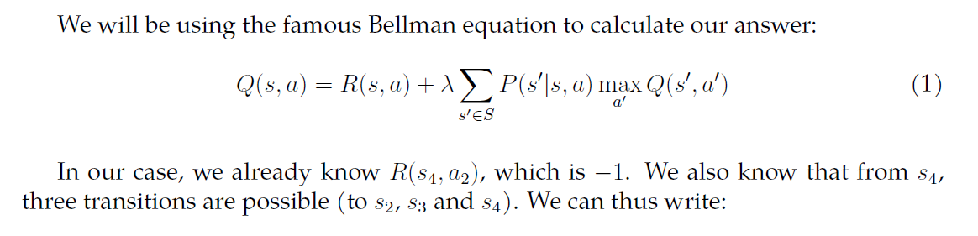

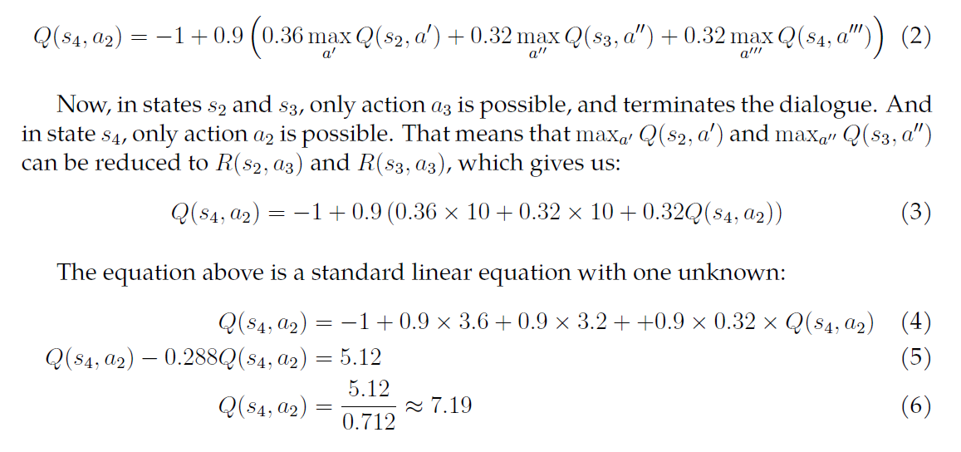

1.2
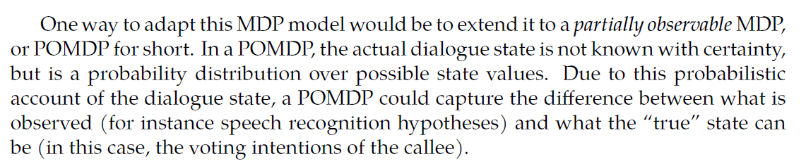

Question 2
We need to compute two Q-values:
$Q\left(HumanNotEngaged, SayHi\right)$
$$=R\left(HumanNotEngaged, SayHi\right)+0.9 \left(0.5*\max_{a_{1}}Q\left(HumanNotEngaged, a_{1}\right)+0.5*\max_{a_{2}}Q\left(HumanEngaged, a_{2}\right)\right)$$
$$=-1+0.9 \left(0.5*\max_{a_{1}}Q\left(HumanNotEngaged, a_{1}\right)+0.5*10\right)$$
$$=3.5+0.45{* max}_{a_{1}}Q\left(HumanNotEngaged, a_{1}\right)$$

$$Q\left(HumanNotEngaged, SayHiWithGestures\right)$$
$$=R\left(HumanNotEngaged, SayHiWithGestures\right)+0.9 \left(0.3*\max_{a_{1}}Q\left(HumanNotEngaged, a_{1}\right)+0.7*\max_{a_{2}}Q\left(HumanEngaged, a_{2}\right)\right)$$
$$=-2+0.9 \left(0.3*\max_{a_{1}}Q\left(HumanNotEngaged, a_{1}\right)+0.7*10\right)$$
$$=4.3+0.27{* max}_{a_{1}}Q\left(HumanNotEngaged, a_{1}\right)$$

So, for the first iteration, starting with Q-values initialized to 0, we get:
$$Q_{t_{1}}\left(HumanNotEngaged, SayHi\right)=3.5$$
$$Q_{t_{1}}\left(HumanNotEngaged, SayHiWithGestures\right)=4.3$$

For the second iteration, we get:
$$Q_{t_{2}}\left(HumanNotEngaged, SayHi\right)=3.5+0.45*4.3=5.44$$
$$Q_{t_{2}}\left(HumanNotEngaged, SayHiWithGestures\right)=4.3+0.27*4.3=5.46$$

We continue:
$$Q_{t_{3}}\left(HumanNotEngaged, SayHi\right)=3.5+0.45*5.46=5.96$$
$$Q_{t_{3}}\left(HumanNotEngaged, SayHiWithGestures\right)=4.3+0.27*5.46=5.77$$

$$Q_{t_{4}}\left(HumanNotEngaged, SayHi\right)=3.5+0.45*5.96=6.18$$
$$Q_{t_{4}}\left(HumanNotEngaged, SayHiWithGestures\right)=4.3+0.27*5.96=5.91$$

$$Q_{t_{5}}\left(HumanNotEngaged, SayHi\right)=3.5+0.45*6.18=6.28$$
$$Q_{t_{5}}\left(HumanNotEngaged, SayHiWithGestures\right)=4.3+0.27*6.18=5.97$$

So the correct answer at the end of iteration fine would be 6.28 for Q(HumanNotEngaged, SayHi) and 5.97 for Q(HumanNotEngaged, SayHiWithGestures).

