Foreword 2
Introduction to VoIP 3
SIP: 3
H.323: 4
SER: 4
Cellular network 4
GSM 5
GPRS 6
3G 6
Wimax 7
Introduction 7
Fixed-WiMAX based on the IEEE 802.16-2004 8
Mobile WiMAX based on the IEEE 802.16e 9
WLAN 10
802.11 10
802.11a 10
802.11b 10
802.11g 10
FMC 12
Network 12
Terminal 12
Service 12
Were did it come 13
FMC trend 13
UMA 13
How it works 14
Roaming 14
Handover 14
Benefits 14
Is UMA a fixed to mobile convergence (FMC) technology? 15

Foreword

This document describes the course of the project. The mid report shows what has been done so far. It describes some background information and an introduction to FMC and UMA.

With some help from INF5162 course teacher, we have managed to formulate a definition of the project.

Project description and frame:

Our basis for this project is to understand FMC and the many different implementations that aspire to follow the FMC specification. Our main goal is to find the implementation that adapts the FMC specification best. In pursuit of this goal we will discuss the different FMC realizations.
We will limit ourselves by only discussing the technical details of the implementations nearest the FMC specification. Another phase of the project will be a market research, where the goal is to find out if the implementation we find to be most compatible with the FMC specification is the preference of potential customers.

Introduction to VoIP

What is voice over IP?
Voice over IP allows you to make phone calls using a computer network, over a data network like the Internet. Voice over IP converts the voice signal from your telephone into a digital signal that travels over the internet then converts it back at the other end so you can speak to anyone with a regular phone number. When placing a voice over IP call using a phone with an adapter, you’ll hear a dial tone and dial just as you always have. Voice over IP may also allow you to make a call directly from a computer using a conventional telephone or a microphone.

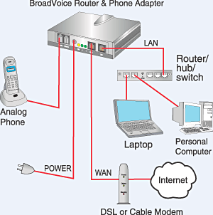

At present there are two standards that are in use for VoIP switching and gateways: SIP and H.323. SIP mainly relates to end-user IP Telephony applications, while H.323 is a new ITU standard for routing between the circuit-switched and packet-switched worlds used for termination of an IP originated call on the PSTN, but the converse is also becoming common at a very fast rate.

The most popular of these two standards and most widely used is SIP.

SIP:

SIP clients use TCP and UDP port 5060 to connect to SIP servers. SIP is only used in setting up and tearing down voice or video calls. All voice/video communications are done over RTP.
A goal for SIP was to provide a superset of the call processing functions and features present in the public switched telephone network (PSTN). As such, features that permit familiar telephone-like operations are present: dialing a number, causing a phone to ring, hearing ringback tones or a busy signal. Implementation and terminology are different.

H.323:
H.323 was designed with a primary target: To provide teleconference with voice and data capacities on packet switching networks.
The continuous researchs and developments of H.323 follow the same purpose. In addition, H.323 and the convergence of voice, video and data allow the services suppliers to provide new facilities for the users and improve the performance for the user reducing costs.
The standard was designed specifically with the following objectives:
· To be based on the existing standards, including H.320, RTP and Q.931
· To add some of the advantages that packet switching networks offer to transport real time data
· To solve the problems of real time data on packet switching networks
The designers of H.323 know that the requirements of the communication differ from one place to another, between users and between companies and obviously the requirements of future applications also change. So, the designers of H.323 defined it in such a way that the companies that manufacture the equipment can add their own specifications to the protocol and can define other structures and standards that allow the devices to acquire new features or capacities.

SER:
SIP Express Router is a high-performance , configurable, free SIP server. It can act as SIP registrar, proxy or redirect server. Its performance allows it to deal with operational burdens, such as broken network components, attacks, power-up reboots and rapidly growing user population. SER’s configuration ability meets needs of a whole range of scenarios including small office use, enterprise PBX replacements and carrier services.

Cellular network
A cellular network is a radio network made up of a number of radio cells. The essential elements of any cellular system are mobile stations (or mobile unit), base stations, and a mobile switching center.

There are multiple cellular network standardizations throughout the world. The cellular system which is in use in Europe uses the GSM standard.

GSM

GSM, Global System for Mobile Communication, is a second-generation cellular system. Some of the specifications of GSM are:

Parameter | Specification
Multiple access  Duplex  Channel bandwidth  Uplink band  Downlink band  Forward/reverse channel data rate  Number if users/channel | TDMA/FDMA  FDD  200 kHz  890-915 MHz  935-960 MHz  270 kbps/user  8

GSM has led to a more integrated mobile network because each operator supports GSM-based infrastructure elements, GSM standard formats, and GSM handsets.
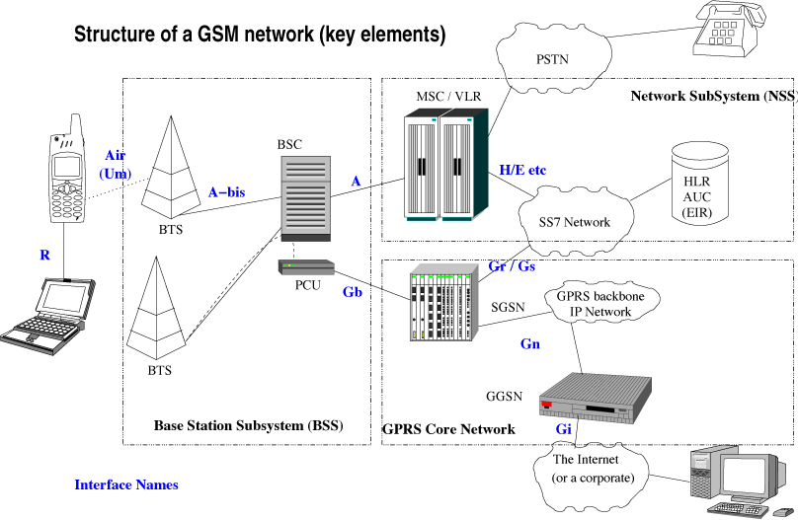

GPRS

GPRS, General Packet Radio Service, is a GSM data transmission technique that does not set up a continuous channel from a portable terminal for the transmission and reception of data, but transmits and receives data in packets, which means that multiple users share the same transmission channel, only transmitting when they have data to send.
The total available bandwidth is dedicated to those users who are sending at any time. GPRS deliver effective data rates up to 50 Kbps.

3G

3G, Third Generation mobile technology, supports much higher data rates, measured in Mbps and there for provide the ability to transfer live video, audio and full Internet access.

3G is a IMT-2000 specification made by International Telecommunications Union’s and supposed to be a single, unified, worldwide standard, but in practice, the 3G world has been split into various camps.

For the 3G to be compatible with GSM, the Europeans adopted the UMTS standard which is based on CDMA technology.

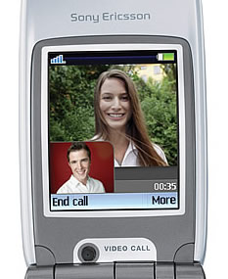3G mobile phone

Wimax

Introduction

WiMAX stands for” World Interoperability for Microwave Access”. It is a global standard based technology for Broadband Wireless Access that supports fixed, nomadic, portable and mobile access. WiMAX is an IP-based Radio Access System configured in much the same way as a traditional cellular network with strategically located base stations using a point to multi-point architecture based on IEEE and ETSI standards.

In its first release the 802.16 standards addressed applications in licensed bands in the 10 to 66 GHZ frequency range. It was optimal for cells with a 7 to 10 km and up to 50 km of range. Future amendments have extended the 802.16 air interface standards to cover non-line of sight ( NLOS ) applications in bands in the sub 11 GHZ frequency range and sub 6 GHZ frequency range for mobile WiMAX.

We will take a further look to the two versions of WiMAX that have been designed, fixed WiMax and to Mobile WiMax.

Fixed-WiMAX based on the IEEE 802.16-2004

Fixed WiMAX has proven to be a cost effective fixed wireless alternative to conventional wired-line DSL and cable in areas where those technologies are already available and none less in areas beyond the reach of DSL and cable.

It uses Orthogonal Frequency Division Multiplexing ( OFDM ) with 256 carriers and supports fixed and nomadic access in Line of Sight ( LOS ) and Non Line of Sight ( NLOS ) environments. Using the 3.5 GHZ frequency range licensed band and the 5.8 GHZ frequency range unlicensed band. It has a typical cell radius of between 5 to 8 km.

WiMAX profiles based on 802.16-2004 are better suited to fixed applications that use directional antennae because OFDM is less complex than SOFDMA. As a result 802.16-2004 networks may be deployed faster and products are less complex and can be used in a wider range of unlicensed bands.

Alternative to other access technologies
for fixed broadband.

Mobile WiMAX based on the IEEE 802.16e

The 802.16e is a amendment add to the 802.16 standard by IEEE, it adds the features and attributes to the standard that are necessary to support mobility.

Mobile WiMAX is a broadband wireless solution that enables convergence of mobile and
fixed broadband networks through a common wide area broadband radio access
technology and flexible network architecture.

It is optimized for dynamic mobile radio channels and provides support for roaming and handoffs. Handoffs are a crucial ability to maintain a connection while moving across cell borders. 802.16e WiMAX will support both hard and soft handoffs. Hard handoffs use a break- before-make approach, the user device is connected to only one base station. It is less complex than soft handoffs, but has a late latency. Soft handoffs are much alike those used in some cellular networks and allow the user device to retain the connection until it is associated ( make-before-break approach ), thus reducing latency. Applications like VoIP benefit greatly by low latency soft handoffs. QoS are maintain during handoffs.

It uses Scalable Orthogonal Frequency Division Multiplexing Access ( SOFDMA, a variation of OFDMA ), a multi-carrier modulation technique that uses sub-channelization. The carrier allocation in OFDMA modes is designed to minimize the effect of the interference on user devices with omni directional antennae. Furthermore the 802.16e offers improved support to Multiple Input Multiple Output ( MIMO ) and Adaptive Antenna Systems ( AAS ) which will bring a substantial increase in throughput and NLOS capabilities. Mobile WiMAX has a typical cell radius of between 1.5 to 5 km. The frequency bands for the 802.16e profiles are not yet certified, but 2.3 GHZ and 2.5 GHZ are the best targets due to better indoor coverage and support for mobile or portable devices.

Some advantages presented by the 802.16e products compared to the 802.16-2004 products are a better link margin, support for mobility, improved indoor coverage and flexible management of spectrum resources.

Mobile broadband access with high capacity.

WLAN
WLAN stands for wireless local area network. It is based on the 802.11 family of specifications developed by IEEE for wireless LAN technology. 802.11 specifies an over the air interface between a wireless client and a base station or between two wireless clients. WLAN cover areas with a radius of up to 100 meters and it is optimized for indoor range.
There are several specifications in the 802.11 family:

802.11
Applies to wireless LANs and provides 1 or 2 Mbps transmission in the 2.4 GHz band using either frequency hopping spread spectrum ( FHSS ) or direct sequence spread spectrum ( DSSS ).

802.11a
Is an extension to 802.11 that applies to wireless LANs and provides up to 54 Mbps in the 5GHz band. 802.11a uses an Orthogonal Frequency Division Multiplexing ( OFDM ) encoding scheme, to support higher data rates rather than FHSS or DSSS.
Products that adhere to this standard are considered "Wi-Fi Certified." It is less potential for RF interference than 802.11b and 802.11g. Better than 802.11b at supporting multimedia voice, video and large-image applications in densely populated user environments, but it has relatively shorter range than 802.11b.

802.11b
Is an extension to 802.11 that applies to wireless LANS and provides 11 Mbps transmission (with a fallback to 5.5, 2 and 1 Mbps) in the 2.4 GHz band. 802.11b uses only DSSS.
Products that adhere to this standard are considered "Wi-Fi Certified." Not interoperable with 802.11a. It requires fewer access points than 802.11a for coverage of large areas and offers high-speed access to data at up to 100 meters from base station.

802.11g
Applies to wireless LANs and provides 20+ Mbps in the 2.4 GHz band.
Which of these wireless LAN technologies should be employed depends on the purpose and the applications that will be used. Range and performance are the big issues to be considered.

802.11a offers excellent support to higher end applications involving video, voice and transmission of large images and files, but the higher operating frequencies equates to relatively shorter range. RF interference presented in 802.11b is avoided in 802.11a, since it operates in the less crowded 5GHZ band and not in the 2.4 GHZ band which 802.11b operates.

FMC
Fixed mobile convergence (FMC) is a generic term that embraces terminal device, service and network convergence. That is merging wire-line and wireless networks, service and terminals. With the convergence between the mobile and fixed networks, telecommunications operators can provide services to users independent of their location, access technology, and terminal. The convergence can then be seen in tree aspect or level, the core network, terminals and services.

Network
Network convergence means that same network will be used for both fixed and mobile service and by both operators. This part can be farther divided in to core network and access network the goal for the core network is to migrate from separate circuit and packet switched networks to a single unified network that supports the existing mobile and fixed access technology.

Terminal
Terminals convergence is that terminals should be interoperable across multiple access technologies and vendor networks seamlessly.

Service
Service convergence is to be able to provide/access new or existing service in both fixed and mobile network independent of your location. This can be composed of one or combined service, such as videophone. An important future of this is that users can access a consistent set of services from any fixed or mobile terminal via any compatible access point, Independent of access network it is attached to.

Receiving Terminal
Figure 1 Fixed mobile convergence

Were did it come
The concept of convergence emerges from telecom service providers' need to find new revenue stream, reduce their operating expenses and simultaneously invest in future-proof network architectures and technologies. Some service providers are looking for a multitude of new services including mobile and fixed access. The primary goal is concurrent delivery of all media type (Voice, data and vidio) to an easy to use graphical user interface, independent of access method, terminal and location. The goal of network convergence is to make all service profitable and enable multiple business models. These goals are related because frequently service that are easy to use become popular and increases revenue.

FMC trend
The fully fixed mobile converged service and network are same years a way, but there are some attempts that are been made. We have IMS, UMA, H323 and SIP. Session initiation protocol is a protocol developed by the ITFG and proposed standard for initiating, modifying, and terminating an interactive user session that involves multimedia elements. It is gaining popularity compared to the complementary protocol H323.The IP Multimedia Subsystem (IMS) is a standardized Next Generation Networking (NGN) architecture for telecom operators that want to provide mobile and fixed multimedia services. It uses a Voice-over-IP (VoIP) implementation based on a 3GPP standardized implementation of SIP, and runs over the standard Internet Protocol (IP). Existing phone systems (both packet-switched and circuit-switched) are supported.

UMA

Unlicensed Mobile Access (UMA) technology provides access to GSM and GPRS mobile services over unlicensed spectrum technologies, including Bluetooth and 802.11. By deploying UMA technology, service providers can enable subscribers to roam and handover between cellular networks and public and private unlicensed wireless networks using dual-mode mobile handsets.

How it works

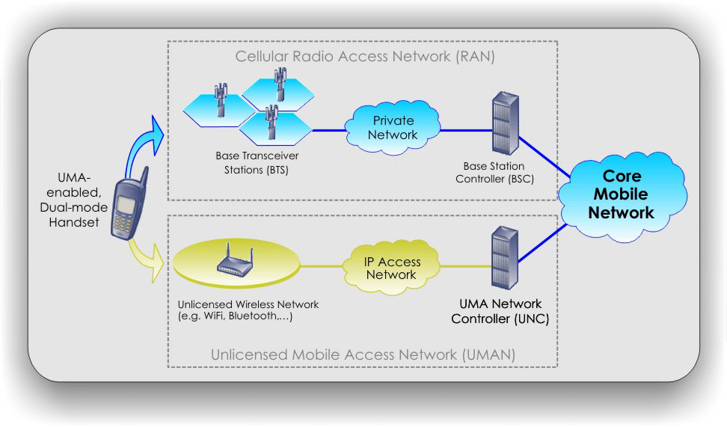

When a subscriber with an UMA enabled handset is in range of an unlicensed wireless network to which the subscriber is allowed to connect, the handset will automatically connect. Upon connection the handset will authenticate with the UNC (UMA Network Controller) over the IP / broadband network. Authentication is required to access GSM voice and GPRS service via the unlicensed wireless network. If the authentication is successful the subscribers location is updated in the core mobile network. Now all voice and data traffic is routed to the subscriber through the unlicensed mobile access network (UMAN).

Roaming
When a UMA-enabled subscriber moves outside the range of an unlicensed wireless network to which they are connected, the UNC and handset facilitate roaming back to the licensed outdoor network (GSM / 3G). This roaming process is completely transparent to the subscriber.

Handover
If a subscriber is on an active GSM voice call or GPRS data session when they come within range (or out of range) of an unlicensed wireless network, that voice call or data session can automatically handover between access networks with no discernable service interruption. Handovers are completely transparent to the subscriber.

Benefits
Mobile operators tend not to deploy new technologies unless they provide either a cost benefit or enhanced user experience. UMA technology delivers on both counts by providing improved voice quality and in-building coverage while offloading traffic from existing (higher cost) GSM radio networks.

A normal GSM cell radius in suburban environments is around 2 km. This gives an approximate coverage area of 12.5 km². Within this cell one could potentially cover more than 12 000 homes, but due to in-building penetration loss the actual coverage can be reduced by up to 70 percent to less than 4000 of the original 12 000 homes. This reduction in radio access and voice quality will ultimately lead to loss of potential revenue for the mobile operator. This is precisely where UMA technology can be a benefit to both operators and end-users.

With a UMA-enabled phone the subscribers will offload traffic on the radio access network (RAN) to local wireless networks. Not only will mobile operators not have to invest in additional base stations to increase coverage, neither will they have to pay for the access points and internet connections as this infrastructure in many cases already is in place and used for internet access.

Is UMA a fixed to mobile convergence (FMC) technology?
UMA is not in total compliance with the specification for fixed to mobile convergence. After all UMA does not in its self provide convergence between the fixed and the mobile networks, it only provides convergence between mobile and wireless networks. But with that said UMA still contains solutions for some of the basic ideas in the FMC specification.

Mobile operators will begin deploying UMA-compliant dual-mode GSM/Wi-Fi handsets with the objective of offering true "one phone, one number" service. Although this initially may be viewed as complementary to existing fixed service, the long-term result could be mobile substitution of fixed service.

From this viewpoint, UMA technology is an extension of FMC with the ultimate goal of mobile substitution in a converged world. A recent survey conducted by BrainJuicer, which targeted 1,000 customers in six European markets (France, Germany, Italy, Spain, Sweden and the United Kingdom), concluded that a UMA-enabled phone would be positively received. If mobile calls in the home were priced the same as fixed line calls, then more than 50 percent of the respondents said they would be likely to sign up for UMA service within 12 months. Of the respondents who would probably buy the service, a third would make most or all of their calls at home on their mobile phone. This makes for a powerful case for mobile substitution.

As initial deployments of UMA handsets begin with the movement toward "one phone, one number" service, the stage will be set for a more significant movement toward FMC. This also seems to be the case in the marketing of the UMA equipment. Almost all of the technology companies that develop equipment for the UMA backbone argue that deploying UMA is a solution that will increase use of mobile services and effectively stimulate the IP multimedia subsystem (IMS) for mobile.

TDMA, Time Division Multiple Access, is digital transmission technology that allows a number of users to access a single radio-frequency channel without interference by allocating unique time slots to each user within each channel. FDMA, Frequency Division Multiple Access, is the division of the frequency band allocated for wireless cellular telephone communication into 30 channels, each of which can carry a voice conversation or, with digital service, carry digital data.
FDD, Frequency Division Duplex, is the application of the FDMA to separate outward and return signals
UMTS, Universal Mobile Telephone System,
CDMA, Code Division Multiple Access

