The Virtual Mirror

A suggestion for the Oslo children museum

INF4260

By Mohammad Usman, Kristian Sporsheim,
Eivind Bergstøl, Ivica Milanovic, Roni Hercz

November 2007
Introduction 3
The mirror in history and culture 4
Virtual mirror applications 6
Mirrors and conception of self 8
Our Virtual Mirror 8
Movement rendering quality 8
View angle problems 9
System setup and placement 10
Screen content: Animated figures 10
User behaviour and focus groups 11
Entering a room with a view 13
Prototype 14
Conclusion 14
References 16
Introduction
This document is the mid-term paper in the Human-Computer-Interface course (INF3260/INF4260) at the University of Oslo. The document talks about our suggestion for an installation called “The Virtual Mirror” which may or may not exhibit at an upcoming Children Museum in Oslo. The document is also expressing thoughts and reflections regarding the solution we provide as well as bringing in historical context similar or conceptually similar applications of mirrors found relevant to our study and decision making.

Our group is made up of the first five students of the five year Information and Interaction Design-programme at The Department of Informatics. Most of use have been working together on other projects and we are thus familiar with each other and each other’s qualifications making it easy for us to delegate individual tasks within our group as to reach a fair work payload in between the group members enabling us to deliver a document we believe will provide with sufficient background and explanations to our solution suggestions.

Our solution is called “The Virtual Mirror” and the concept is to create an installation consisting of a large video screen acting as a mirror, a camera or sensor and a real time processing unit. The purpose is to capture the movements of the person(s) standing in front of the camera or sensor, and imitating these movements in real time by use of animated figures presented on the video screen. This way we hope to give the impression that these images are the mirror images of the persons in front of the video screen and by this transforming the video screen into a virtual mirror - except that what the observer sees is not one self’s mirror image, but instead an animated figure.

We shall in our paper not dwell upon wether this task is feasible or wether it is impossible to create such an installation. We’ll assume there is ready made technology out there that will allow us to put this installation together, as it is the conceptual idea and problems that interests us.

Immediate questions that will arise while working on this project are questions like “Will this be a fun and popular installation?”, “What will this installation mean in a deeper sense?”, “Is there anything we can learn from this?” and “How will the installation be perceived? - “Will the observer see a mirror image, or just an imitating figure?” and “Will this installation enable people to view themselves differently or in other ways enhance their self-experience?” or “Will the observer learn anything from this experience?”. There are of course many more questions, and we will not find answers to all these questions, but we are aware of and we have raised those questions.

The mirror in history and culture
From the Oxford American Dictionary we learn that the mirror is a reflective surface, now typically of glass coated with a metal amalgam, that reflects clear image. Furthermore, figuratively speaking a mirror is something regarded as accurately representing something else as in “the stage is supposed to be the mirror of life”.
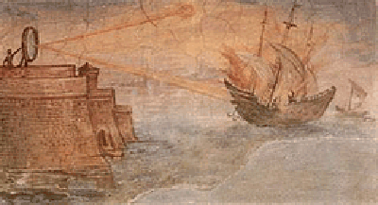
The earliest known mirrors were polished stone mirrors from 6200 BCE found in what is now Turkey. The Egyptians made mirrors from polished copper and bronze, and sometimes even silver or gold. Egyptian mirrors were used for secular purposes such as applying make up, but also had religious significance as a symbol of the god Ra. Mirrors are mentioned in the Bible, and ancient Roman and Greek records tells us about military use of mirrors during the siege of Syracuse were Archimedes constructed a burning glass to set roman ships afire.

Ancient mirrors have been found throughout the rest of the world, among the pre-Mayan cultures in the West to the Chinese in the east. The first mirrors were hand held mirrors, and the first mirrors to be able to reflect the whole body appeared in the first century AD. By the end of the Middle Ages mirrors had become common throughout Europe.
Archimedes’ death ray

The applications of the mirror ranged from secular to religious, from decorative to scientific or even military. Mirrors are also surrounded by superstitiousness; someone who breakes a mirror will receive seven years of bad luck. Two mirrors facing each others means bad luck, and demons and vampyres are invisible in the mirror.

Mirrors were frequently used in fine arts, either as a production tool or as an object within the artistic image. Brunelleschi discovered the linear perspective with the help of the mirror. Leonardo da Vinci called the mirror the master of painters. He recommended “When you wish to see whether your whole picture accords with what you have portrayed from nature take a mirror and reflect the actual object in it. Compare what is reflected with your painting and carefully consider whether both likenesses of the subject correspond, particularly in regard to the mirror.” Great painters like Rembrandt and Van Gogh would not be able to paint their famous self-portraits without mirrors.


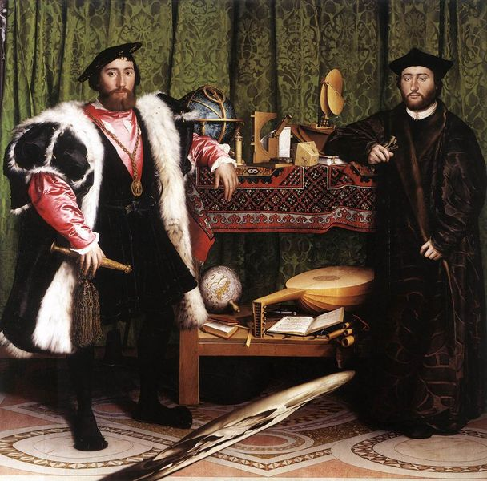
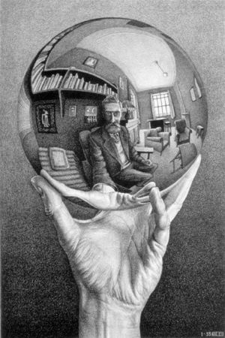
Many famous masterpieces of art in Europe use the mirror as a central device of the painting itself. Like Van Eyck’s “Marriage of Arnolfini” and Velazquez’s “Las Meninas”. Furthermore, brought to Europe by the Chinese in the 16th century, the invention of the anamorphoscopes enabled the European painters to create paintings entailing the use of mirrors to view the masterpiece or in other cases to view the picture from a certain spot at a certian angle. These techniques are called the perspective or mirror anamorphosis and perhaps the most famous examples are that of Holbein the Younger’s painting “The Ambassadors” with the distorted scull in a central spot of the painting, still “invisible” to many. This technique was also used to hide erotic images from the public, or to give the impression that the flat ceiling actually had a dome, like Andrea Pozzo’s painted ceiling in the Church of St. Ignazio.
Marriage of Arnolfini, Van Eyck

The Ambassadors, Holbein the Younger

Hand with reflecting sphere, Escher

In more modern days Escher integrated mirror images of cones, spheres, cubes, rings and spirals in his work. His self-portrait called “Hand with reflecting sphere” is an outstanding example of this. Also the Hungarian artist Istvan Orosz played with mirroring. His anamorphic works are images distorted in such a way that they only become visible when reflected in a specially-shaped mirror placed in a certain position, like his “Mirror Anamorphosis with Column” or his “Portrait of Jules Verne on the Mysterious Island” from 1983 which by many is considered his most important work.

Mirrors are also used in movies as independent objects with special purpose, with one of the most famous appearances being the scene from the fun house in Orson Welles’ 1947 movie “The Lady from Shanghai”. A rather recent example of the use of mirror is the Andy and Larry Wachowski’s movie “The Matrix” from 1999 where Neo touches the mirror and gets sucked inside. A special mirror effects appears in the movie trailer listed in the reference list at the end of this document.

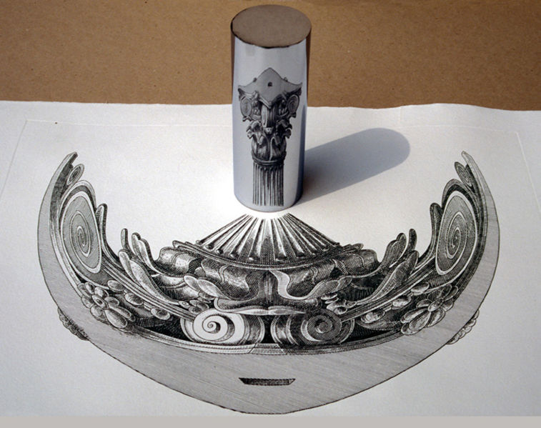
Today there is even a website called “The Mirror Project - Self portrait through reflective surfaces” where people present photographs of themselves as reflected in mirror or mirror-like surfaces. Still, mirrors are, especially today, used in uncountably more ways, wether it is for research or technology, like astronomy, or by dentists looking into the patient’s mouth or when a car repair man looks into the engine or solely for the purpose of entertainment like in a night club or disco hall to being parts of architectural landscapes.
Mirror Anamorphosis with Column, Istvan Orosz

From: The Lady from Shanghai, Orson Welles

Virtual mirror applications
Mirrors have more and more applications as technology advances, and some of the most fascinating applications are those implemented by the advertising and computer industries. The Japanese auto-maker Nissan used large wall to ceiling sized mirrors to project full size presentations in front of the observer. The mirrors were interactive and the observer could push buttons just by holding up the hand without actually touching the button image.

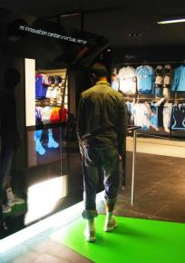
Adidas are known for their virtual mirror which allows the observer to view how different shoes would appear on the observers foot without he or her actually putting them on. In the Nanette Lepore department at Bloomingdale’s on Manhattan a prototype mirror doubling as a high-resolution digital screen allowe customers to view themselves in the mirror with different clothes on without actually trying them on. The Israeli company EZFace created a virtual make-up mirror which allows the observer to add make-up and change the color of one’s hair on a picture taken by a camera in front of a personal computer.
Adidas virtual mirror 1

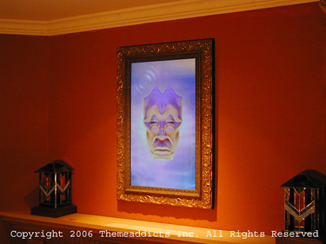
Apple Inc. has in its latest operating system done a modification to the Photo Booth application adding an effect which now allows the user to capture a live self-portrait while changing the background where the user sits to something else, this being either a still image or a movie clip. More than two years ago Japanese Hitachi launched a mirror that functions as a computer display. This technology is called Miragraphy and it integrates different sensors , ranging from cameras to RFIDs, as to allow input from the users thereby returning personalized content. Themeaddicts Inc. of California has created a magic laughing virtual mirror, the Magic Mirror (M30P) which is a mirror in a classic bold frame that can be connected to a residential surveillance system delivering voice and video messages as a portrait image within the mirror frame.
Adidas virtual mirror

On the other side of the scale there are mirrors integrated with LED-displays which are often seen in business or home appliances like LED-message panes or clock-radios. There are student research works attempting to create a virtual handheld mirror which is a device made up of a web camera and digital screen. This is fitted together in a way that the elements you have seen on the screen, viewed from any angle, is precisely the same as what you would see in a real handheld mirror. The problem here is that the perception of the world reflected through a mirror depends on the viewer’s position with respect to the mirror and the 3D geometry of the world. How do you achieve this effect when there is more than one person looking into the mirror? And how will this affect our installation which should allow more than one person approaching the mirror, or digital screen?
Themeaddicts’ Virtual Mirror

Mirrors and conception of self
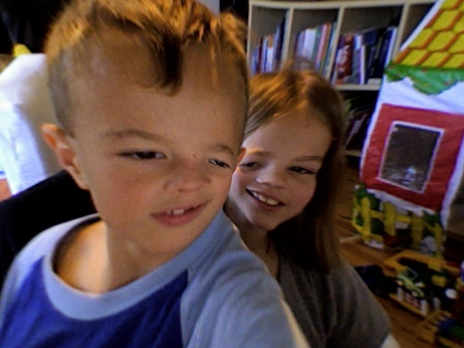
Only a few large social mammals are able to understand when a reflected image is an image of one selves. The so called “Mirror test” is a measure of self-awareness developed by Gordon Gallup Jr in 1970. According to this test it was found that only common chimpanzees, bonobos, asian elephants, orangutans and dolphins are able to recognize their own reflections. Human toddlers are expected to do this from the age around 18 months till 2 years. old.

Our Virtual Mirror
In our project we try to create a virtual mirror made up by a large digital screen, a sensory device like a camera and of course a computer. The system will work in the following way:
Distorted image from Apple Photo Booth

When a person enters the field of view of the camera it will start capturing the image of the person, and at the same time show an animated figure on the digital screen reflecting the movements of the person in front of the camera. Each new person entering the camera’s field of view will trigger the computer to generate another animated figure on the screen reflecting this other person’s image.

Movement rendering quality
How bold or sharp the movements of this reflection appear will be a result of how advanced the software in use will be. The simplest solution will perhaps be to create a system with small sensors adhered to some of the body limbs that will function like trackers for the body movement. If one adheres sensors to the hands, feet and head only, many mistakes in the real time rendering may appear because so few sensors are not necessary for reproducing a good movement reflection. Therefore, as many sensors as possible must be adhered to the body parts of the spectator. Ultimately, though, it would not be necessary to adhere sensors to the body at all. With modern technology it should be possible to recognize the true movements of the body in real time without applying sensory stickers. Examples of this are the recently launched Sony digital cameras which incorporates the so called Smile Shutter Mode which knows how to interpret a smile and take pictures exactly in the right moment of the occurring smile. The camera can interpret the smile of up to eight people in the field of view simultaneously. A similar, but quiet opposite example, is the Apple Incs.’s Photo Booth application which knows how to replace the background of the view field, leaving only the foreground, or actually moving pixels in the image, to be displayed as it is. In our prototype we choose to imitate software not dependent on sensors, but software than can capture real movement and regenerate this in the animated figure.

View angle problems
The fact that more than one person is allowed to appear in front of the camera or on the screen simultaneously creates a problem depicting the background or extension of the view-space as seen from the observers angle. Two persons looking into a mirror do not see the same image because they are gazing at the mirror from different angles. Actually, a fixed camera can not depict the real image of view-space extension or 3D background surrounding the person in front of the camera unless this person stands in a straight angle in front of the camera. How to overcome this problem is shown by student groups working with virtual handheld mirrors involving a mechanical mechanism that moves the camera contrary to the person holding the mirror.

A solution to this problem is to replace the background all together as we have done in our prototype.

Another practical problem will be to choose the right size of the screen in relation to the position of the camera and the person(s) appearing in the field of view of the camera in front of the screen. How far down on the wall should we hang the screen? The average height of a child two years old is around 80-90 cm. In order to enable such a small child to see him or herself, the screen must not be higher up from the ground than even a few centimeters below this. What will then happen with grown ups who may be up to 190 cm tall? The screen must therefore be very large, which is very expensive, and will introduce a problem in regards to the camera position and distance of view from the screen.

One solution regarding the screen is of course to connect several digital screens together. This creates a grid effect on the perceived large screen field, but will most probably decrease the equipment cost to a more reasonable cost level. Another perhaps cheaper solution is to use projectors. Using a projector with a regular set up may introduce a new problem. If a person comes between the projector beam and the screen he may cast shadows on the screen. Therefore the only viable projector setup is to place the projector behind the screen.
Sketch with schematic setup of Virtual Mirror setup
Sketch of Virtual Mirror setup 1

The problem with the positioning of the camera is solved less easily. If we are to allow people to come too close to the screen they may exit the field of view of the camera and will thereby not be reflected on the screen. One may assume that a sufficiently wide angled camera lens will solve this problem, but a ultra-wide lens will introduce more problems, both in regards to people standing further away and in regards to distortions of perspective and size. A normal or telephoto lens will in this case maybe be a better choice, but because the lens can not be placed behind the screen, this will force us not to allow strong telelens, or we will have to move the screen further away from the nearest point of observation. The camera must also be placed in a proper position to maintain correcting perspective while capturing the observers movements.

System setup and placement
Based on the information and details discussed above our suggestion for a system setup will be to use a projector placed behind a white screen and to place a small cameralens in the middle of the screen, and to place the screen at some distance from the observers. This will ensure that the observers will not fall out of the camera’s field of view, as well as allowing for a normal view angle and impression of perspective on the screen.

Because projectors demand room with a lower ambient lightning it will be necessary to find cameras that have to be strong enough to capture the movements even in the low lightning of the room. Else, we will be forced to make a setup based on several smaller screens placed together in a grid.

Screen content: Animated figures
The screen will not show real images of the persons in front of the camera, but instead show animated figures replicating or reflecting the movements of those persons. The animated figures will be pre-made and independent of the actual look or physical appearance of the person in front of the camera, thus to allow the person or observer to forget about his or her own self while at the same time being aware that what is “reflected” actually is oneself. It will be possible to make indefinable numbers of figures, and with an expansion of the system capabilities it will be possible to make the animated figures automatically receive parts of the physical appearances of the person it reflects. A tall and thin person could automatically be represented by a tall and thin figure, while a short and fat person could be represented by such a figure.
Participant and 3D model imitation from prototype

In a future extension of the system is imaginable that the system actually could implement the figures in a way that they are actually portraying the persons captured with a real life resemblance as if it was true reflections of those persons. Taking this line of thought even further it could be possible for two persons in front of the screen to swap or interchange their bodies. Only the imagination would stop short of how intriguingly fun it could be to borrow someone else’s body in front of the mirror.

User behaviour and focus groups
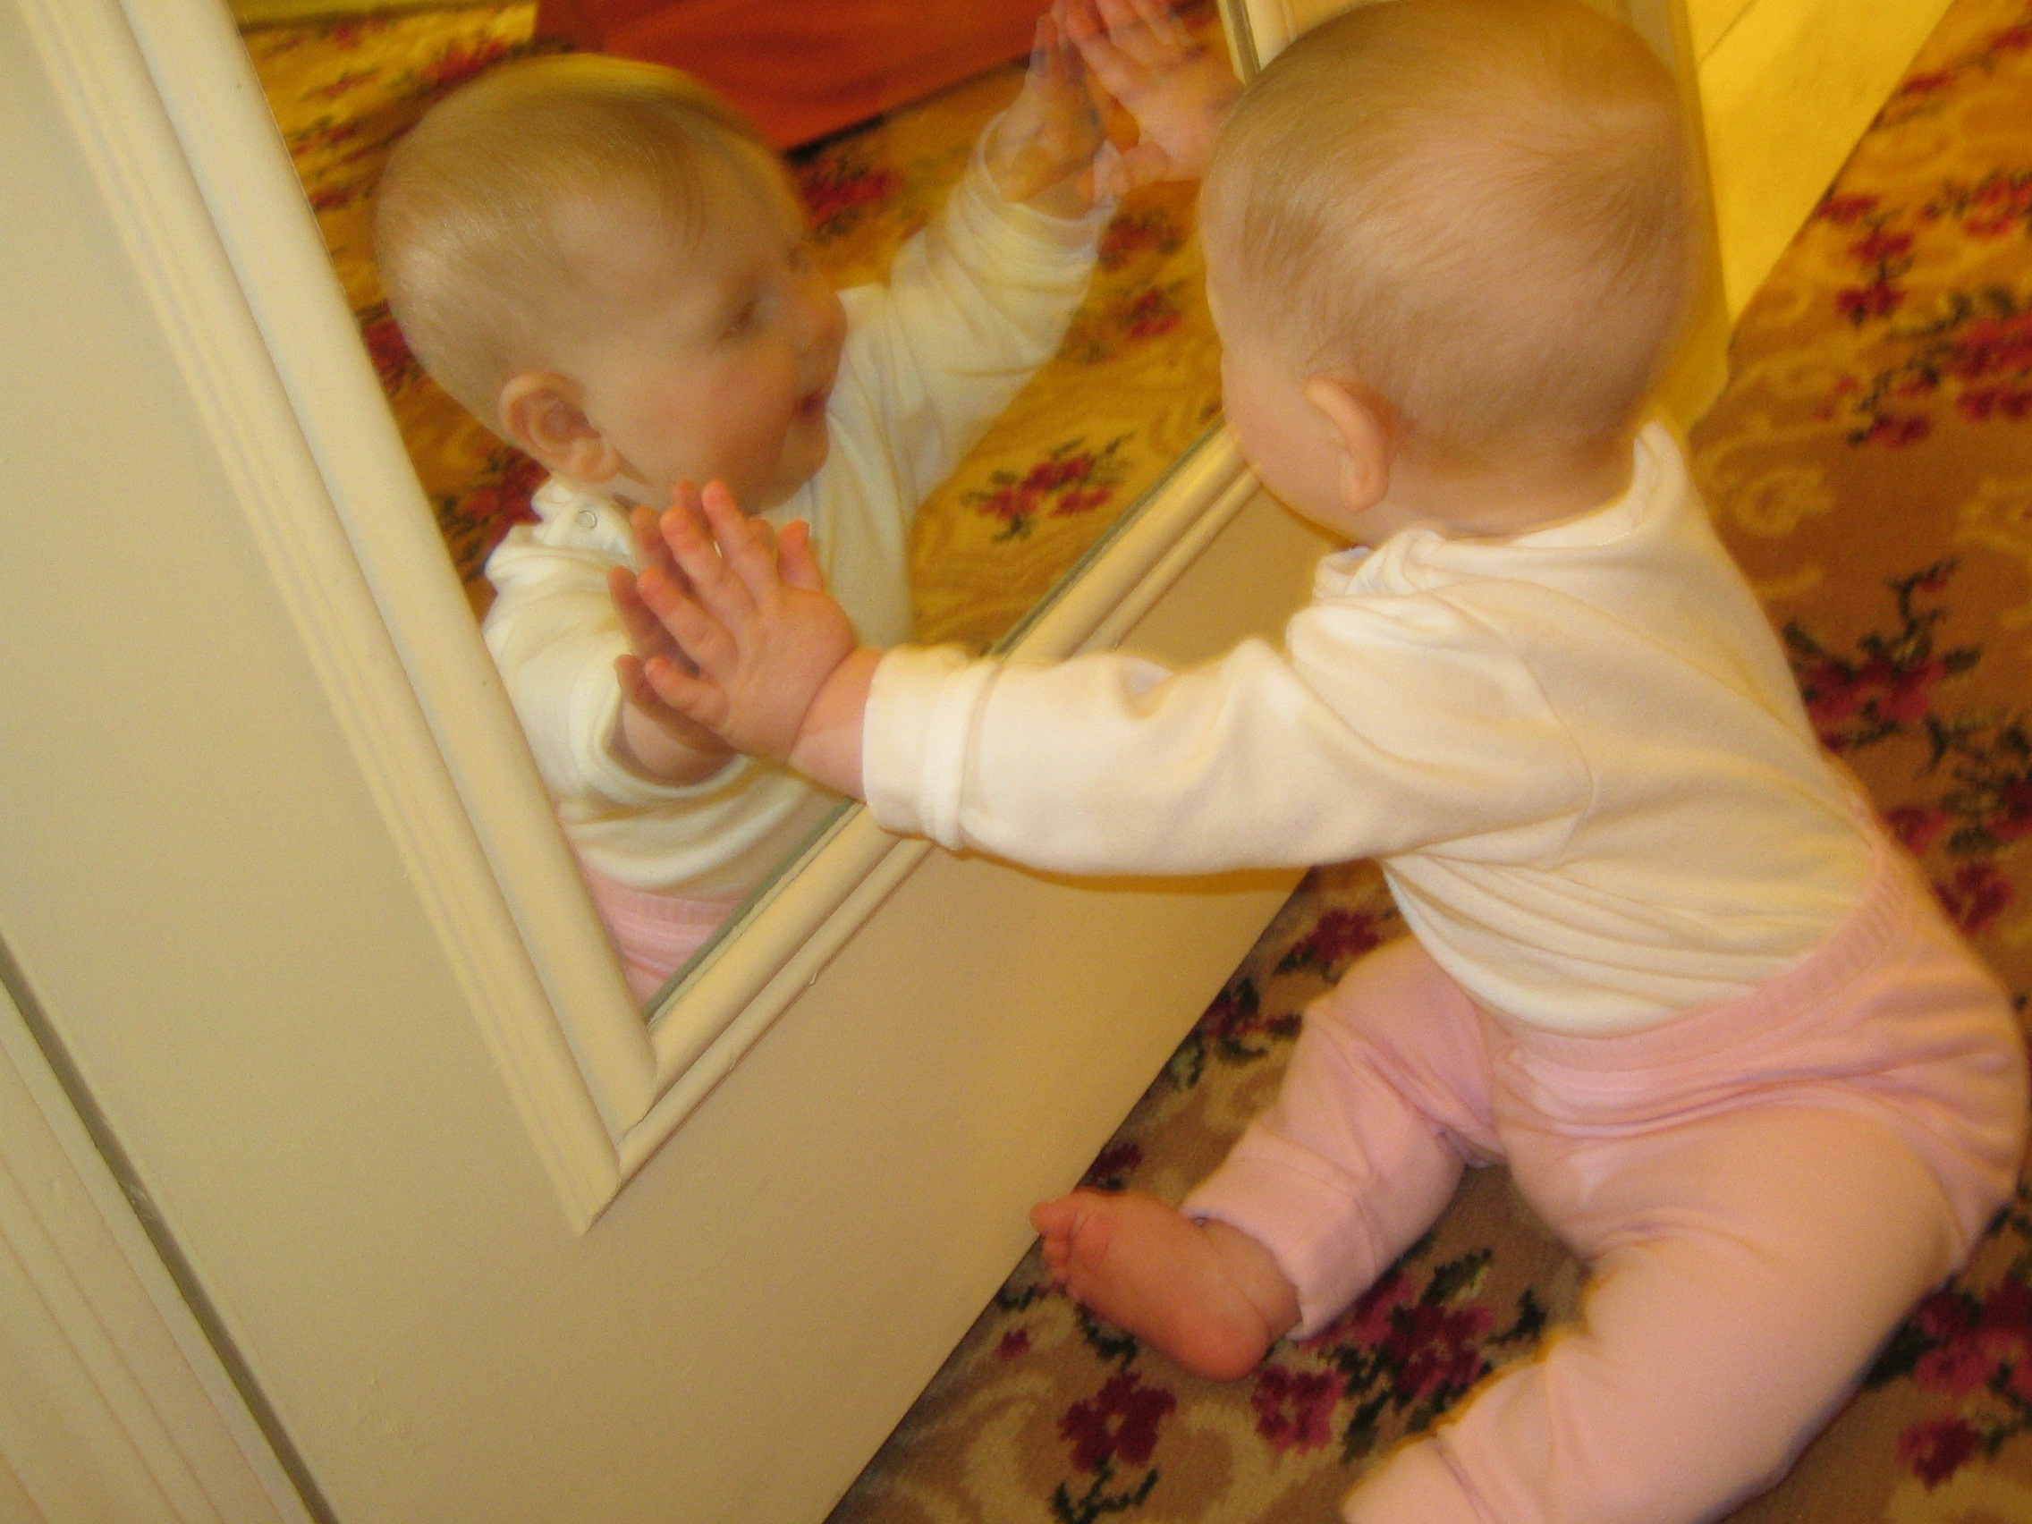
We have so far discussed the physical setup and some of the problems that are related to it. We have also briefly touch upon some of the problems the users may experience with such a system, but we have not done so from a psycho-philosophical viewpoint. We know that most people are attracted to watch themselves in the mirror, though they don’t always like what they see. This discomfort with their own self-image start at a very early age, sometimes even at pre-school age. This discomfort is by researchers believed to be a result of how our society perceives beauty. The princess is always beautiful, and the beast is always ugly. It doesn’t really help that images of people seen on TV or in magazines have looks that are achievable by less than 1% of the population. Research has shown us that different cultures emphasize and define beauty differently as mentioned by a study (Kate Fox, 1997, “Mirror, mirror”) of women’s self image among different cultures:
Fascinated by the mirror

A study of Mexican immigrants in America found that those who had immigrated after the age of 17 were less affected by the prevailing super-thin ideal than those who were 16 or younger when they came to the US. In a Washington University study, Black women with high self-esteem and a strong sense of racial identity actually rated themselves more attractive than pictures of supposedly 'beautiful' white fashion models. In another study about 40% of moderately and severely overweight Black women rated their figures to be attractive or very attractive. Other research indicates that this may be because African-American women are more flexible in their concepts of beauty than their White counterparts, who express rigid ideals and greater dissatisfaction with their own body-shape.

On the contrary people think it’s fun to see distorted images of themselves. Mirror fun houses will always be popular at luna parks, and now with the Photo Booth application from Apple Inc. one can add realtime special effects distorting one’s self-portrait on the computer screen.

Humans are already from a very young age attracted to their own image. This can be be seen just by watching small kids play in front of the mirror, or by letting them view the screen of a video camera recorder. We tested this with two children between the ages 1 and 3 by observation and children 7 and 10 by questions. The child aged 7, a boy, said that he did not like to watch himself in the mirror, but got very excited while playing with Apple Photo Booth. The child age 10 is a girl and she said in a careful tone that she does like to look at the mirror. She also found it fun playing with the distortion effects of the Photo Booth application and when asked what kind of mirror she would prefer at home, she said that she would prefer the one with the distorted image.

A question that arise is wether our system merely will provide some fun for a few seconds, or wether it can provide the observer with anything else with a deeper. Can a person who don’t have a high self esteem now enjoy the self-image reflection because the body appearance is replaced with a new figure? Perhaps dancers or performers could learn something from using our system allowing them to disconnect from their own image while studying their movements? We didn’t find answers to this as the scope of our study was not wide enough.

In the previous chapter we discussed the physical set up of the system, but we didn’t relate it to the perceptual issues. We have just discussed a few psychological issues, but we are left with at least a couple of perceptual issues to discuss. One regarding the setup of the system, and one regarding the use of animated figures.

Entering a room with a view
We have already discussed the kind of technical setup we suggest for our virtual mirror, but we have not yet discussed how people should move around in the room in relation to the camera and the screen. From where should the visitors enter the room? Should they enter and exit from the same door? Should there be more than one door in the room? Should the room have four walls in straight angles? Should the floor be flat at all?

Principally one wall or section of the room will always be occupied by the Virtual Mirror installation, and we will always try to lead the visitors passed the camera in such a way that he or she immediately sees the screen and discovers that the figures on the screen are reflections of the visitor before the visitors exits the room. If the visitor walks through the exhibition room without noticing this, we may have failed our task and the visitor will be deprived of the experience we wish to create.

In all cases we believe it will be best to put the entrance in such a way that the visitor will see the screen head front immediately after entering the room. Furthermore, we suggest that the exit will be placed far enough away from the entrance to give enough time to the visitor to perceive that the figures appearing on the screen are images reflecting the visitor’s movements. This could either be done by placing the exit in the other corner of the room, forcing the visitor to pass through the wall with the screen, or by placing the exit in parallell to the entrance forcing the visitor to spend some time to search for the exit thereby hopefully getting caught by what occurs on screen.

Other options are to create a room imitating a cinema theater hall, where there are entrances in the back, an angled floor, and exits at the bottom section of the hall, adjacent to the screen. Yet another option is to create a banana-shaped room with the screen on the outer bow, leading the visitor from one edge of the room to the other while passing the screen.
Prototype
Film sequence from the prototype

We have created a prototype using two short movie sequenses that shows how individuals could perform movements and view these movements in front of a television screen as they are reflecting by the animated figures. We did not use the same equipment as needed in an exhibition nor did we use a proper setup, but after testing the prototype on grown ups it was shown that the idea was conceived correctly and that they understood

that the movement of the animated figures on the television screen portrayed those persons performing these movements in front of the screen. The question we were asked was “How did you do this?” - asked with a tone of excitement in the voice.

One of the grown up focus group member came up with an idea for another application after viewing the prototype film sequence. He suggested that the system can be used to create animated movies for children. To follow this idea is like opening a pandora box, but it is clearly a nice idea and hopefully one day someone will explore this possibility. The only alteration to our system features in order to achieve this possibility would be to add recording possibilities.

Conclusion
We do believe it is possible to create our Virtual Mirror without too many difficulties. By the use of a projector, the cost is also not very high. The camera must have the necessary qualities to capture the objects in such a low light as is necessary because of the use of a projector. It is possible to use a regular room, but a custom built space may be more suitable. The software necessary to capture and transform the movements is not written yet. A similar and usable software suit may exist already but we have not found it yet.

From the social viewpoint we believe, based on our tests with the focus group, that it will be great fun to use the Virtual Mirror. On the contrary we didn’t find any answers to potential psychological effects and questions that arose in relation to the use of our system.

If we had time and the economical means to go ahead with this project we would do so, even though if the Virtual Mirror wouldn’t be exhibited in a future museum in Oslo. There are just too many possible applications and open options with such a system that it is a shame not to follow up on it if we could. Hopefully someone else will have the means to take this project to the next step.

References
Darrell. T, Gordon G, Harville m. & Woodfill J. A Virtual Mirror Interface using Real-time Robust Face Tracking [URL] Interval Research Corp [Visited 16.10.2007] Accessible
http://www.vincent-net.com/gaile/papers/FG98/fg98.html

EZFace virtual make up mirror [URL] ezface.com [Visited 16.10.2007] Accessible at
http://www.ezface.com/site/index.html

Exploratorium [URL] The museum of science, art and human perception [Visited 20.10.2007] Accessible at http://www.exploratoriumstore.com/

Fox Kate 1997, Mirror, mirror. A summary of research findings on body image [URL] Social Issues Research Centre [Visited 20.10.2007] Accessible at http://www.sirc.org/publik/mirror.html

François Alexandre & Kang Elaine The virtual mirror [URL] [Visited 16.10.2007] Accessible at http://pollux.usc.edu/~afrancoi/virtualmirror/

Hands-off shoe fitting[URL] gizmag.com [Visited 15.10.2007] Accessible at
http://www.gizmag.com/go/6933/

Konomi, 2005 Miragraphy - RFID enabled mirror [URL] RFID in Japan [Visited 15.10.2007] Accessible at http://ubiks.net/local/blog/jmt/archives3/004103.html

Krauss Leah 2006 Virtual Mirror Tech Used To Sell Makeup [URL] Space Mart [Visited 16.10.2007] Accessible at
http://www.spacemart.com/reports/Virtual_Mirror_Tech_Used_To_Sell_Makeup.html

Magic Mirror (laughing virtual mirror) 2006 [URL] Themeaddicts.Inc [Visited 12.10.2007] Accessible at http://www.themeaddicts.com/pages/mirror.html

Marlissa 2004 "Mirror, Mirror; A History of the Human Love Affair With Reflection," by Mark Pendergrast [URL] [Visited 25.10.2007] Accessible at
http://plaguedocs.blogspot.com/2004_12_01_archive.html

Martyn Christopher 1998 Medicin and multimedia: Mirror image [URL] British Medical Journal [Visited 20.10.2007] Accessible at
http://www.pubmedcentral.nih.gov/articlerender.fcgi?artid=1114318

MIT 2005 Archimedes Death Ray: Idea Feasibility Testing [URL] Massachusetts Institute of Technology [Visited 25.10.2007] Accessible at http://web.mit.edu/2.009/www//experiments/deathray/10_ArchimedesResult.html

Mirror with LED-messages 2005 [URL] [Visited 15.10.2007] Accessible at
http://adverlab.blogspot.com/2005/05/mirror-with-led-messages.html

Natasha Singer, 2007 If the Mirror Could Talk (It Can)[URL] The New York Times.
[Visited 15.10.2007] Accessible at
http://www.nytimes.com/2007/03/18/fashion/18mirror.html?_r=1&th&emc=th&oref=slogin

Nissan Infiniti Interactive Mirror [URL] Nissan [Visited 10.10.2007] Accessible at
http://www.interactivemirror.net/

ScienceDaily 2007 Why Autistic Children Do Not Imitate Or Empathize: It Could Be A Dysfunctional Mirror-neuron System[URL] ScienceDaily [Visited 20.10.2007] Accessible at
http://www.sciencedaily.com/releases/2007/05/070504121241.htm

The Matrix, [URL] YouTube [Visited 16.10.2007] Accessible at http://www.youtube.com/watch?v=UM5yepZ21pI

The Mirror Project. Self portraits through reflective surfaces [URL] The Mirror Project [Visited 09.10.2007] Accessible at http://www.mirrorproject.com/

Virtual field mirrors (Visa and Matrix) 2006 [URL] [Visited 12.10.2007] Accessible at
http://adverlab.blogspot.com/2006/03/promotion-for-visa-bridges-real-and.html

Wells Orson 1947. The Lady from Shanghai, [URL] YouTube [Visited 16.10.2007] Accessible at http://www.youtube.com/watch?v=3_p66HjTweo

Wikipedia Mirror [URL] Wikipedia [Visited 25.10.2007] Accessible at http://en.wikipedia.org/wiki/Mirror

Wikipedia Mirror test [URL] Wikipedia [Visited 25.10.2007] Accessible at
http://en.wikipedia.org/wiki/Mirror_test

Wikipedia Anamorphosis [URL] Wikipedia [Visited 25.10.2007] Accessible at
http://en.wikipedia.org/wiki/Anamorphosis

Willet Edward 1998. Mirrors, [URL] Edward Willet [Visited 04.10.2007] Accessible at
http://www.edwardwillett.com/Columns/mirrors.htm

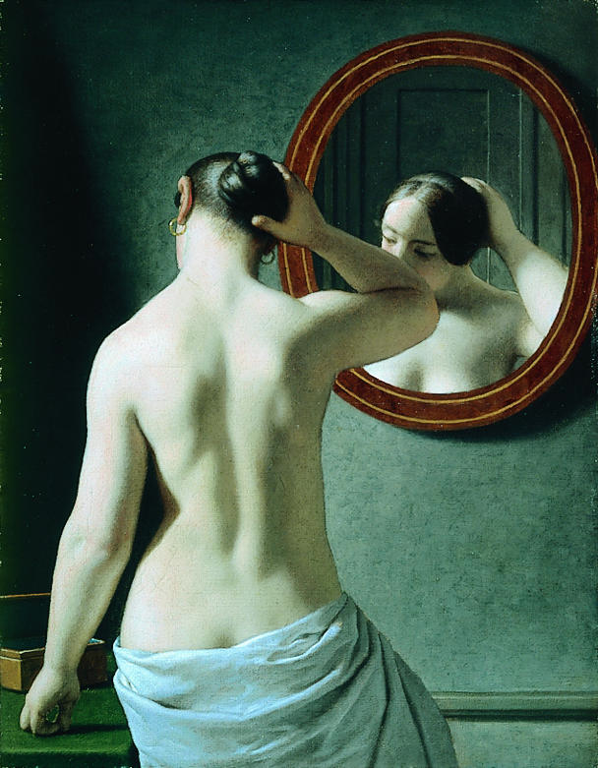
Woman before a mirror by Christopher Wilhelm Eckersberg from the Hirshsprung Collection, Copenhagen.

