http://echa.europa.eu/image/image_gallery?uuid=1ed01b8e-695d-461b-9ebb-b41cf4f638ec&groupId=10162&t=1408006670815

**Classification and labelling of aqueous solutions of one substance**

**Introduction   
with exercises**



Content

Aims 3

CLP, GHS, REACH, ECHA 3

GHS and CLP 3

CLP in Norway 3

ECHA or the Agency 3

REACH 3

Example label: 4

Location of information on the CLP hazard label 5

Labelling with only hazard pictogram and signal word 5

Not classified, according to CLP 5

Concepts in CLP 6

Classification and finding label elements 9

Exercise 1: Label 3 % NaOH, in 1L bottle 9

Exercise 2: Label 15 % HCl in 1 L bottle 11

Exercise 3: Label 9 % NH3 in 1 L bottle (“Salmi”) 12

Exercise 4: Label 2 % CuSO4 in 1 L bottle 13

Exercise 5 (Optional): Can you make a nickel(II)sulphate solution that is not classified as hazardous? 14

Links 15

# Aims

*Competence aims*

The aims of the studies are to enable students to:

* Explain some fundamental concepts used in classification and labelling of hazardous substances or mixtures.
* Explain the elements of CLP hazard label
* Label aquatic solutions of 3 % NaOH, 15 % HCl, 9 % NH3 and 2 % CuSO4

# CLP, GHS, REACH, ECHA

## GHS and CLP

Trade in substances and mixtures is not only an issue relating to the internal market, but also to the global market. With a view to facilitating worldwide trade while protecting human health and the environment, harmonised criteria for classification and labelling together with general principles of their application have been carefully developed over a period of 12 years within the United Nations (UN) structure. The result was called the Globally Harmonised System of Classification and Labelling of Chemicals (UN GHS): <http://www.unece.org/trans/danger/publi/ghs/ghs_welcome_e.html> ).

The CLP Regulation is legally binding across the Member States (and Norway). It is directly applicable to industry. The hazard of a substance or mixture is the potential for that substance or mixture to cause harm. It depends on the intrinsic properties of the substance or mixture. Hazard labelling allows for the communication of hazard classification to the user of a substance or mixture, to alert the user to the presence of a hazard and the need to avoid exposures and the resulting risks. CLP sets general packaging standards, in order to ensure the safe supply of hazardous substances and mixtures.

## CLP in Norway

[*Forskrift om klassifisering, merking og emballering av stoffer og stoffblandinger* (CLP)](http://lovdata.no/dokument/SF/forskrift/2012-06-16-622) in force in Norway from 16. June 2012, replacing *Forskrift om klassifisering, merking mv. av farlige kjemikalier (Merkeforskriften)* after 1. June 2015.

## ECHA or the Agency

What is the role of the European Chemicals Agency (ECHA or the Agency)? The European Chemicals Agency (the Agency) is a Community body which was established for the purpose of managing REACH. It is central to the implementation of both REACH and CLP, to ensure consistency across the EU.

## REACH

REACH is the Regulation on Registration, Evaluation, Authorization and Restriction of Chemicals. It entered into force on 1st June 2007. It streamlines and improves the former legislative framework on chemicals of the European Union (EU).

Labelling

## Example label:

**Sodium hydroxide, 4 % NaOH**

1 mol/L NaOH, CAS no. 1310-73-2

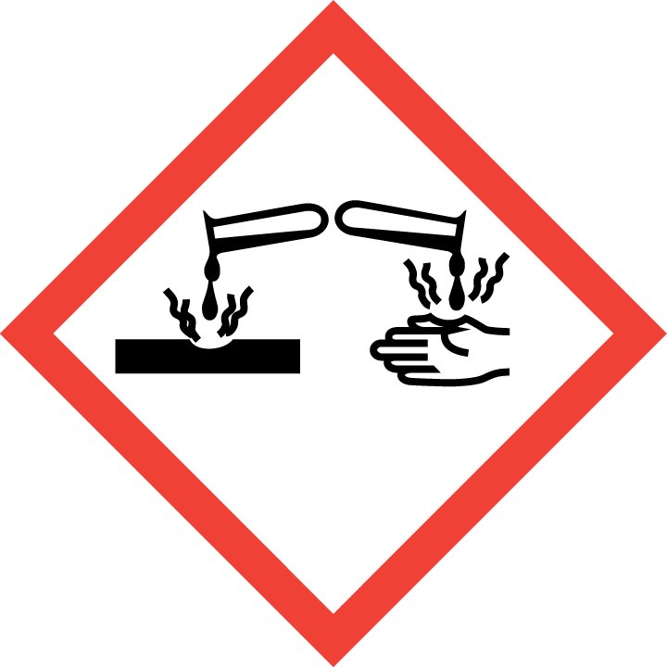

Danger

Causes severe skin burns and eye damage.

Wear protective gloves/protective clothing/eye protection/face protection. IF SWALLOWED: Rinse mouth. Do NOT induce vomiting. IF ON SKIN (or hair): Take off immediately all contaminated clothing. Rinse skin with water / shower. IF IN EYES: Rinse cautiously with water for several minutes. Remove contact lenses, if present and easy to do. Continue rinsing. If eye irritation persists: Get medical advice/attention. IF exposed or concerned: Immediately call a POISON CENTER/ doctor/….

Company’s name , adress and telephone number:

(Made by, date)

Hazard statement

Product identifier

Concentration in %

Hazard pictogram

Signal word

Precautionary statements

Company’s identity

Supplemental labelling information

CLP requires the label to be written in the official language, additional languages may be used.

## Location of information on the CLP hazard label

The hazard pictograms signal word, hazard statements and precautionary statements shall be kept together on the label.

Hazard statements shall be grouped together on the label while the order of the hazard statements can be chosen freely.

Precautionary statements shall be grouped together on the label while the order of the precautionary statements can be chosen freely.

In case more than one language is used on the label, the hazard and precautionary statements of the same language shall be grouped together on the label.

Any supplemental information as referred to in CLP Article 25 shall be included in the section for supplemental labelling and placed alongside the label elements referred to in CLP Article 17(1)(a)– (g).

## Labelling with only hazard pictogram and signal word

Exemptions where the contents do not exceed 125 ml

**

## Not classified, according to CLP

Bottles with mixtures that are not classified as hazardous may be labelled “Not classified, according to CLP” for obvious reasons.

# Concepts in CLP

***Hazardous substances and mixtures***All substances and mixtures meeting the criteria of one or more of the hazard classes in CLP are considered hazardous.

***CLP hazard classes and categories***

There are three groups of hazard classes: Physical hazards, Health hazards, Environmental hazards  
Categories: Category 1A, 1B, and 1C, Category 2, Category 3 and Category 4:

Leaflet with all hazard classes and categories,

in English: [CLP leaflet](http://www.hsa.ie/eng/Publications_and_Forms/Publications/Chemical_and_Hazardous_Substances/CLP_Poster_1_A1_size_.pdf)  
in Norwegian: [Plakat for klassifisering og merking.](http://www.miljodirektoratet.no/Documents/publikasjoner/M259/M259.pdf)

***Product identifier***

A name and an identification number as they appear in the Classification an Labelling Inventory.

***Hazard pictograms***

[Oversikt fra Miljødirektoratet](http://www.miljodirektoratet.no/old/klif/publikasjoner/2771/ta2771.pdf)  
[Leaflet from ECHA](http://echa.europa.eu/documents/10162/2621167/eu-osha_chemical_hazard_pictograms_leaflet_en.pdf)

***Signal words***CLP introduces the two UN GHS signal words ‘Danger’ (Fare) and ‘Warning’ (Advarsel) to indicate the severity of a hazard.  
Where you have to use the signal word “Danger”, the signal word “Warning” shall not appear on the label.

***Hazard statements***

[Oversikt fra Miljødirektoratet](http://www.miljodirektoratet.no/Global/dokumenter/tema/kjemikaler/H-setninger__revisjon%203_juli2013.pdf) (in English and Norwegian)  
Code ranges of hazard statements under CLP



***Precautionary statements***[Oversikt fra Miljødirektoratet](http://www.miljodirektoratet.no/Global/dokumenter/tema/kjemikaler/P-setninger_revisjon3_juli%202013.pdf) (in English and Norwegian)  
Code ranges of precautionary statements under CLP



***CAS-number*** Chemical Abstract Service number, identification number

***ATE*** Acute Toxicity Estimate

***M-factor:***

M-factor means a multiplying factor. It is applied to the concentration of a substance classified as hazardous to the aquatic environment acute category 1 or chronic category 1, and is used to derive by the summation method the classification of a mixture in which the substance is present.

***C&L Inventory***The classifications of all substances notified or registered under REACH or CLP will be included in the Classification and Labelling Inventory established at the Agency (CLP Article 42). The inventory will indicate whether a classification is harmonised or whether it has been agreed between two or more notifiers or registrants.

**Capacity of the package Dimensions of the label)**

***Sizes***

Label: ≤ 3 liters If possible, at least 52 mm x 74 mm

Pictogram: If possible, at least 16 mm x 16 mm.

Each hazard pictogram shall cover at least one fifteenth of the minimum surface area of the label dedicated to CLP information, but the minimum area shall not be less than 1 cm2.

**16 mm x 16 mm pictograms**

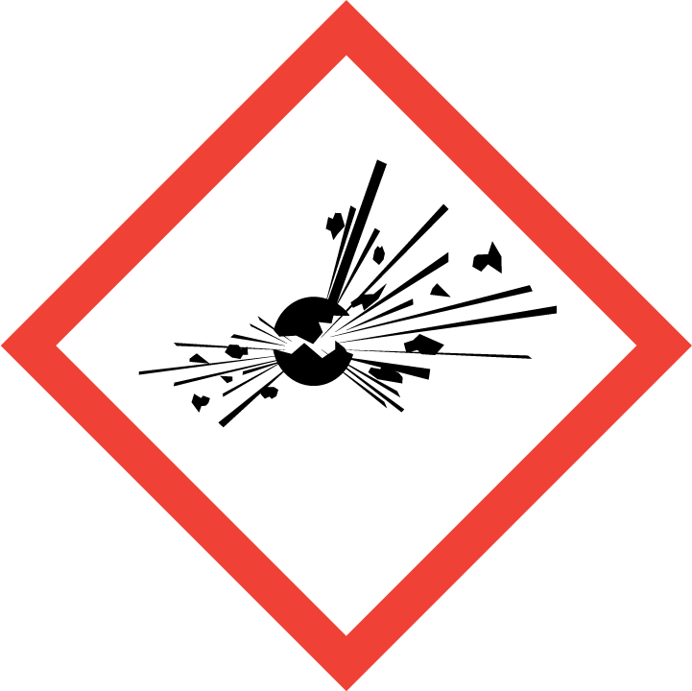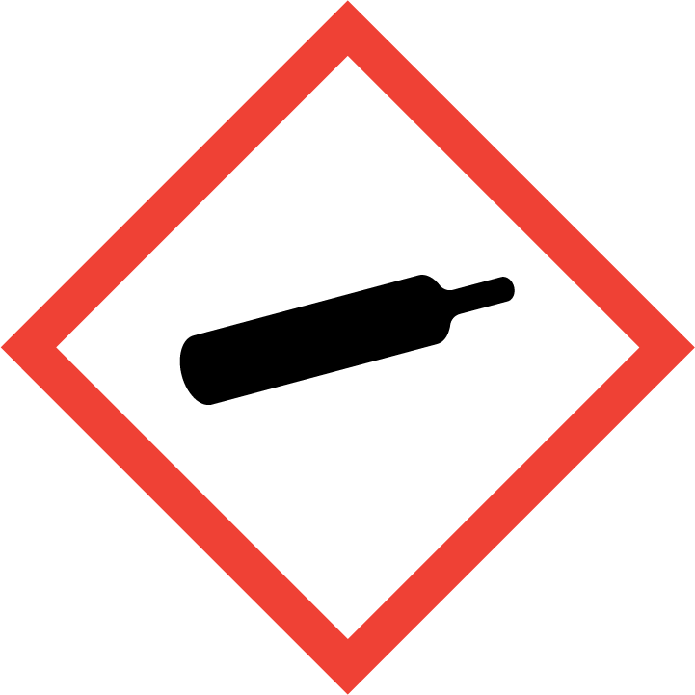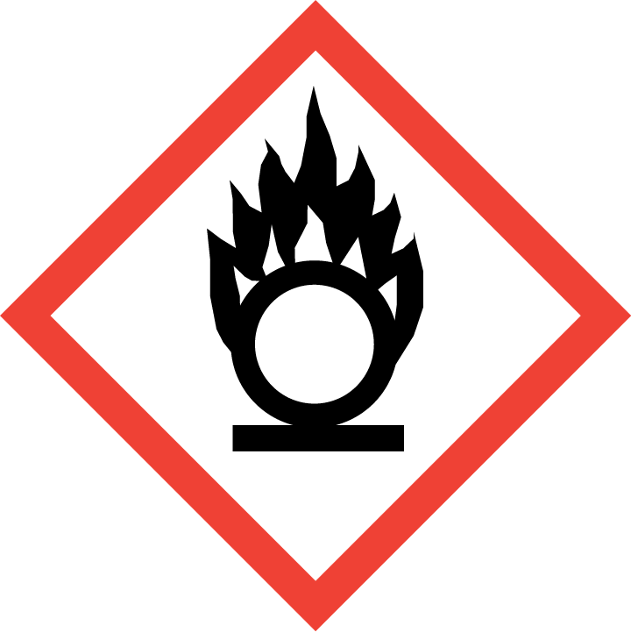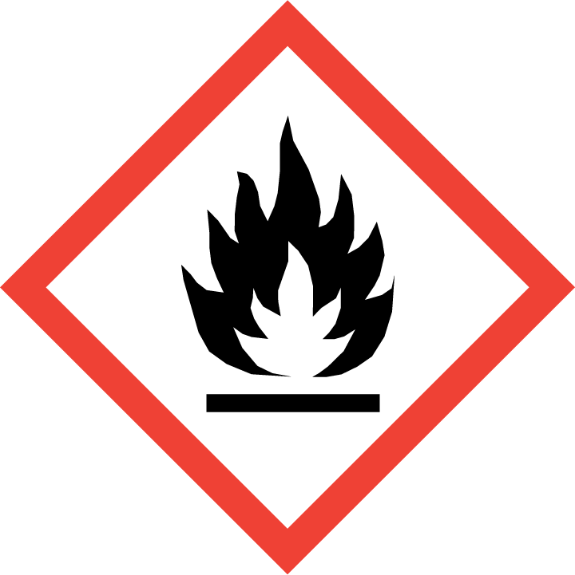

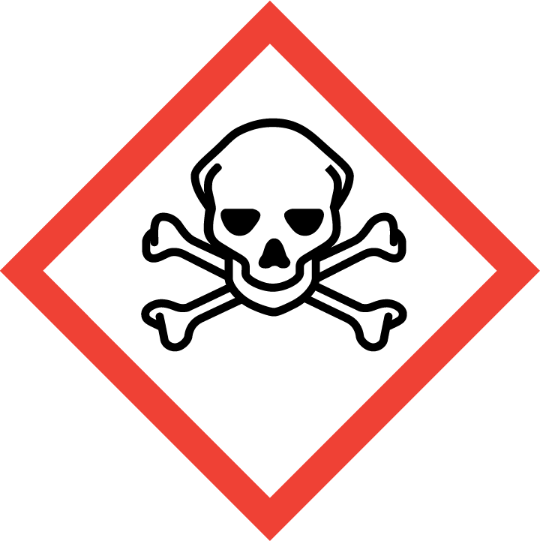 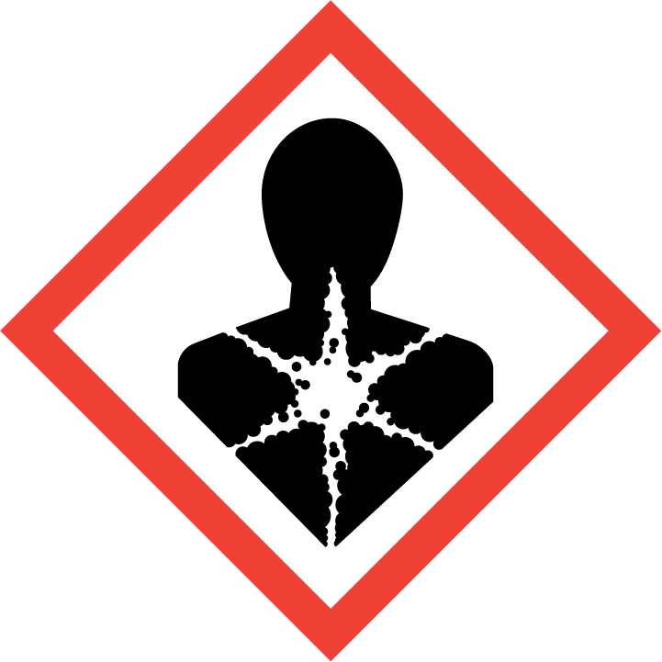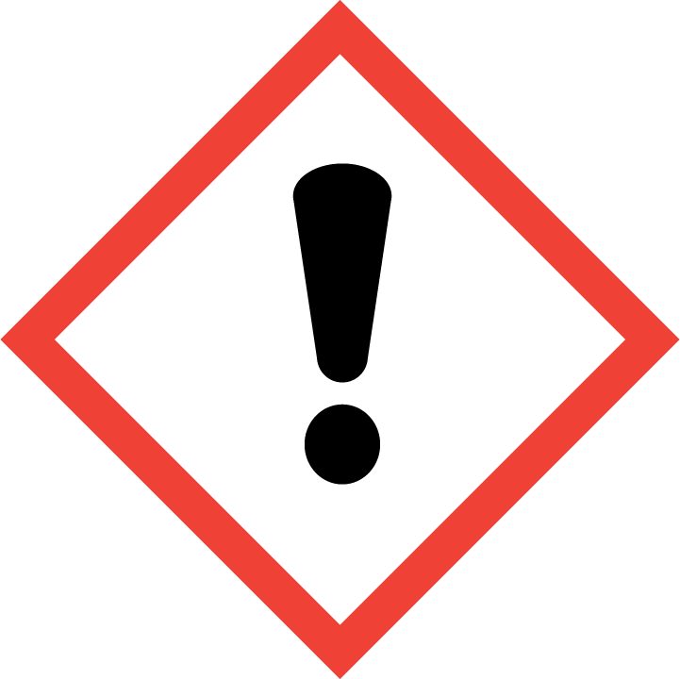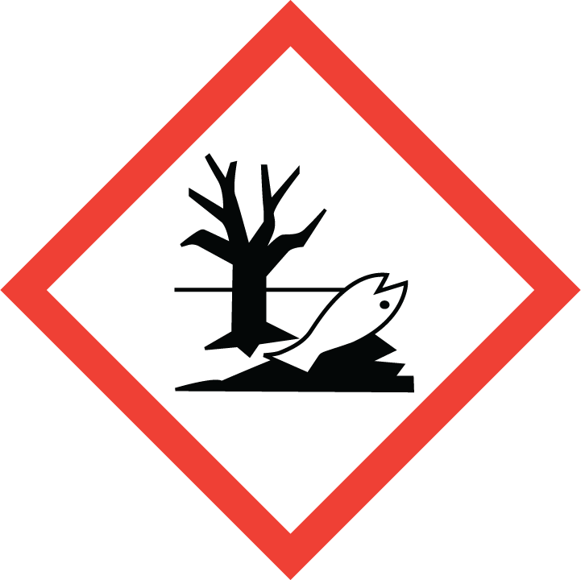

**10 mm x 10 mm pictograms**



# Classification and finding label elements

## Exercise 1: Label 3 % NaOH, in 1L bottle

1. Find the classification of the pure substance NaOH.
2. Go to [C&L Inventory](http://echa.europa.eu/information-on-chemicals/cl-inventory-database).
3. Write the name (Substance Name), in English: sodium hydroxide or CAS-number for the substance (Other identifier).
4. Check the box «legal disclaimer»
5. Hit «Search» down on the page.
6. On the new page, click on the magnifier glass on the right side, in the row which has the name and/or the CAS-number for your substance.
7. In table 3.1 “CLP Classification”, find the column **“Specific Concentration limits”** and find the concentration range for your mixture, which is 2 % ≤ C < 5 %.
8. The classification is:

Skin Corr. 1B; H314.

Go to [Plakat for klassifisering og merking](http://www.miljodirektoratet.no/Documents/publikasjoner/M259/M259.pdf) (in Norwegian) or [CLP leaflet](http://www.hsa.ie/eng/Publications_and_Forms/Publications/Chemical_and_Hazardous_Substances/CLP_Poster_1_A1_size_.pdf) (English). Under «Klassifisering» find Skin Corr. 1B. Under «Merking» you will find the labelling elements for substances classified as Skin Corr. 1B; H314. These are the labelling elements:

http://esis.jrc.ec.europa.eu/clp/image/ghs05s.gif

* Hazard pictogram, corrosive (GHS05*):
* Signal word: Fare (Danger)
* Hazard statement (H314*): Gir alvorlig etseskade på hud og øyne (Causes severe skin burns and eye damage).

GHS05 and H314 are not written on the label.

The wording of the hazard statements should be taken as stated in:

[oversikt over faresetningene fra Miljødirektoratet](http://www.miljodirektoratet.no/Global/dokumenter/tema/kjemikaler/H-setninger__revisjon_%20februar2014.pdf) eller [Plakat for klassifisering og merking](http://www.miljodirektoratet.no/no/Publikasjoner/Publikasjoner/2011/Mars/Klassifisering_og_merking_i_CLP/)

As a general rule, all hazard statements resulting from the classification shall appear on the label.

1. Precautionary statements:

You can find precautionary statements for skin corrosion/irritation in the CLP regulation [CLP (EF) nr. 1272/2008](http://lovdata.no/static/SF/32008r1272u.pdf) (Norwegian) [CLP (EC) no. 1272/2008](http://eur-lex.europa.eu/LexUriServ/LexUriServ.do?uri=OJ:L:2008:353:0001:1355:en:PDF) (engelsk)

See table 3.2.5 (Ctrl+F – tabell 3.2.5 / Ctrl+F – table 3.2.5): **Label elements for skin corrosion/irritation**.

The wording of the precautionary statements should be taken as stated in [En oversikt over sikkerhetssetningene fra Miljødirektoratet](http://www.miljodirektoratet.no/Global/dokumenter/tema/kjemikaler/P-setninger_revisjon3_juli%202013.pdf). Normally, not more than six precautionary statements shall appear on the label, unless necessary to reflect the nature and the severity of the hazards. Any selection shall take into account the hazard statements used, and the intended use or uses of the mixture. Precautionary statemens with + between them, shall appear together. In chapter 7 of [Guidance on labelling and packaging in accordance with Regulation (EC) No 1272/2008](https://echa.europa.eu/documents/10162/13562/clp_labelling_en.pdf) you will find guidance on how to select precautionary statements.

Create the label for a 1 L bottle of 3 % NaOH:

## Exercise 2: Label 15 % HCl in 1 L bottle

1. Go to [C&L Inventory](http://echa.europa.eu/information-on-chemicals/cl-inventory-database)
2. Write the substance name: hydrochloric acid or CAS-number (Other identifier)
3. Check for «Legal disclaimer»
4. Hit «Search”, down on the page.
5. Scroll down. On the same page, click on the magnifier glass, to the right, for the name or CAS-no. which is relevant for your substance. Scroll down to the table displaying “hydrochloric acid …%”, under “General Information”. In the table «CLP Classification … table 3.1» go to **Specific Concentration limits** and find the hazard class and category code and the hazard statements for your mixture, 10 % ≤ C < 25 %. Go to [Plakat for klassifisering og merking](http://www.miljodirektoratet.no/Documents/publikasjoner/M259/M259.pdf) (in Norwegian) or [CLP leaflet](http://www.hsa.ie/eng/Publications_and_Forms/Publications/Chemical_and_Hazardous_Substances/CLP_Poster_1_A1_size_.pdf) (English) and find the labelling elements (pictogram(s), signal word and hazard statement(s)).
6. Precautionary statements:

You can find precautionary statements for each hazard class and category in the CLP regulation [CLP (EF) nr. 1272/2008](http://lovdata.no/static/SF/32008r1272u.pdf) (Norwegian) [CLP (EC) no. 1272/2008](http://eur-lex.europa.eu/LexUriServ/LexUriServ.do?uri=OJ:L:2008:353:0001:1355:en:PDF) (engelsk)

See tables 3.2.5, 3.3.5 and 3.8.4

The wording of the precautionary statements should be taken as stated in [En oversikt over sikkerhetssetningene fra Miljødirektoratet](http://www.miljodirektoratet.no/Global/dokumenter/tema/kjemikaler/P-setninger_revisjon3_juli%202013.pdf). Normally, not more than six precautionary statements shall appear on the label. Unless necessary to reflect the nature and the severity of the hazards. Any selection shall take into account the hazard statements used, and the intended use or uses of the mixture. Precautionary statemens with + between them, shall appear together. In chapter 7 of [Guidance on labelling and packaging in accordance with Regulation (EC) No 1272/2008](https://echa.europa.eu/documents/10162/13562/clp_labelling_en.pdf) you will find guidance on how to select precautionary statements.

Create the label for a 1 L bottle of 15 % HCl:

## Exercise 3: Label 9 % NH3 in 1 L bottle (“Salmi”)

1. Go to [C&L Inventory](http://echa.europa.eu/information-on-chemicals/cl-inventory-database)
2. Write the substance name: ammonia or CAS-number (Other identifier)
3. Check for «Legal disclaimer»
4. Hit «Search”, down on the page.
5. Scroll down. On the same page, click on the magnifier glass, to the right, for the name or CAS-no. which is relevant for your substance.
   1. In the table «CLP Classification … table 3.1» go to **Specific Concentration limits** and find the hazard class and category code and the hazard statements for your mixture.
   2. For the two hazard classes without specific consentration limits, you must use other information to decide if and how the 9 % ammonia solution should be classified.
      1. Use table 3.2.3 (Skin corr 1B) in the CLP regulation [CLP (EF) nr. 1272/2008](http://lovdata.no/static/SF/32008r1272u.pdf) (Norwegian) [CLP (EC) no. 1272/2008](http://eur-lex.europa.eu/LexUriServ/LexUriServ.do?uri=OJ:L:2008:353:0001:1355:en:PDF) (engelsk)
      2. Use the lowest L(E)C50-verdien found in chapter 12 of [the safety data sheet for ammonia](https://www.sigmaaldrich.com/MSDS/MSDS/DisplayMSDSPage.do?country=NO&language=EN-generic&productNumber=09682&brand=SIAL&PageToGoToURL=https%3A%2F%2Fwww.sigmaaldrich.com%2Fcatalog%2Fsearch%3Fterm%3Dammonia%26interface%3DAll%26N%3D0%26mode%3Dmatch%2520partialmax%26lang%3Den%26region%3DNO%26focus%3Dproduct), and tables 4.1.3 and 4.1.1 in the CLP regulation [CLP (EF) nr. 1272/2008](http://lovdata.no/static/SF/32008r1272u.pdf) (Norwegian) [CLP (EC) no. 1272/2008](http://eur-lex.europa.eu/LexUriServ/LexUriServ.do?uri=OJ:L:2008:353:0001:1355:en:PDF) (engelsk) (Aquatic acute 1).

Go to [Plakat for klassifisering og merking](http://www.miljodirektoratet.no/Documents/publikasjoner/M259/M259.pdf) (in Norwegian) or [CLP leaflet](http://www.hsa.ie/eng/Publications_and_Forms/Publications/Chemical_and_Hazardous_Substances/CLP_Poster_1_A1_size_.pdf) (English) and find the labelling elements (pictogram(s), signal word and hazard statement(s)).

1. Precautionary statements:

You can find precautionary statements for each hazard class and category in the CLP regulation [CLP (EF) nr. 1272/2008](http://lovdata.no/static/SF/32008r1272u.pdf) (Norwegian) [CLP (EC) no. 1272/2008](http://eur-lex.europa.eu/LexUriServ/LexUriServ.do?uri=OJ:L:2008:353:0001:1355:en:PDF) (engelsk)

See tables 3.2.5 and 3.8.4. The wording of the precautionary statements should be taken as stated in [En oversikt over sikkerhetssetningene fra Miljødirektoratet](http://www.miljodirektoratet.no/Global/dokumenter/tema/kjemikaler/P-setninger_revisjon3_juli%202013.pdf). In chapter 7 of [Guidance on labelling and packaging in accordance with Regulation (EC) No 1272/2008](https://echa.europa.eu/documents/10162/13562/clp_labelling_en.pdf) you will find guidance on how to select precautionary statements.

Create the label for a 1 L bottle of 9 % ammonia:

## Exercise 4: Label 2 % CuSO4 in 1 L bottle

1. Go to [C&L Inventory](http://echa.europa.eu/information-on-chemicals/cl-inventory-database)
2. Write the substance name: copper(II)sulfate or CAS-number (Other identifier)
3. Check for «Legal disclaimer»
4. Hit «Search”, down on the page.
5. Scroll down. On the same page, click on the magnifier glass, to the right, for the name or CAS-no. which is relevant for your substance.
   1. Check for **Specific Concentration limits**
   2. For hazard classes without specific consentration limits, you must use other information to decide if and how the 2 % copper(II)sulfate solution should be classified.
      1. Use table 3.2.3 (Skin irrit. 2) in the CLP regulation [CLP (EF) nr. 1272/2008](http://lovdata.no/static/SF/32008r1272u.pdf) (Norwegian) [CLP (EC) no. 1272/2008](http://eur-lex.europa.eu/LexUriServ/LexUriServ.do?uri=OJ:L:2008:353:0001:1355:en:PDF) (engelsk)
      2. Use table 3.3.3 (Eye irrit. 2) in the CLP regulation [CLP (EF) nr. 1272/2008](http://lovdata.no/static/SF/32008r1272u.pdf) (Norwegian) [CLP (EC) no. 1272/2008](http://eur-lex.europa.eu/LexUriServ/LexUriServ.do?uri=OJ:L:2008:353:0001:1355:en:PDF) (engelsk)
      3. Use the lowest L(E)C50-verdien found in chapter 12 of the [safety data sheet for copper(II)sulfate](https://www.sigmaaldrich.com/MSDS/MSDS/DisplayMSDSPage.do?country=NO&language=EN-generic&productNumber=451657&brand=ALDRICH&PageToGoToURL=https%3A%2F%2Fwww.sigmaaldrich.com%2Fcatalog%2Fsearch%3Fterm%3DCopper%2BSulfate%26interface%3DProduct%2520Name%26N%3D0%2B%26mode%3Dmode%2520matchpartialmax%26lang%3Den%26region%3DNO%26focus%3DproductN%3D0%2520220003048%2520219853286%2520219853206) and tables 4.1.3 and 4.1.1 in the CLP regulation [CLP-forordningen (EF) nr. 1272/2008](http://lovdata.no/static/SF/32008r1272u.pdf) (Aquatic acute 1).
      4. Use the lowest L(E)C50-verdien found in chapter 12 of the [safety data sheet for copper(II)sulfate](https://www.sigmaaldrich.com/MSDS/MSDS/DisplayMSDSPage.do?country=NO&language=EN-generic&productNumber=451657&brand=ALDRICH&PageToGoToURL=https%3A%2F%2Fwww.sigmaaldrich.com%2Fcatalog%2Fsearch%3Fterm%3DCopper%2BSulfate%26interface%3DProduct%2520Name%26N%3D0%2B%26mode%3Dmode%2520matchpartialmax%26lang%3Den%26region%3DNO%26focus%3DproductN%3D0%2520220003048%2520219853286%2520219853206), and tables 4.1.3 and 4.1.2 in the CLP regulation [CLP-forordningen (EF) nr. 1272/2008](http://lovdata.no/static/SF/32008r1272u.pdf) (Aquatic chronic 1).
      5. Use table 3.1.1 and 3.1.2 and the equation given in 3.1.3.6.1 and below (Acute tox. 4).

$${ATE}_{mix}=\frac{100*{ATE}_{i}}{c_{i}}=2000$$

Create the label for a 1 L bottle of 2 % copper(II)sulfate solution:

## Exercise 5 (Optional): Can you make a nickel (II) sulfate solution that is not classified as hazardous?

1. Go to [C&L Inventory](http://echa.europa.eu/information-on-chemicals/cl-inventory-database)
2. Write the substance name: nickel(II)sulfate or CAS-number (Other identifier)
3. Check for «Legal disclaimer»
4. Hit «Search”, down on the page.
5. Scroll down. On the same page, click on the magnifier glass, to the right, for the name or CAS-no. which is relevant for your substance.

|  |  |  |
| --- | --- | --- |
| Hazard class | To determine the classification of the mixture | Concentration limit |
| Acute Tox. 4;H302 | Use table 3.1.1 and 3.1.2 and the equation given in 3.1.3.6.1 in the CLP regulation: [CLP (EC) no. 1272/2008](http://eur-lex.europa.eu/LexUriServ/LexUriServ.do?uri=OJ:L:2008:353:0001:1355:en:PDF) (eng)  [CLP-forordningen (EF) nr. 1272/2008](http://lovdata.no/static/SF/32008r1272u.pdf) |  |
| Skin irrit. 2;H315 | Specific concentration limit |  |
| Skin Sens. 1;H317 | Specific concentration limit |  |
| Acute Tox. 4;H332 | Use table 3.1.1 and 3.1.2 and the equation given in 3.1.3.6.1 in the CLP regulation. |  |
| Resp. Sens. 1;H334 | Generic concentration limit – use table 3.4.3 in the CLP regulation. |  |
| Muta. 2;H341 | Generic concentration limit – use table 3.5.2 in the CLP regulation. |  |
| Carc. 1A;H350i | Generic concentration limit – use table 3.6.2 in the CLP regulation. |  |
| Repr. 1B;H360D | Generic concentration limit – use table 3.7.2 in the CLP regulation. |  |
| STOT RE 1;H372 | Specific concentration limit |  |
| STOT RE 2;H373 | Specific concentration limit |  |
| Aquatic Acute 1 | Use the lowest L(E)C50-verdien found in chapter 12 of the safety data sheet safety data sheet for [nickel(II)sulfate](http://www.sigmaaldrich.com/MSDS/MSDS/DisplayMSDSPage.do?country=NO&language=EN-generic&productNumber=656895&brand=ALDRICH&PageToGoToURL=http%3A%2F%2Fwww.sigmaaldrich.com%2Fcatalog%2Fsearch%3Fterm%3D7786-81-4%26interface%3DCAS%2520No.%26N%3D0%2B%26mode%3Dpartialmax%26lang%3Den%26region%3DNO%26focus%3Dproduct) and tables 4.1.3 and 4.1.1 in the CLP regulation. |  |
| Aquatic Chronic 1 | Use the lowest L(E)C50-verdien found in chapter 12 of the safety data sheet safety data sheet for [nickel(II)sulfate](http://www.sigmaaldrich.com/MSDS/MSDS/DisplayMSDSPage.do?country=NO&language=EN-generic&productNumber=656895&brand=ALDRICH&PageToGoToURL=http%3A%2F%2Fwww.sigmaaldrich.com%2Fcatalog%2Fsearch%3Fterm%3D7786-81-4%26interface%3DCAS%2520No.%26N%3D0%2B%26mode%3Dpartialmax%26lang%3Den%26region%3DNO%26focus%3Dproduct) , and tables 4.1.3 and 4.1.2 in the CLP regulation. |  |

State the concentration limit of a nickel (II) sulfate solution that is not classified as hazardous: ____%

# Links

[Miljødirektoratet; Kjemikalier](http://www.miljodirektoratet.no/no/?query=Kjemikalier&q=Kjemikalier)

[Arbeidstilsynet: Kjemikalier](http://www.arbeidstilsynet.no/resultat.html?q=Kjemikalier)

[CLP- og REACH-ordbok](http://www.miljodirektoratet.no/no/Tjenester-og-verktoy/Annet/REACH_ordbok/)

[Lovdata: Forskrift om klassifisering, merking og emballering av stoffer og stoffblandinger (CLP)](http://lovdata.no/dokument/SF/forskrift/2012-06-16-622)

[Guidance on labelling and packaging in accordance with Regulation (EC) No 1272/2008](https://echa.europa.eu/documents/10162/13562/clp_labelling_en.pdf)

[CLP (EC) no. 1272/2008](http://eur-lex.europa.eu/LexUriServ/LexUriServ.do?uri=OJ:L:2008:353:0001:1355:en:PDF) (eng)

[CLP-forordningen (EF) nr. 1272/2008](http://lovdata.no/static/SF/32008r1272u.pdf)