Example for solution to   
Exam in KJM3700 Environmental chemistry Spring 2015

1. **Radiochemistry**
2. Radiation dose is the amount of absorbed **radiation energy per unit mass** of the absorber, D = Eabs/m. [D] = J/kg = Gr, where Gr is the abbreviation for **Gray**.

Different **types of radiation** incur different amount of biological damage (as a function of transferred radiation energy density). E.g. alpha is 20 times more dangerous than gamma and beta. We therefore introduce a "quality factor" Q to take this into account: Biological equivalent dose H = Q x D (or H = Q x D x N). The unit for H is the **Sievert**.

1. 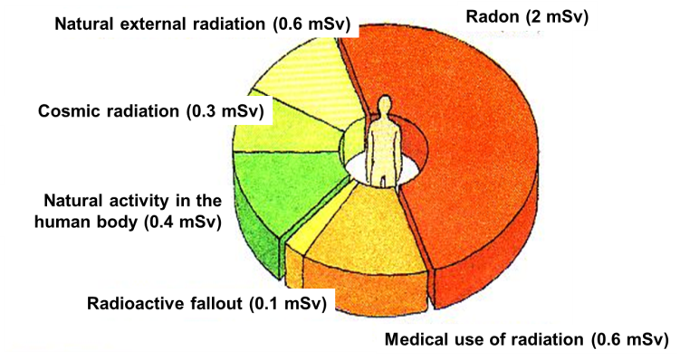Sources for radioactivity is from the **ground** (40K, thorium and uranium, plus their daughters – in particular radon gas), radiation from **space** (cosmic radiation), radionuclei produced by interaction with cosmic radiation and the earth's atmosphere (in particular 14C), and from artificially made sources such as radioactive **fallout** and **medical** use. Average yearly dose in Norway is **4 mSv**. Biggest contribution is from **radon**, se slide from lecture notes.
2. **Spillage** from stored radioactive waste, spillage from mining in Th- or U-containing rock, nuclear **accidents**. (Here it is also partly accepted to answer damage to **DNA** and cause **cancer**, and the use for nuclear weapons, although this was not the intention with the question.)

Used as a **tracer** for atmospheric or hydrosphere studies. The tracer can be added intentionally (lots of red tape..) or from nuclear accidents (e.g. ocean currents studied as a result of the release of 137Cs from Fukushima). More "normal" use would be as tracer for controlled **lab-environment studies**.

1. **Chemistry and Biology**

A) A mutation is any **alteration of a DNA** molecule in our cells, either in the noncoding part (99 %) or in the coding part (1 %).

The latter may lead to incorporation of another **amino acid** into the polypeptide. The **majority** can be considered **negative or harmful** (a figure of 70 % was given in the lectures), while the rest are neutral or weakly positive.

B) The effect of two chemicals (drugs, toxins or any other compound) given simultaneously are said to be "synergistic" when their combined effect is **higher than the sum** of their isolated effects, i.e. they serve to promote the effects of each other. Quantified in the lecture by the equation "2 + 2 = 20".

The compounds are said to be "antagonistic" when their combined effect is less than the sum of their isolated effects, i.e. they serve to **cancel each other out**. Quantified in the lecture by the equation "4+6 = 8".

1. **Reactive nitrogen**
2. **Ammonium** (NH4+) dominates the nitrogen forms in domestic wastewater (ca. 2/3). At VEAS this is removed **biologically** in two consecutive processes; first ammonium is oxidized to nitrate in the **nitrification** process and then nitrate is reduced to nitrogen gas in the **denitrification** process. These processes are run as biofilm processes (BIOFOR) at VEAS, hence the biomass is growing on a solid support that is easily retained in the bioreactors.
3. 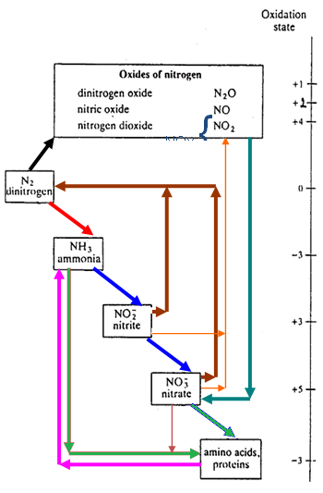

1. Fixation
2. Nitrification
3. Assimilation   
   by plants
4. Ammonification
5. Denitrification
6. Microbial NOx production
7. Combustion
8. Nitrate containing precipitation
   * Precipitation contains also ammonium
9. Acid Rain – Depletion of ozone layer – Tropospheric ozone – Global warming - marine eutrophication
10. **Energy**

A) Oil (33), Coal (30), gas (24), hydropower (7), and nuclear power (4).

Alt. answer is Fossil fuel (87%), Hydro (7%), Nuclear (4%) and other renewable (2%; wind, sun). In addition biomass contributes 4%.   
Developing countries or non-OECD countries, especially Asia with China and India, have the greatest increase in energy demand.   
  
B) Exergy: Energy **quality** or available energy. When you buy energy you actually buy exergy. You can find the energy as **heat** when the exergy is spent.

**Feasibility** of economic recovery

Reserves

Resources

recoverable

paramarginal

submarginal

proved

probable

possible

undiscovered

Degree of **uncertainty**

You can use energy forms with high exergy to do work before it is converted to heat (energy with low exergy).

Energy intensity is a measure for the energy **efficiency** and is calculated as the ratio between energy need and **GDP**

1. **Wind, Hydro, Photovoltaic and Biomass**  
   The main challenges are **cost** and to **match** the supply and demand. Mentioning of visual pollution and other env. Implications are also warranted.
2. The acid oxide CO2 reacts in an **acid-base reaction** with amine and becomes water soluble
3. **Toxicology**

A) Emerging contaminants is used to describe chemicals or other substances that are:

* **Not regulated**
* Found in the environment (often due to improved analytical chemistry and detection limits)
* Presence and impact not evaluated, though **potential** for negative effects at environmental relevant concentrations
* does not have to be new chemicals.

Legacy contaminants: Well known, **regulated**, **monitored**

Source: Industry and agriculture

Persistent, Bioaccumulative, Toxic

Emerging contaminants: Not regulated, not monitored, little knowledge

Source: also consumer

Found in the environment

B) Properties:

**Persistent** – strong **bonds** (element dependent, double and triple bonds, aromatic compounds),

**Bioaccumulates** – **C** makes them soluble in organic phases such as lipids (lipophilic)

**Toxic** – molecular structures that **interfere with biological receptors** (different functional groups, organohalogens, O, P, N S containing functional groups)

1. The ideal insecticide: Important criteria:

* High biological **selectivity** (species specific)
* **Low human toxicity**
* Rapid **degradation** without forming harmful degradation products (not accumulate)
* No development of **resistance** in the target species

None of the insecticides used today comply with all these criteria.

Among the questions we have to ask before banning the use of an effective insecticide are:

* Do we have any solid **evidence** that justify banning the substance?
* Does the substance **really** represent a hazard?
* What will be the **consequences** to health and food production if we ban this substance?
* Are there any **alternative** substances that can replace this one?
* What will be the **cost and inconvenience** of switching to another substance?
* Can **dispensation** from the ban be granted under special circumstances?