Department of Health Management and Health Economics

##### Written Exam 23 May 2013, 09:00-13:00

HMM4301-Optimal allocation of health care resources and economic evaluation of health care technologies

(Economic Evaluation for short)

Exam resources: Calculator (only the calculator Citizen SR-270X is allowed)

Results will be posted on the board at the Department of Health Management and Health Economics, Forskningsveien 3A. The results will also be posted on Studentweb.

The receiving day of the results is the day the results are posted on the board outside the Department. Appeals must be submitted within three weeks of this date.

The Written Exam consists of **3 pages** including this one.

Remember to write down your candidate number so that you have it when the results are made available.

**Good luck!**

**FINAL EXAM HMM4301 – May 23, 2013**

**Question 1 (10 points)**

Describe three principles of distributive justice in health (max 0.5 page)

**Question 2 (10 points)**

Compare and contrast time-trade-off, standard gamble and visual analog scale (VAS) for measurement of health related quality of life (HRQoL)(max 0.5 page).

**Question 3 (10 points)**

What is meant by indirect costs in economic evaluation of health care? How can indirect costs be estimated? Present practical and theoretical arguments against including indirect costs in economic evaluation (max 0.5 page).

**Question 4 (30)**

The picture below shows the result of a Monte Carlo simulation based on a decision analytic model of two interventions.

1. Explain briefly how such a graph has been produced. Use terms such as uncertainty, parameter, distribution and others you find appropriate (max 0.5 page)
2. Translate the graph into a cost-effectiveness acceptability curve and state any assumptions you make in the translation (max 1 page including graph).
3. Imagine that the costs are measured in dollars ($) and the effectiveness in QALYs, and that society’s willingness-to-pay is $2,000 per QALY. Approximately what is the net monetary value of the technology? Show your calculation (max 0.25 pages)

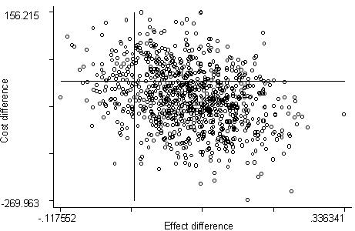

**Question 5 (40 points)**

There are two treatment options for pancreatic cancer:

* Surgery which has three outcomes
  + Die during surgery (probability 5%, cost $15,000)
  + Die later from metastases (probability 94%, cost $35,000, mean survival time 1.5 years)
  + Cure (cost $45,000, mean survival time 20)
* Chemotherapy which has two outcomes
  + Complications and discontinuation of chemotherapy (probability 20%, cost $20,000, mean survival time 6 months)
  + Continued chemotherapy (cost $60,000, mean survival time 3 years)

1. What is the expected costs and survival time of the two strategies?
2. What is the ICER?
3. What would you recommend the patient?
4. There is a test that can predict complications from chemotherapy. The test has a sensitivity of 80% and specificity of 90%. If the test is positive, you do not offer chemotherapy, and the survival time is then 1.0 year. Would you use the test if the test were cost-less? State any assumptions you make explicitly.
5. **Non-mandatory bonus question (max 10 points bonus):** What would the sensitivity of the test in Question 5d need to be in order for the testing and no-testing strategies to be equally good? State any assumptions you make explicitly.