More exercises for seminars ECON 4150

Problem set 6. Testing simultaneous hypotheses on the regression coefficients - $F$tests.
Solve the exercises: 8.9 using the file codd.xls, 8.13 using the data in the file cars.xls.

Problem set 7. This is an exercise in demand analysis. You will find the data in the file table 8-3.xls

Demand analysis:

We are concerned with analysing the demand for beer in a sample of households. Our sample reports observations on 5 variables: the quantity of beer demanded $(\text{QB})$, the price of beer $(\text{PB})$, the price of other liquor , a price index of the remaining goods and services on the households’ budgets $(\text{PR})$, and finally the households income $(\text{INC})\text{.}$ We are not certain of what will be the appropriate specification of this demand so we will try different forms. We start with the ln-ln functional form:

(1)

where $ε_{i}$ denotes the random disturbances.

Question A. How will you interpret the regression parameters in this demand function.

Use PcGive and the attached data file table 8-3.xls to estimate this model.

Question B. Do you think the signs of the estimates are reasonable? Substantiate your assertions. Explain how the numbers in the column are calculated.

Standard consumer demand theory tells us that if prices and income increase by the same proportion we should expect no change in the quantity demanded. The consumers are said to have no money illusion.

Question C. Show that the assumption of no money illusion applied to the demand function (1) implies the restriction:

(2)

Question D. Use results and information from your regression to test the hypothesis:

against
with significance level .

Now we are told that the ln-ln functional form (1) has certain theoretical drawbacks. In addition to (1) we thus wish to analyse two forms which are linear in the relative price and the real income.

(3)

(4)

where $u_{i}$ and $v_{i}$denote random disturbances.

Use PcGive to estimate the regression equations (3) and (4).

Question E. Which of the two equations (3) or (4) do you think is appropriate for testing the assumption of no money illusion? State the reason for your choice and explain how you would test this hypothesis.

Question F. Assume that the number of household members have been wrongly excluded from the regressions (3) and (4). Choose one of these regressions for further study, and explain formally how this misspecification effects the OLS estimates of the when:
(i) is uncorrelated with the explanatory variables already used in the equation.
(ii) is correlated with the explanatory variables already used in the equation.

Problem set 8. The next exercise illustrates the use of dummy variables in regression analysis.

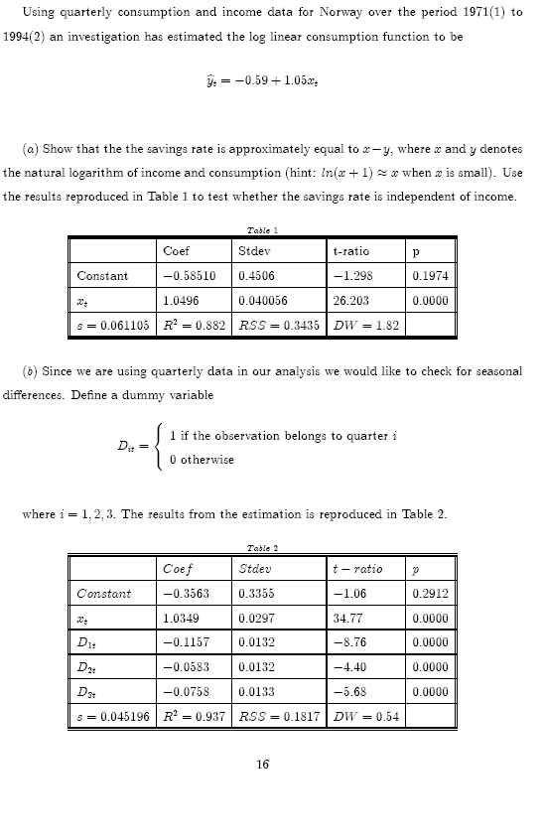
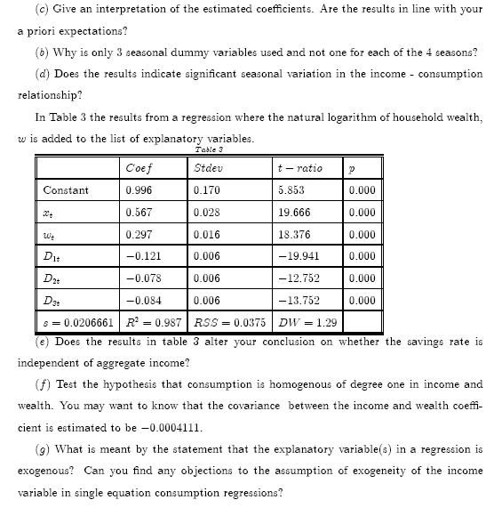

Problem set 9. Households’ expenditures on food.

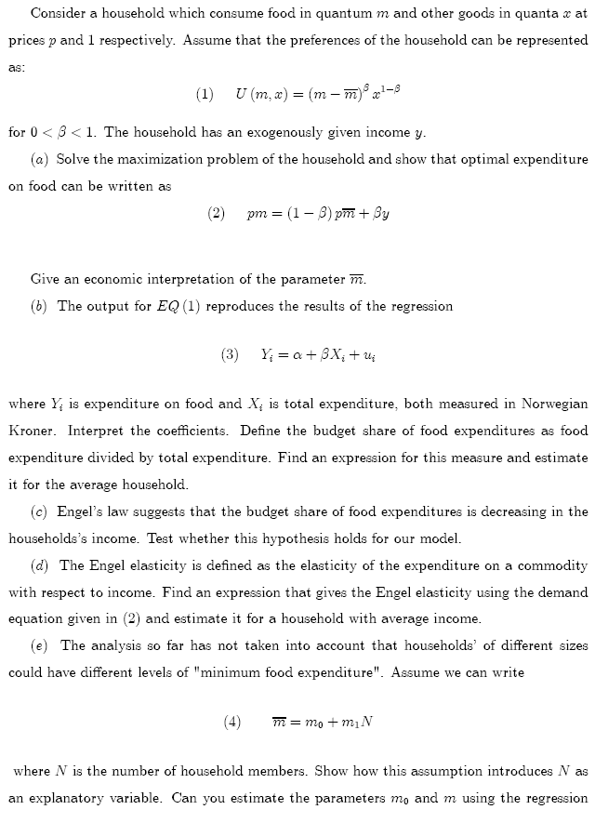

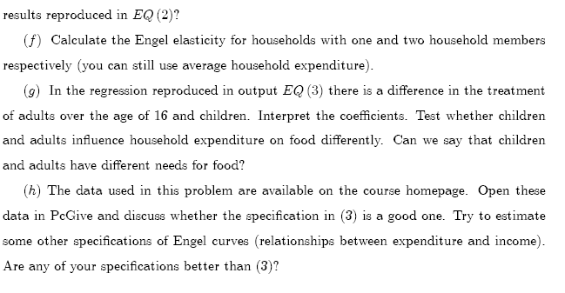
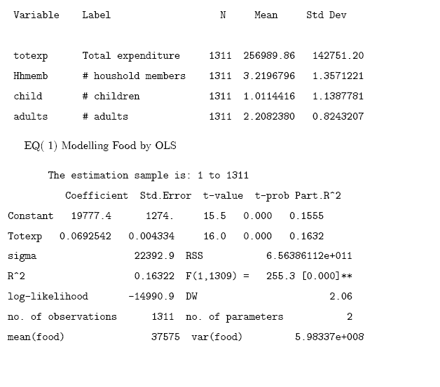

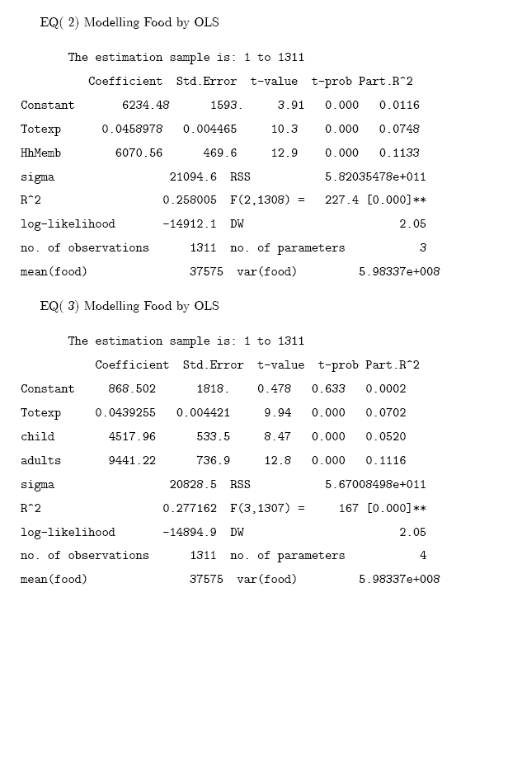
Problem set 10. Exercises with dummy variables.
Solve the exercises: 9.6 using the data file tuna.xls, 9.8

Problem set 11. This is an exercise with non-linear models.

We are interested in investigating how households’ expenditures on food vary with their income . We have observations on the households’ expenditures on food (Y) and incomes for 50 Norwegian households, both variables are measured in 1000 kroner. In addition do we have observations on the number of members in the households.
For a given income $R$ do we assume that the expected value of $Y$, denoted $\tilde{Y}$, is given by the function:

(1) $\tilde{Y}=\frac{αR}{R+β}$

where $α$ and $β$ denote unknown, positive parameters.

- Discuss if, in your opinion, the function (1) gives a good description of the relation between expenditures on food and income.

Since (1) is non-linear in the parameters, we are unable to estimate the parameters $α$ og $β$ with ordinary OLS regression. We shall therefore approximate (1), first with a linear and then with quadratic funksjon. The linear approximation $Y_{i}$ is given by:

(2) $Y_{i}=γ_{1}R_{i}+ε_{i}$ where $γ_{1}=\frac{α}{β}$ and $ε_{i}$ denotes random disturbances,
$i=1,2,$…..$,\text{50}$

- Show that OLS estimator of $γ_{1}$ is given by:

(3) ${\hat{γ}}_{1}=\frac{\sum_{i=1}^{\text{50}}{Y_{i}R_{i}}}{\sum_{i=1}^{\text{50}}{R_{i^{2}}}}$

Out-print 1 shows the results of the OLS applied to regression (2) together with the histogram of the residuals ${\hat{ε}}_{i}$.

- Give your comments to this regression, calculate the Jarque-Bera observator when (skewness) $S=0\text{.}\text{6332}$ and kurtosis $k=4\text{.}\text{5288}\text{.}$

In order to improve the approximation of $\tilde{Y}$, we now approximate (1) by a quadratic function.. The quadratic approximation of $Y_{i}$ is given by:

(4) $Y_{i}=γ_{1}R_{i}+γ_{2}R_{i^{2}}+δ_{i}$ where and $δ_{i}$ are random disturbances,
$i=1,2,\text{.}\text{.}\text{.}\text{.}\text{.}\text{.}\text{50}$

Outprint 2 shows the results of OLS applied to the regression (4) together with histogram of the residuals ${\hat{δ}}_{i}$. The variable RR in the outprint corresponds to $R^{2}$ in the regression equation (4).

- Do you think that the results as they appear in this out-print are reasonable? Substantiate your answer.
- Explain how you will use these results to deduce estimates of $α$ og $β$ and calculate $\hat{α}$ and$\hat{β}$.
- Use the expenditure function (1) to derive the Engel elasticity. Use your results above to calculate this elasticity for a household with income equal to 100 000

We suspect that the parameter $γ_{1}$ in equation (4) depends on the number of member in the household $S,$ but we are uncertain how to specify this dependency. There are two proposals:

(5) $γ_{1}=θ_{0}+θ_{1}S$
eller
(6) $γ_{1}=θ_{0}+θ_{1}S+ω$
where $ω$ denotes the random disturbances satisfying the usual conditions.

Out-print 3 shows the results of the regression:

(7) $i=1,2,\text{.}\text{.}\text{.}\text{.}\text{.}\text{.}\text{.},\text{50}$
where$u_{i}$ denotes the random disturbances in this regression

- Give your comments to this out-print.
- Explain your opinion about choosing (5) or (6).

Out-print 1

EQ( 1) Modelling Y by OLS-CS (using data.eksoppg.h2003.xls)
The estimation sample is: 1 to 50

Coefficient Std.Error t-value t-prob
R 0.233338 0.01760 13.3 0.000

sigma 6.55912 RSS 2108.08312

no. of observations 50 no. of parameters 1
mean(Y) 12.5025 var(Y) 37.0663

no. of observations 50 no. of parameters 1
mean(Y) 12.5025 var(Y) 37.0663

Out-print 2

Q( 2) Modelling Y by OLS-CS (using data.eksoppg.h2003.xls)
The estimation sample is: 1 to 50

Coefficient Std.Error t-value t-prob
R 0.371463 0.05604 6.63 0.000
RR -0.00213237 0.0008260 -2.58 0.013

sigma 6.20997 RSS 1851.05693
no. of observations 50 no. of parameters 2
mean(Y) 12.5025 var(Y) 37.0663

Out-print 3

Q( 3) Modelling Y by OLS-CS (using data.eksoppg.h2003.xls)
The estimation sample is: 1 to 50

Coefficient Std.Error t-value t-prob
R 0.170144 0.06098 2.79 0.008
RS 0.0623471 0.01248 5.00 0.000
RR -0.00238358 0.0006765 -3.52 0.001

sigma 5.07192 RSS 1209.04536
no. of observations 50 no. of parameters 3
mean(Y) 12.5025 var(Y) 37.0663

