ECON 4715 Seminar 3

Problem 1: Insurance
To be solved by the group consisting of Jan Herfort, Kathrin Weny, Anna Irger, Cho Sueyon and Sunwook Hwang.

Consider the insurance model described in 2.1.1. Chapter 6.
- Explain equation (3) and the Arrow-Borch condition.
- Let the Agent’s utility function be given by $U\left(C,L\right)=10ln(C)+5ln⁡(L)$. Leisure is 24-hours worked. The production function is given by $f\left(h,ε\right)=10ε+εh$ while the Principal’s utility function is $v\left(π\right)=2\sqrt{π}$. Is the following contract optimal?

CONTRACT 1:
Good state: $ε=g=1$
W(g)=, 10, h(g)=19

Bad state: $ε=g=0,5$
W(b)=10, h(g)=14

Assume now that the Principal’s utility function instead is given by $v\left(π\right)=10π$. Is the contract optimal now?

- The figure below shows profits and wage costs in the Norwegian Maritime sector. Comment the figure in light of the theoretical model (“Driftsresultat”= profits, “Lønnskostnader”= wage costs).
- Use the provided dataset for the US and compare the predictions from the insurance model (regarding business cycles) to the fluctuations in hours worked and weekly earnings from 1979 to 2010.
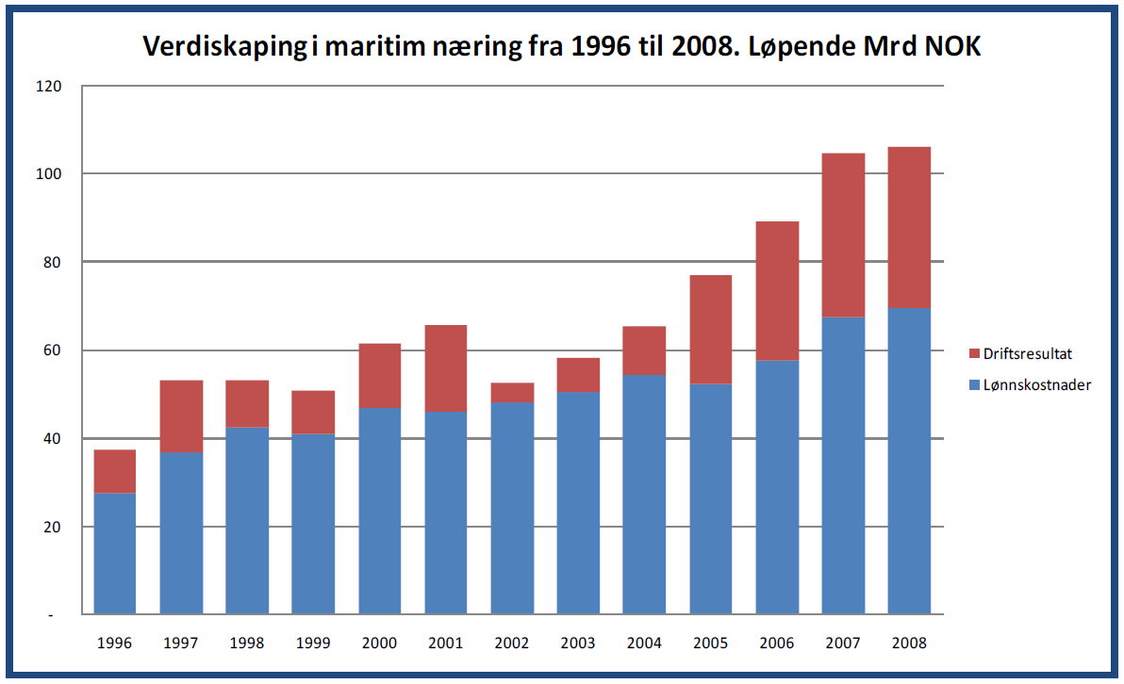

Problem 2: Incentives
To be solved by the group consisting of Chama Yoram, Alessandro Freitas and Tesfay Zeru.

Consider the model of section 3.1 in Chapter 6 as a model of executive pay. The owner of the firm is able to measure the value of sales of the firm, but is unable to distinguish between the results of the effort of the manager and general market conditions for the good produced.

1) Discuss how a bonus rate on the value of sales should be designed. Next show how the bonus rate changes with the volatility of the product market.

2) Assume now that the owner may observe total sales in the industry. This measure is positively correlated with the unobserved variation in the firm’s sales. Discuss a remuneration scheme that also takes this observation into account.

3) Assume now that all unobserved shocks to the firm are industry specific and that the unobserved variation in the firm’s sales is perfectly correlated with variations in total sales in the industry. How should the contract look like now?

